**Homework #4**

AWS Cloud9 is a cloud IDE for writing, running, and debugging code

* Creating an environment for Cloud9

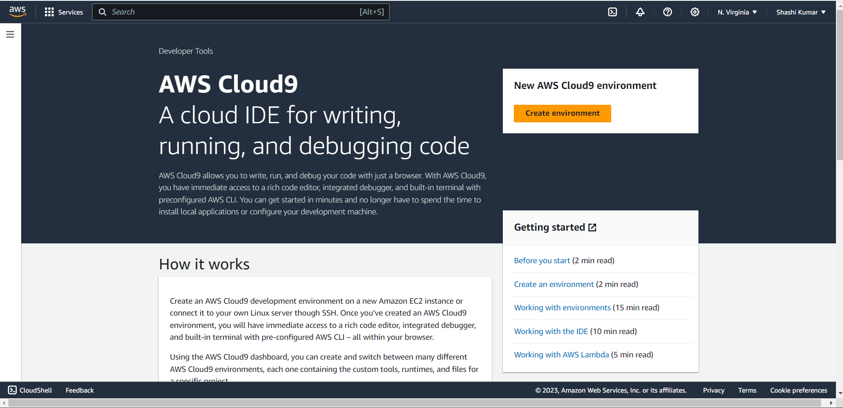

* Creating the new environment by naming it bigdatahw4

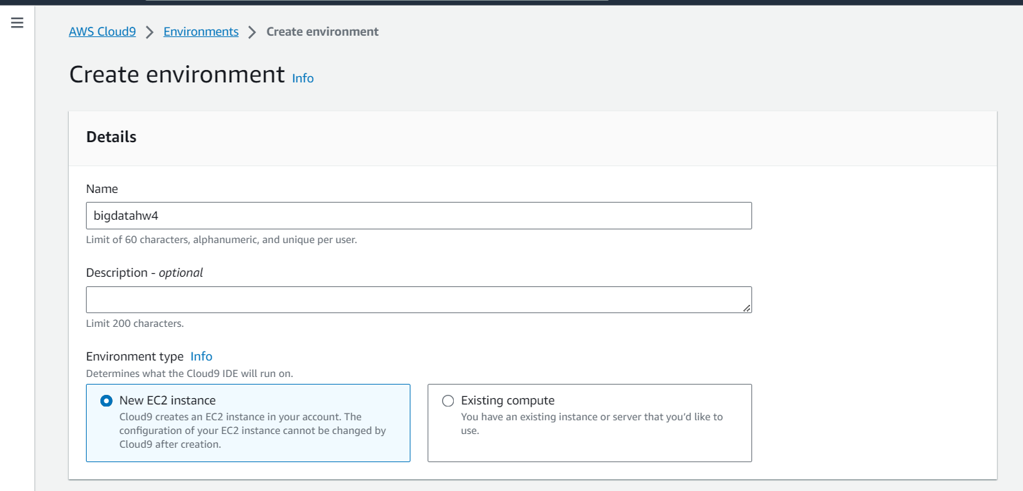

* Configuring the new ec2 instance for the environment as a micro for free tier and chose Amazon Linux 2 as a platform and have 30 min timeout

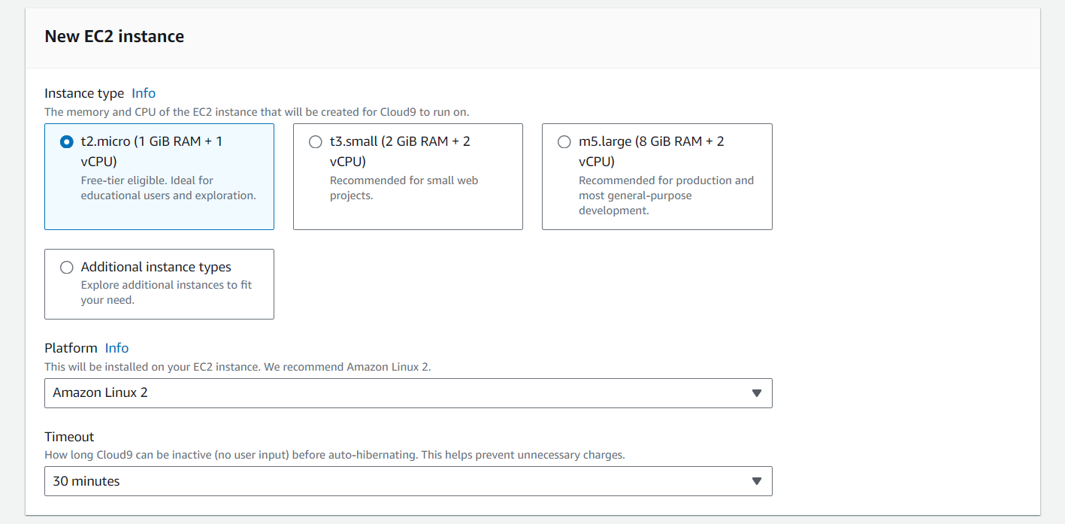

* Configuring the network settings for the environment using AWS systems manager for connection access and choosing the default VPC cloud

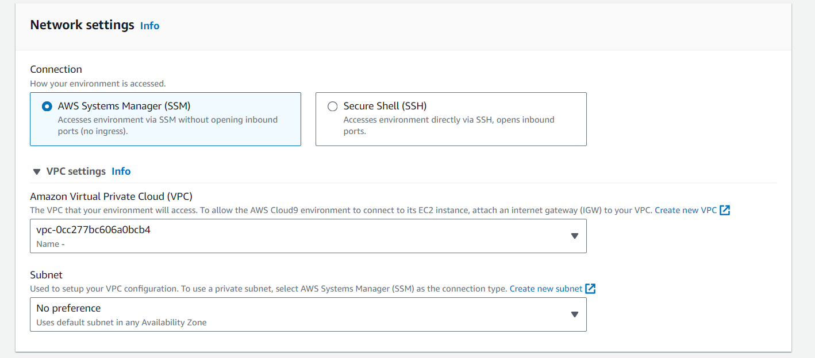

* Created the AWS Cloud9 environment

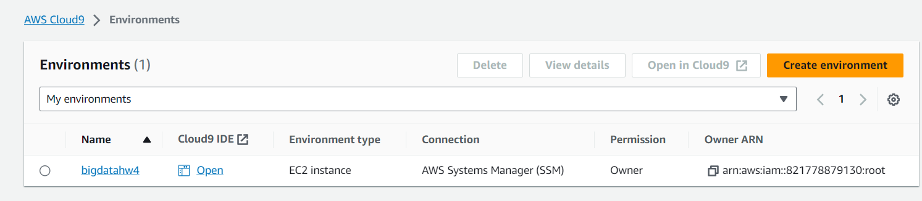

* Opening the newly created Cloud9 environment

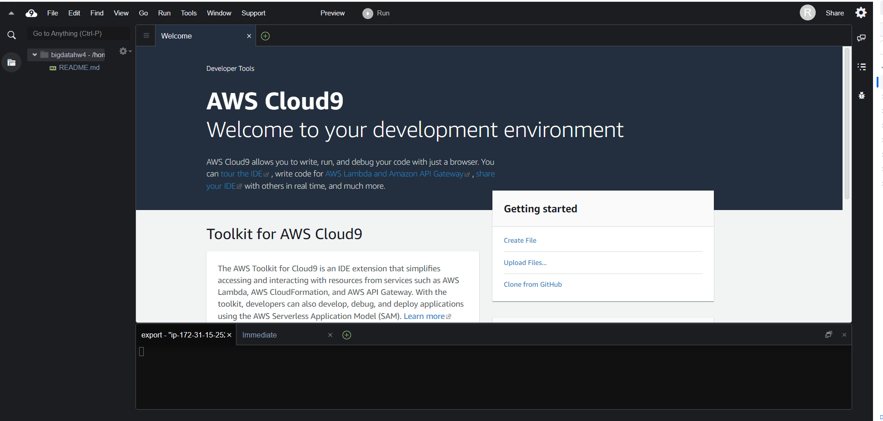

* Installing node and nvm on the environment which is required for AngularJS front end using the command shell using nvm install 8.9.1 and setting the default to 8.9.1 version

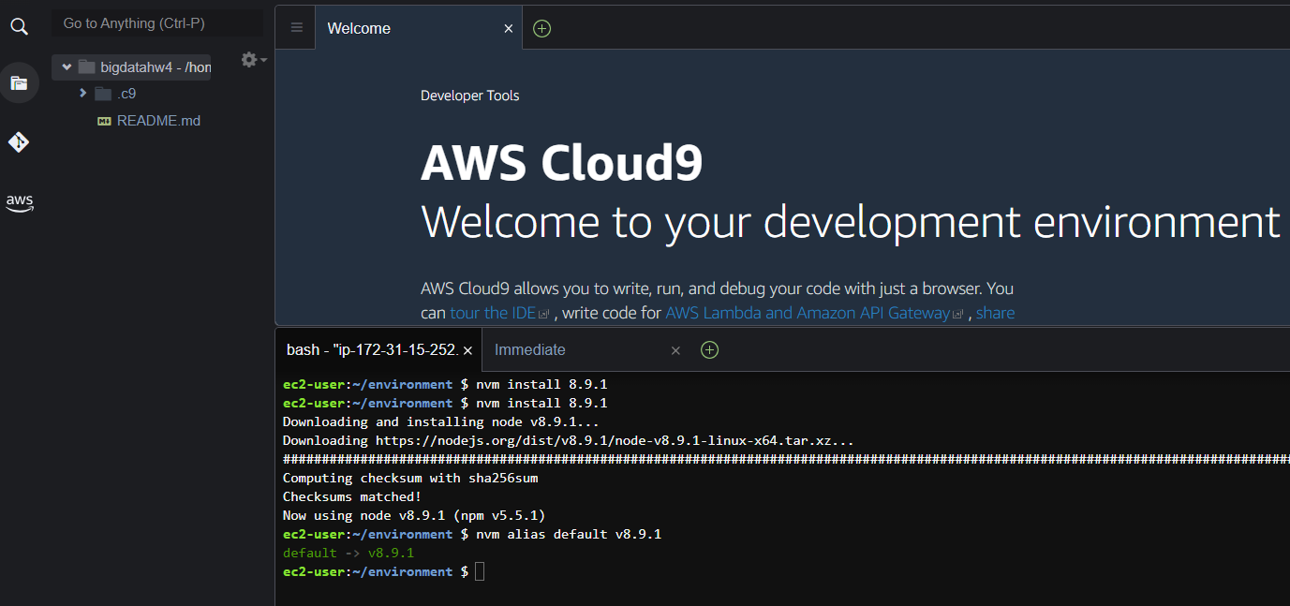

* Verifying that we have the right version of node and npm

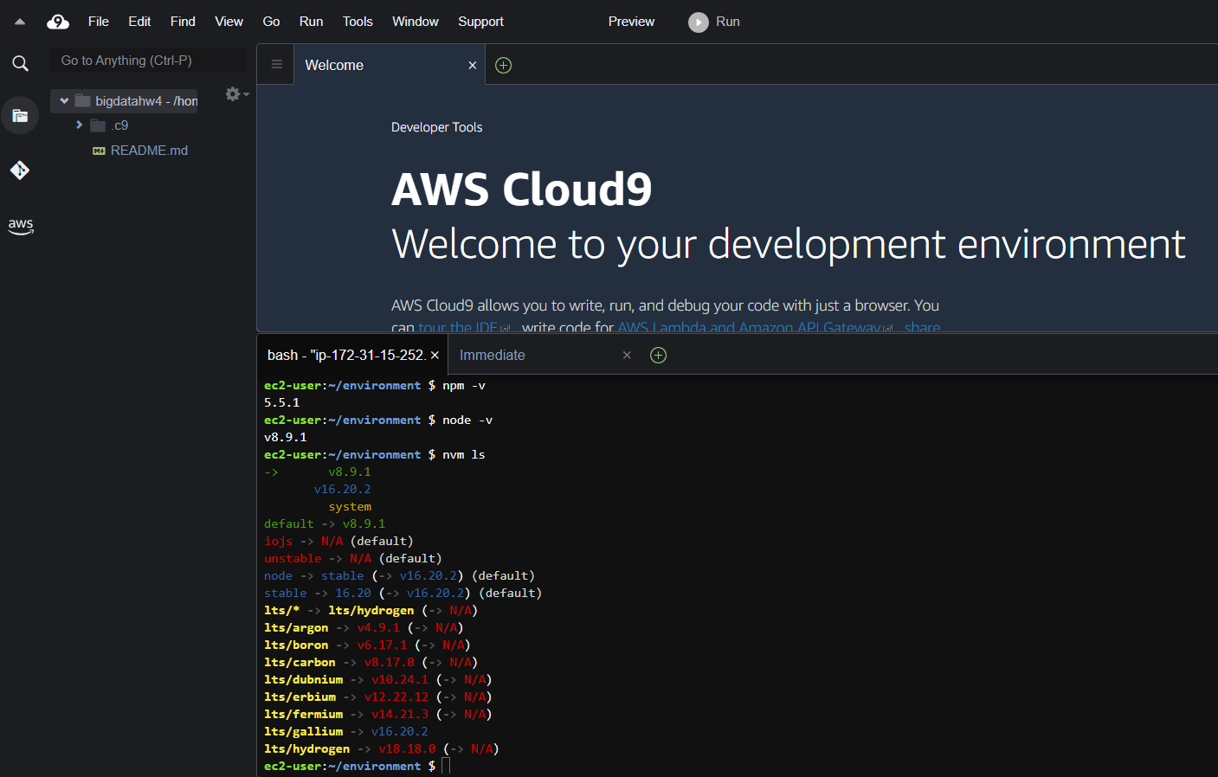

* Cloning the workshop project from GitHub into cloud9 using the command: git clone https://github.com/enghwa/MultiRegion-Serverless-Workshop.git

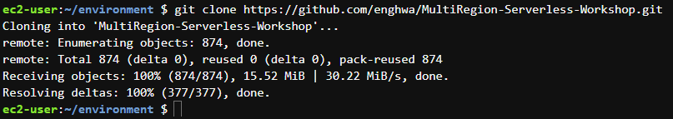

* Successfully cloned the project from github

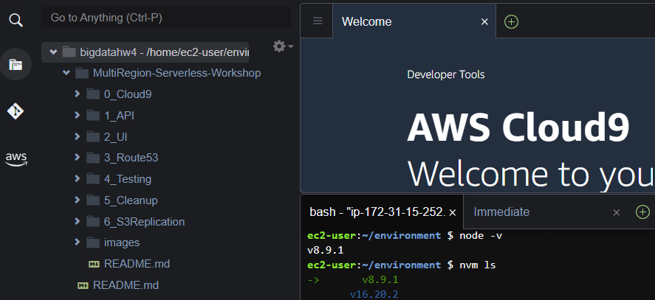

**Step 2:** Build an API layer

Building the Wild Rydes Backend components layer which involves deploying the components to 2 AWS regions using the console. The different backend components are: 3 AWS Lambda functions, 2 API gateway endpoints, and DynamoDB Global Table per region along with setting up the IAM roles

* Creating a policy using JSON. IAM->Policies->Create policy->Select JSON->copied the policy description in raw format that was available in the GitHub link

*Github policy JSON data to be copied*

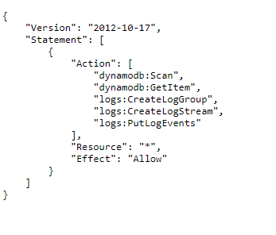

Posted the above code under the JSON tab for creating the IAM role

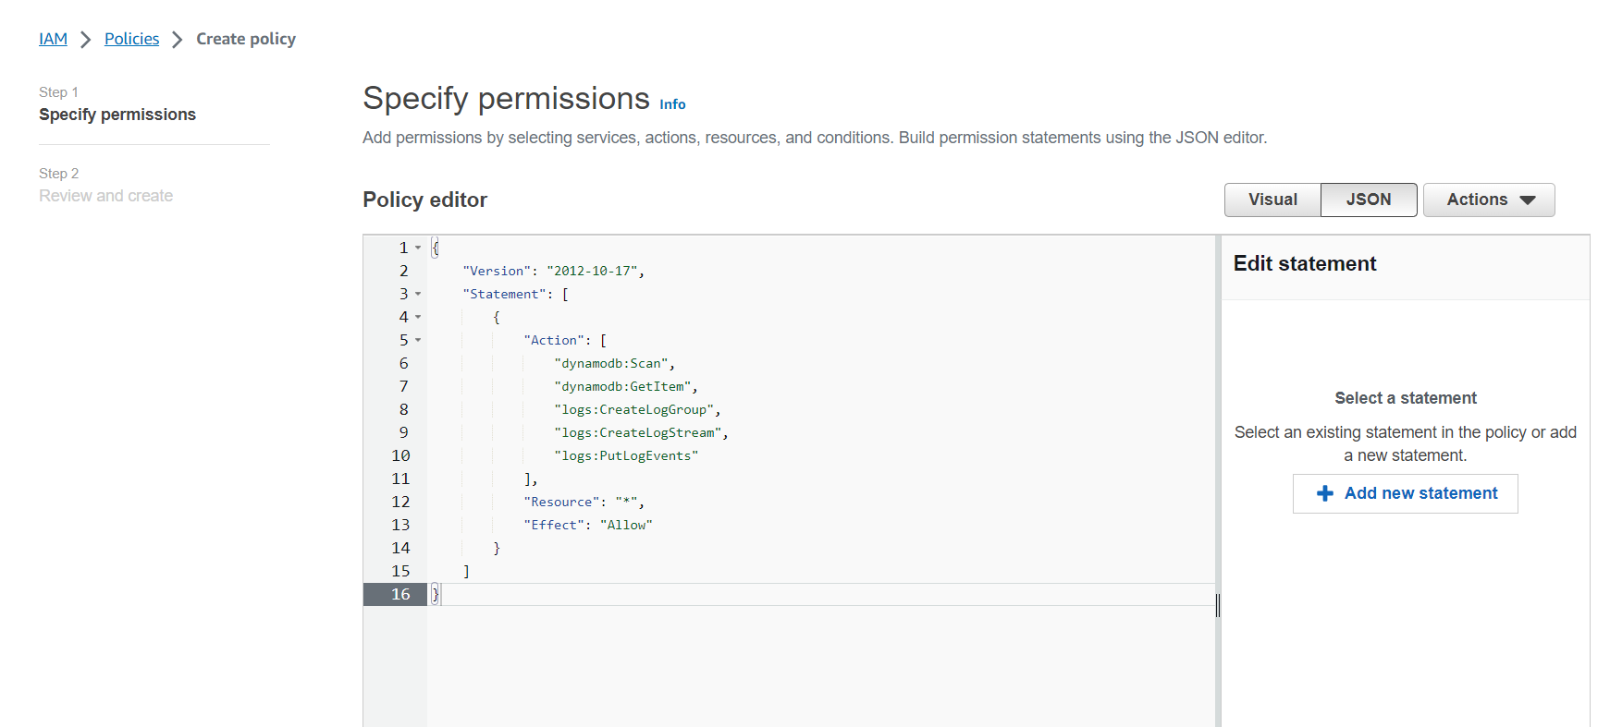

* Reviewing and creating the policy called TicketGetPolicy for DynamoDB and CloudWatch Logs with Read access to DynamoDB and write access to CloudWatch Logs

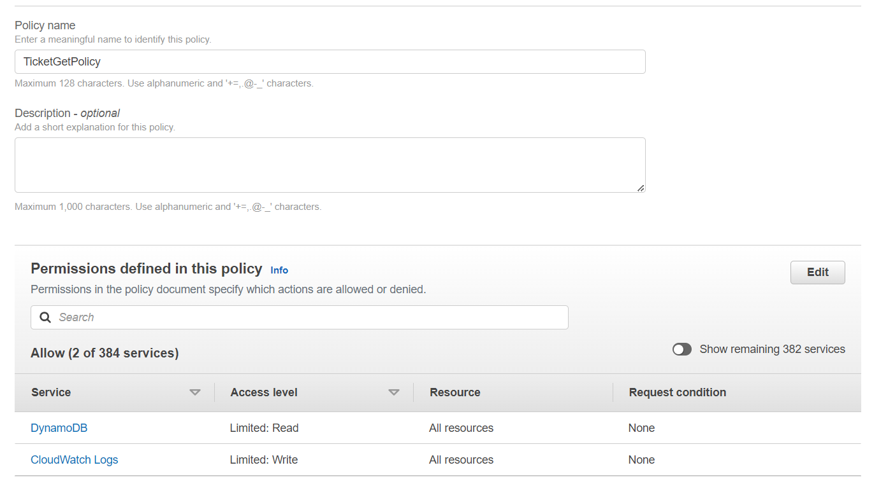

* Successfully created the policy

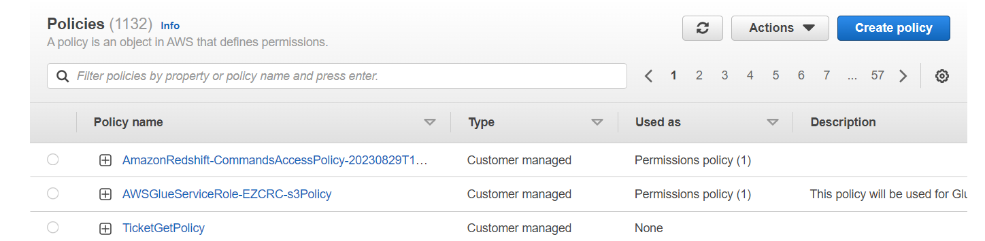

* Similarly, we copied the Ticket Post Policy JSON data from GitHub in raw format

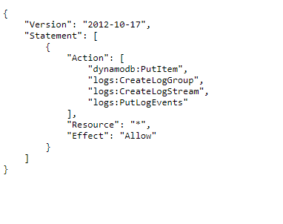

* Pasted the above code under the JSON tab while creating a new policy for Ticket Post

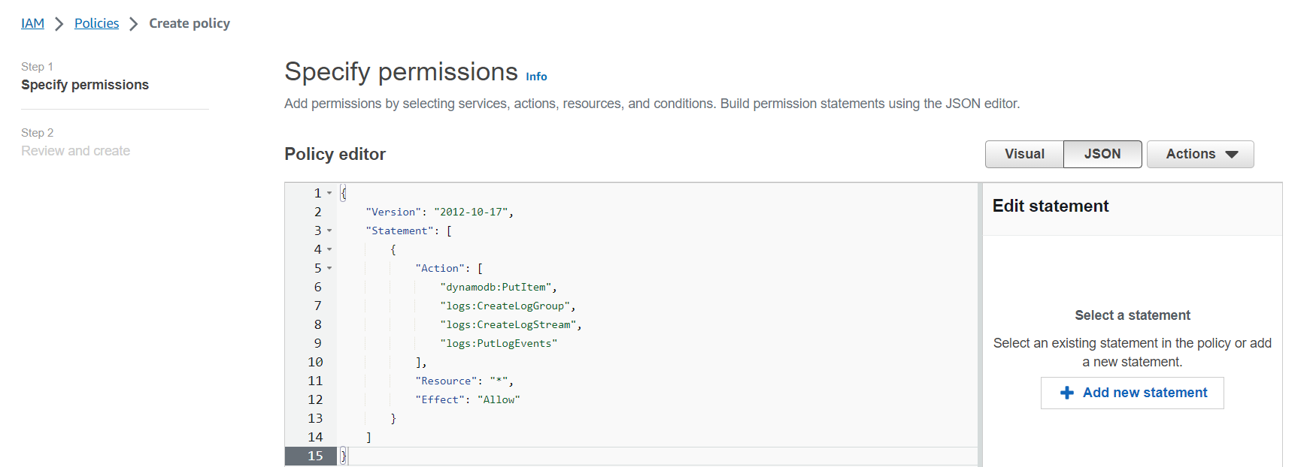

* Reviewing and creating the new policy called TicketPostPolicy with write access to both DynamoDB and Cloudwatch Logs

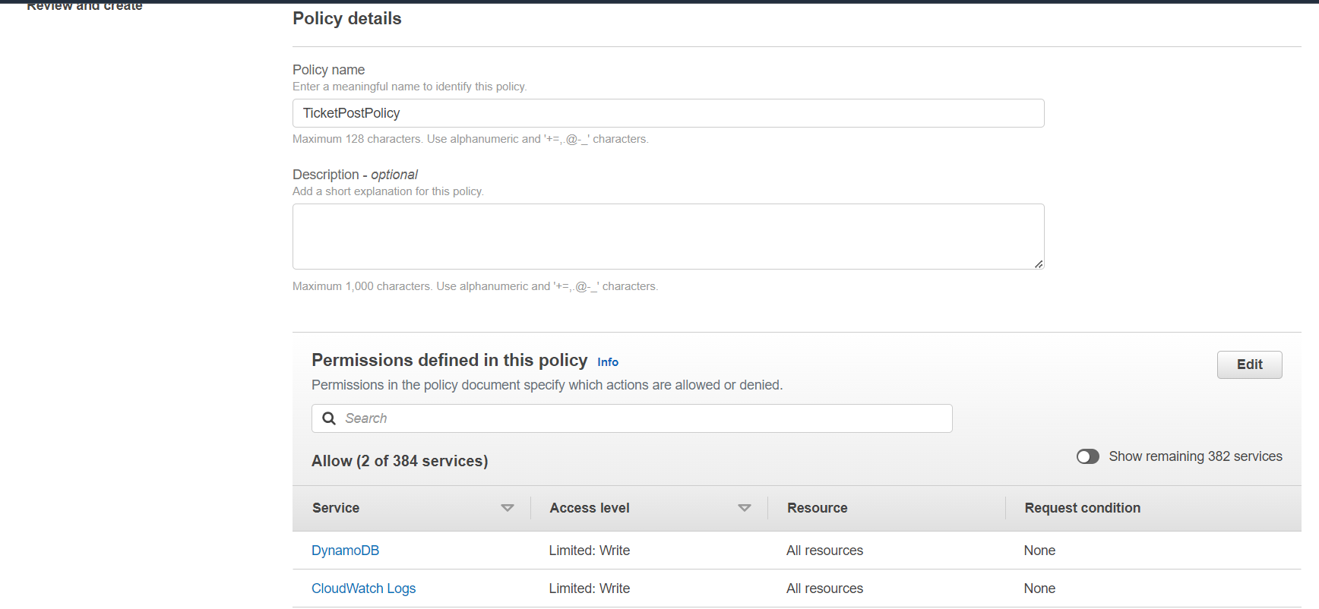

* The new policy was successfully created called TicketPostPolicy

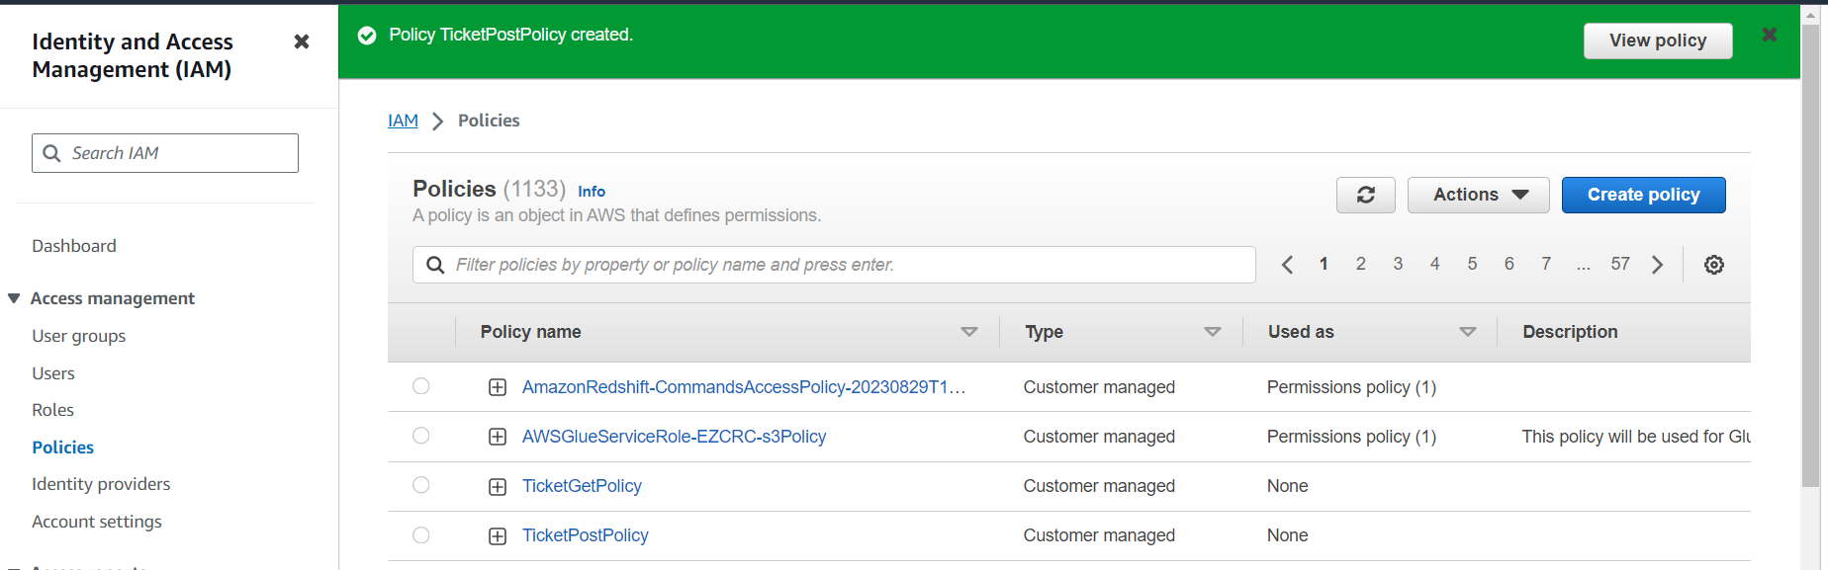

* Creating a role for lambda service that corresponds to TicketGetPolicy that we first created

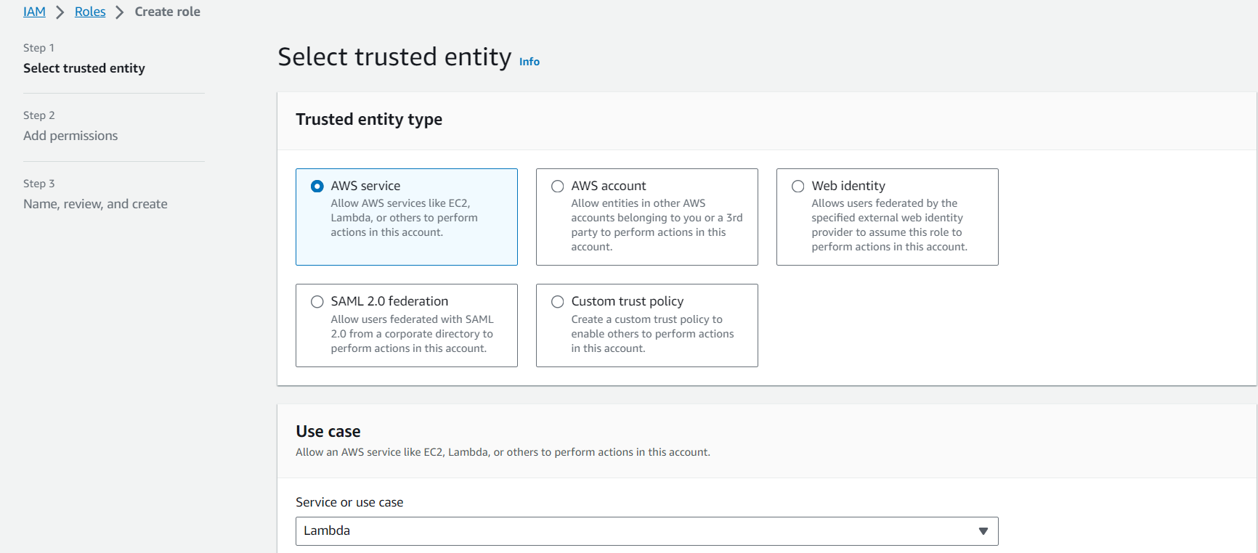

* Adding TicketGetPolicy that we created to this new role

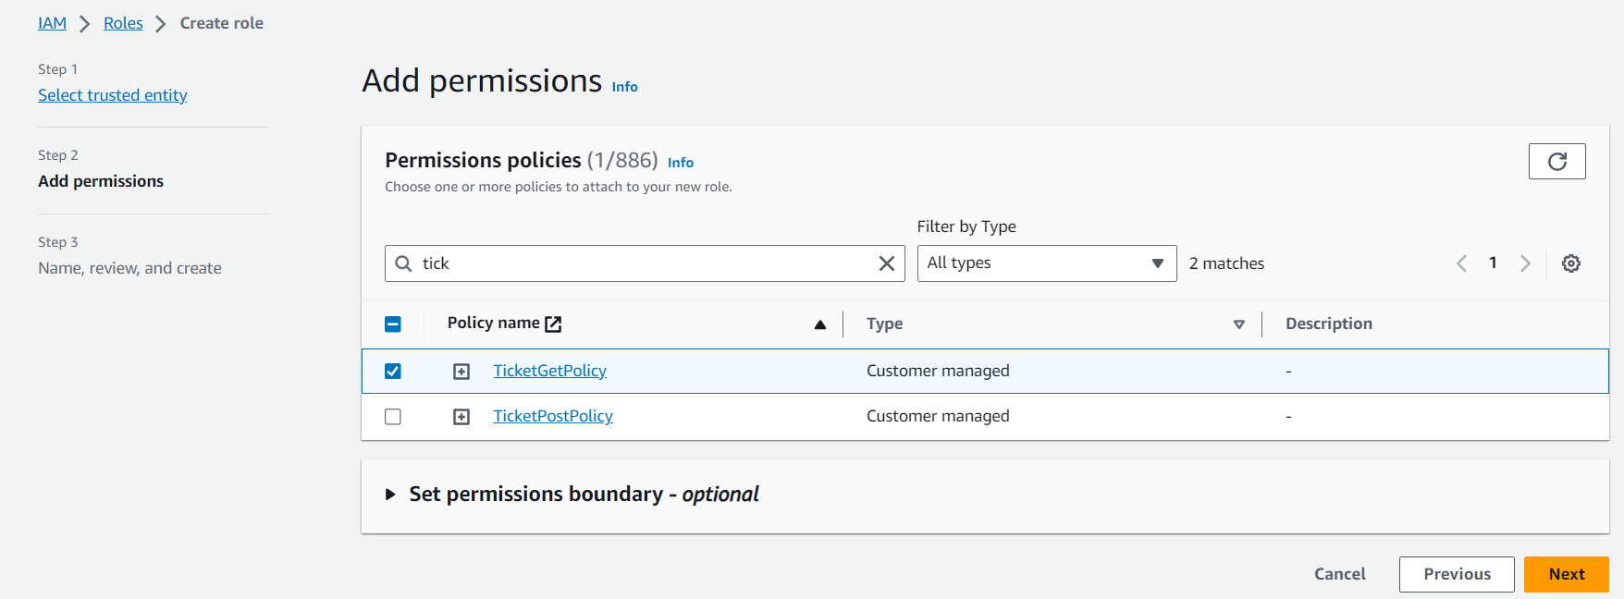

* Reviewing and creating the new role called TicketGetRole

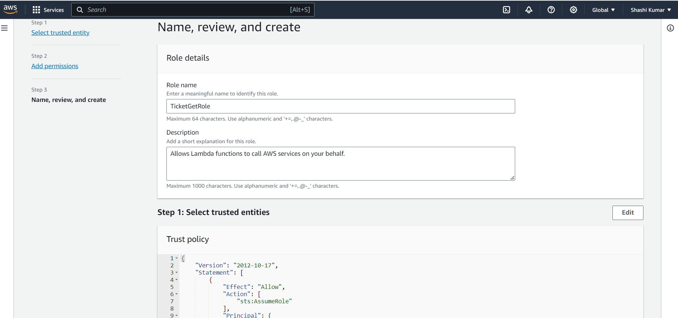

* TicketGetRole was successfully created

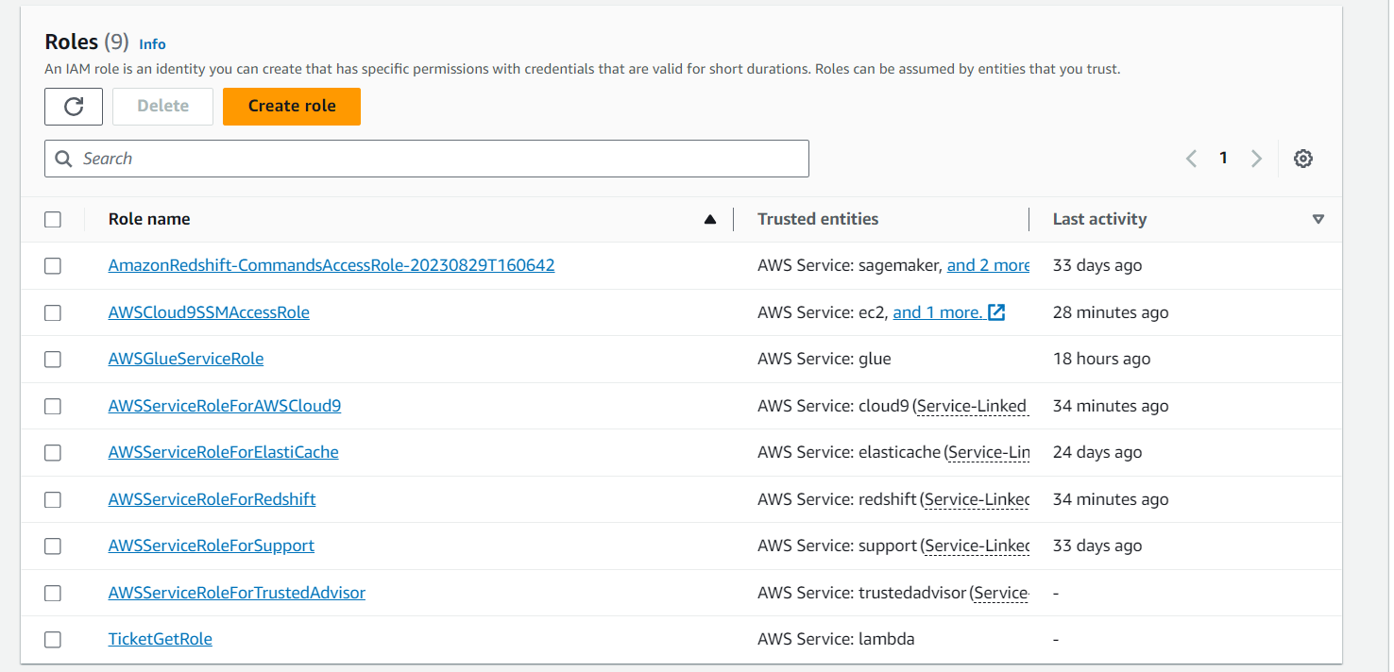

* Similarly, creating a role for lambda service that corresponds to TicketPostPolicy that we created



* Adding TicketPostPolicy that we created to this new role

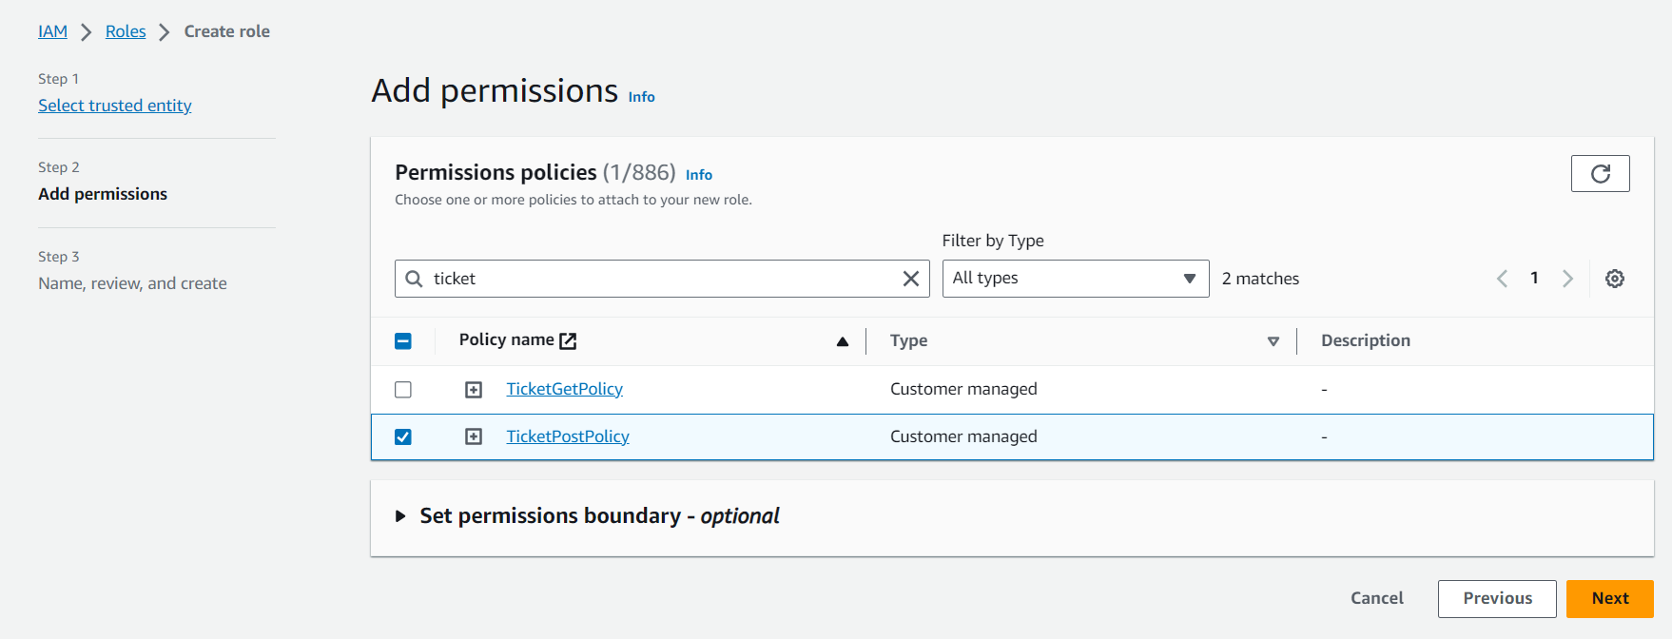

* Reviewing and creating the new role called TicketPostRole

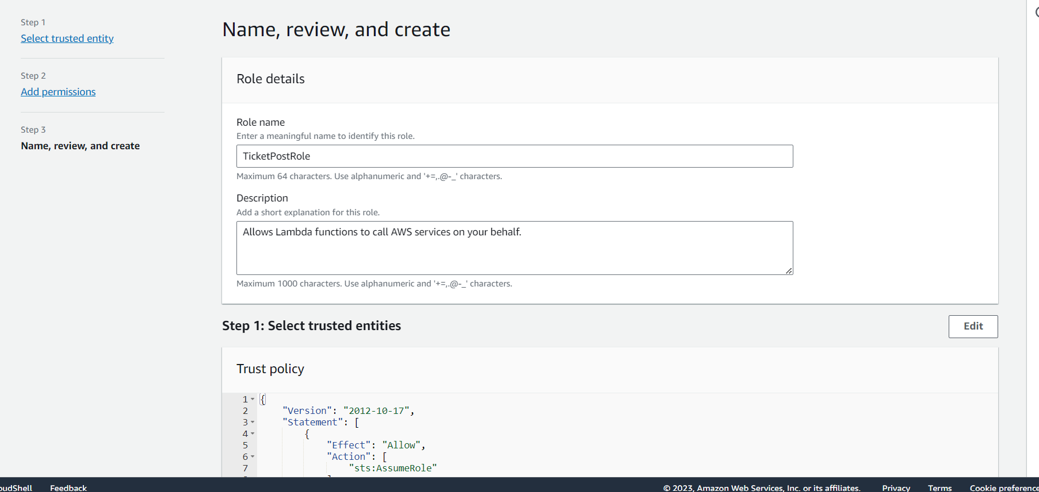

* TicketPostRole was successfully created

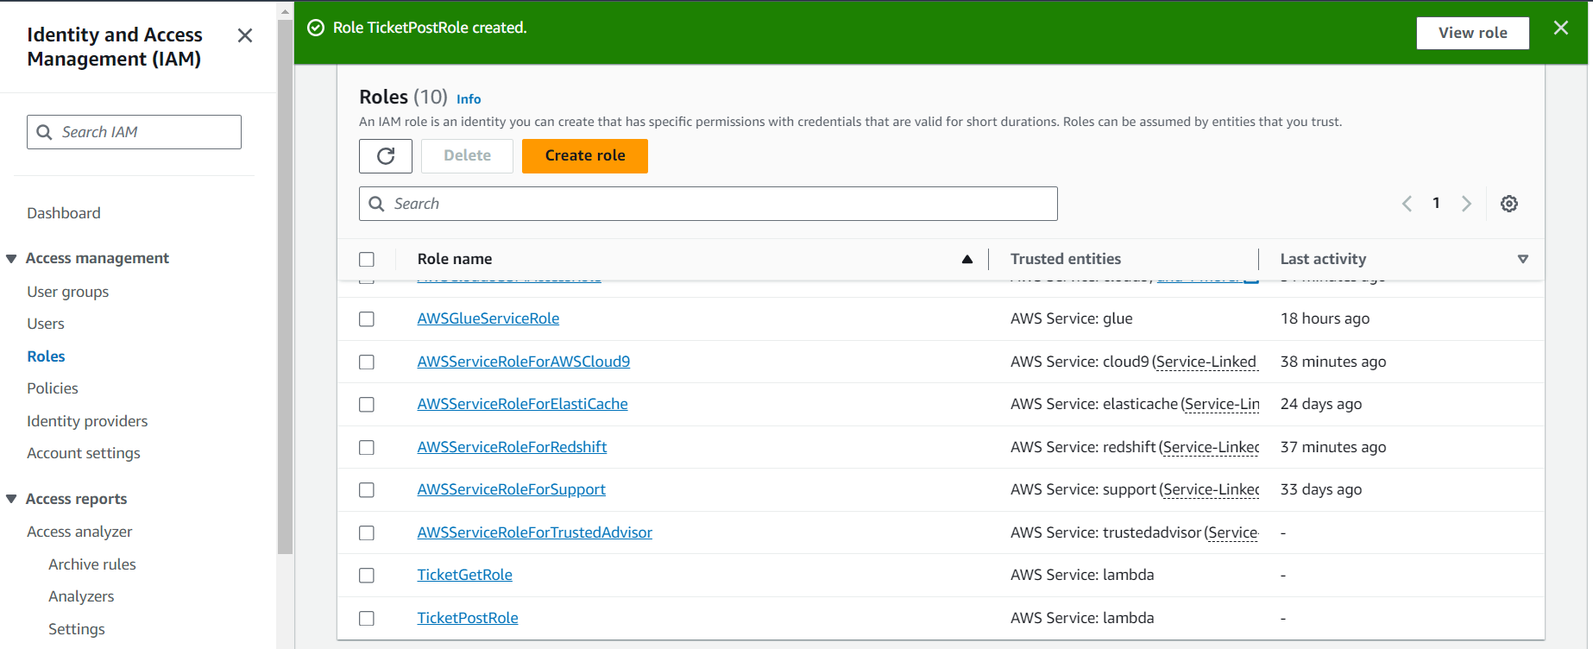

* Setting up DynamoDB table which is a NoSQL databaseservice for storing the application data

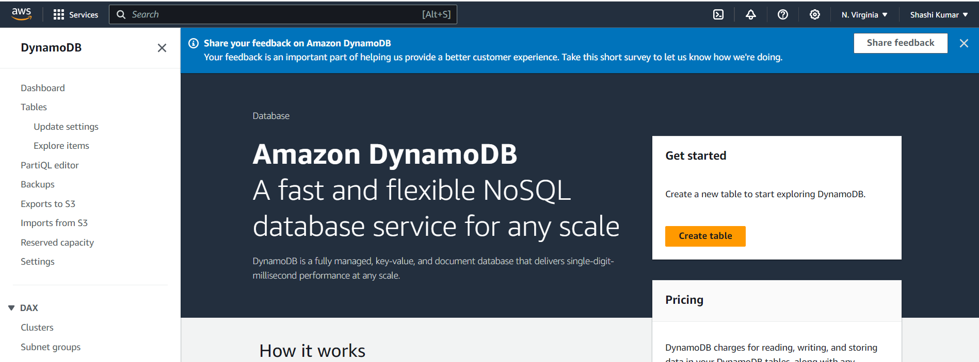

* Creating a table called SRXTickets with id as partition key which is of string datatype

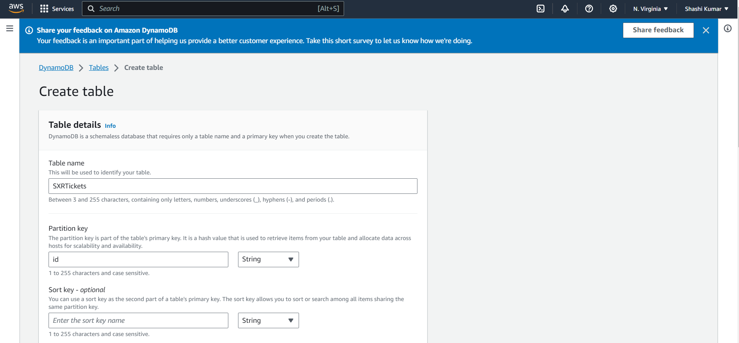

* Creating the above table with default table settings

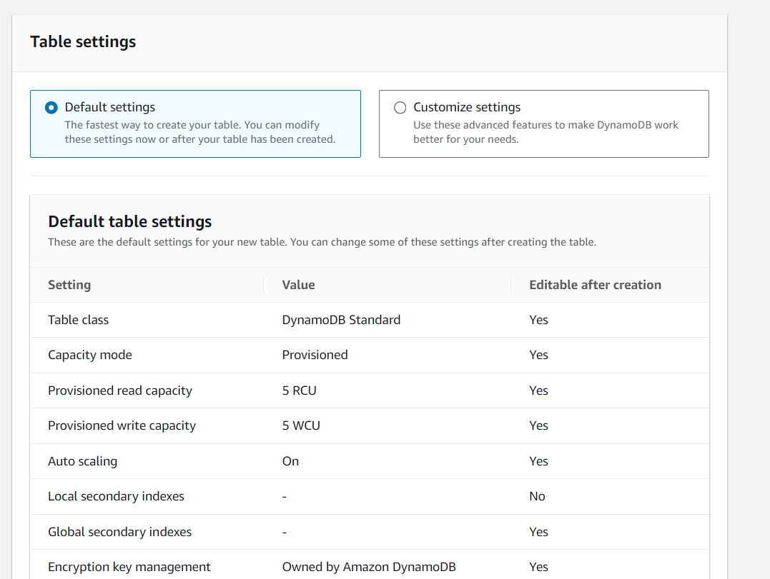

* Successfully created the above table in N. Virginia region

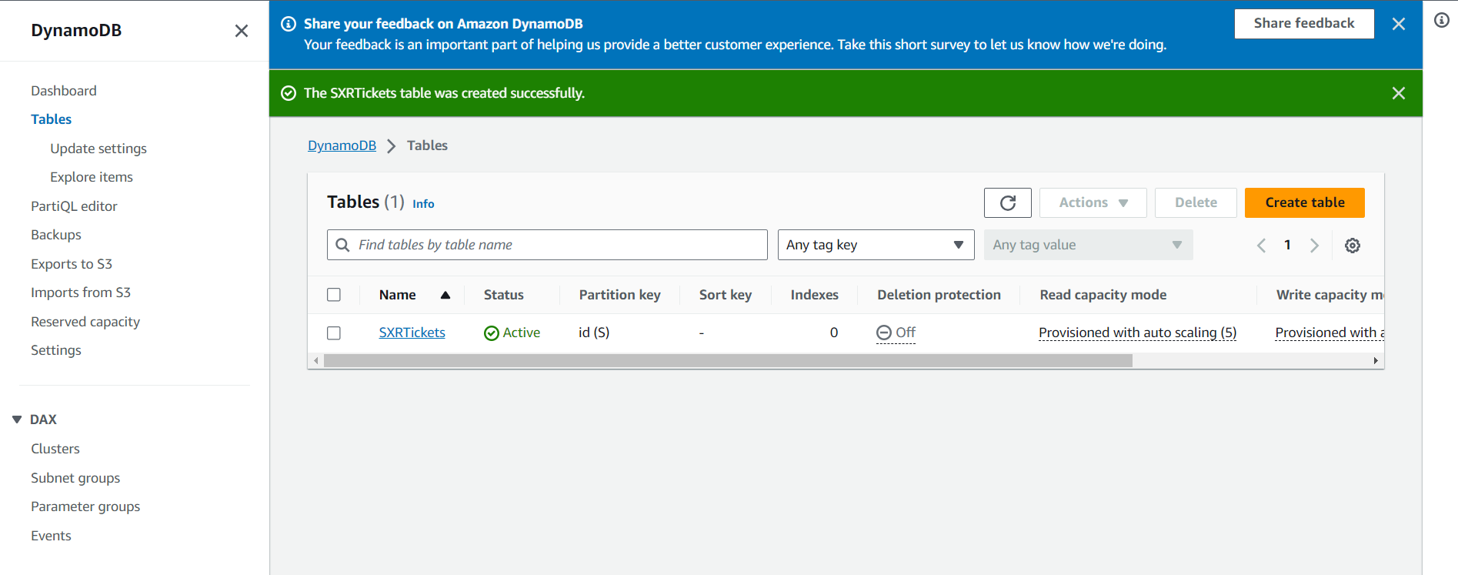

* Select Update setting->Global tables option where we can set the streams/replicas

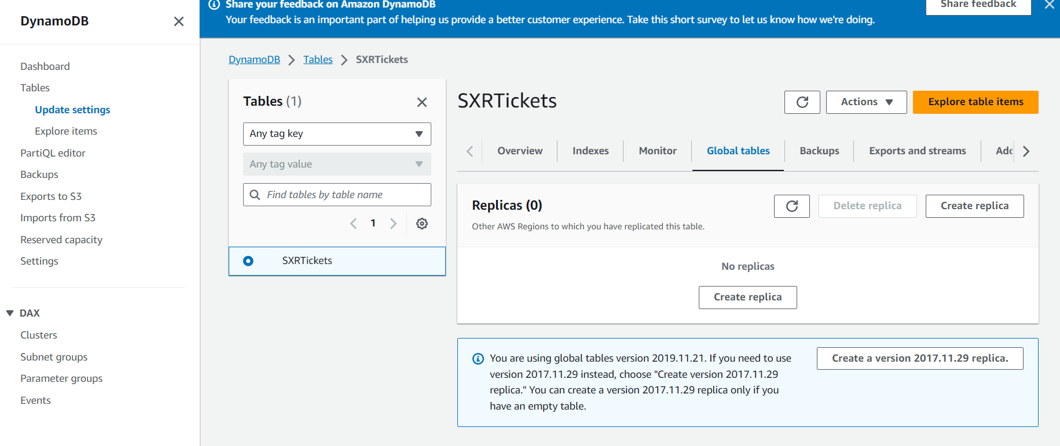

* Creating the replica in Asia Pacific (Singapore) using the default IAM role called AWSServiceRoleForDynamoDBReplication

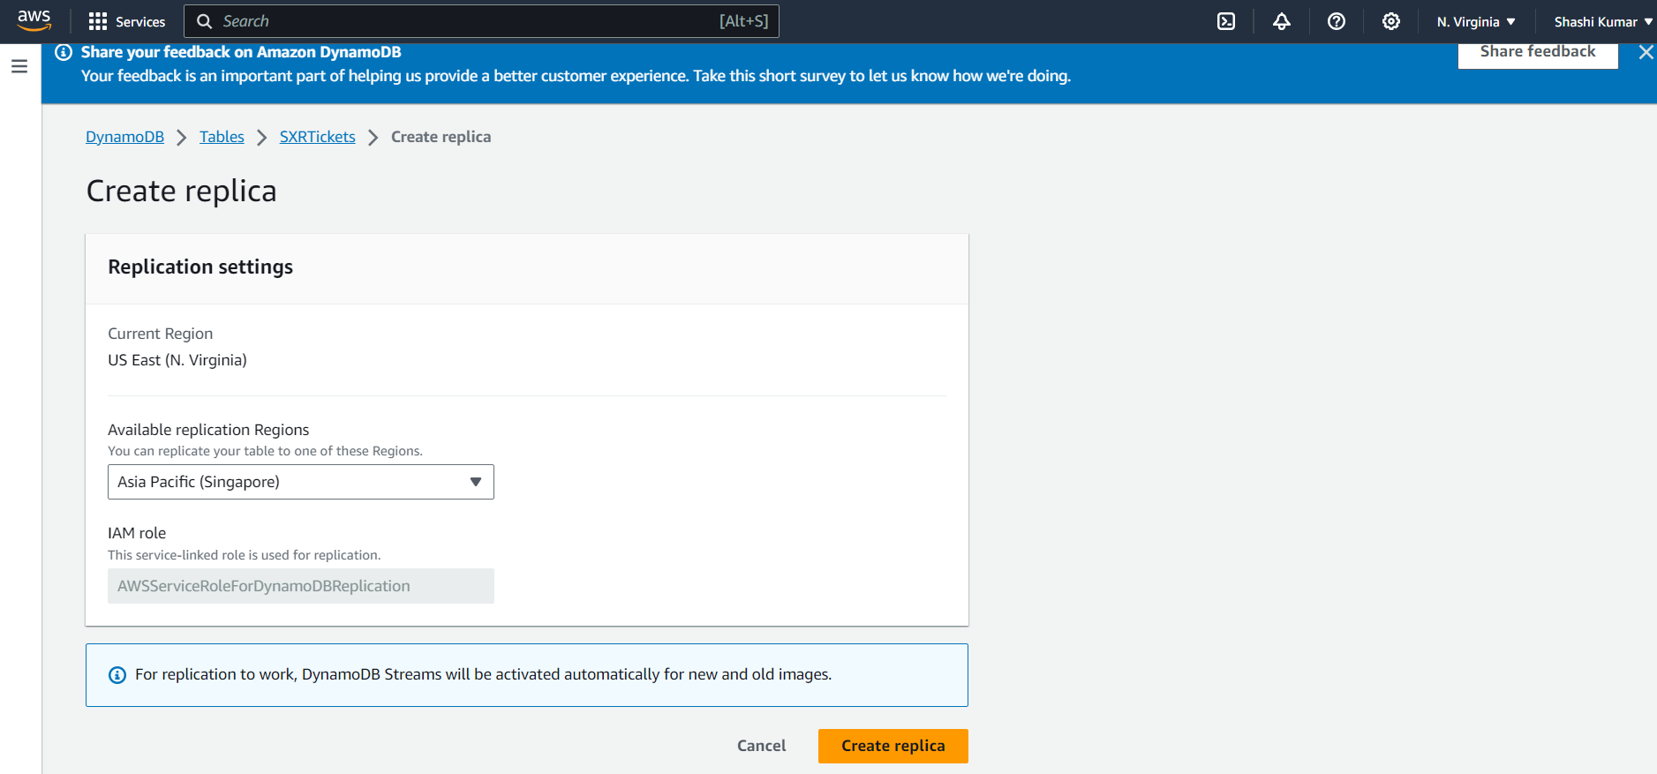

* Successfully created the replica in Asia Pacific(Singapore)

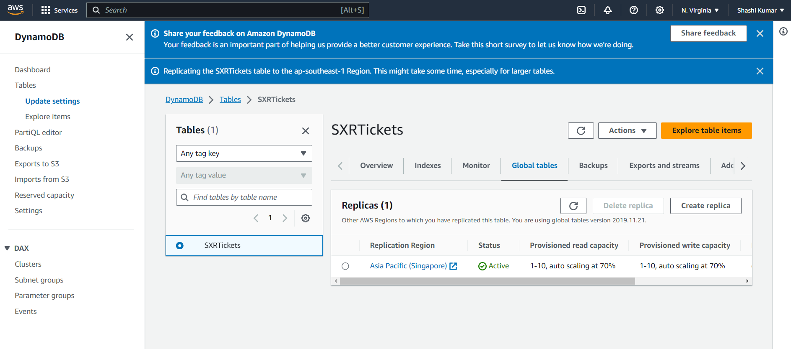

* Creating Lambda functions to run the code

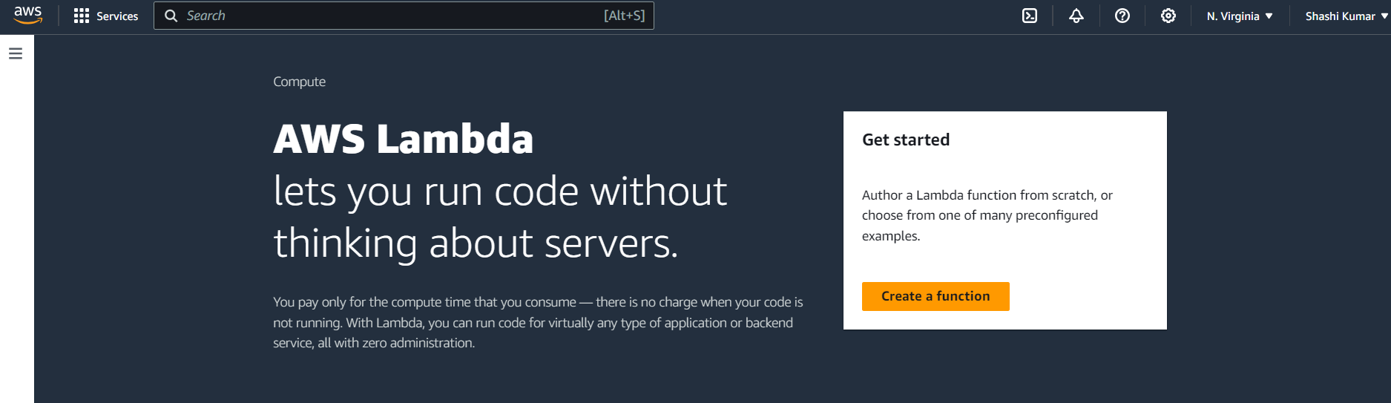

* Creating a new lambda called TicketGetFunction

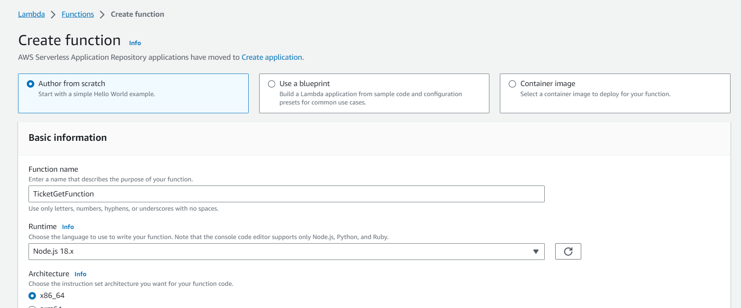

* Choosing the node.js runtime for the function with x86_64 architecture. Chose the previously created TicketGetRole as the execution role for this function

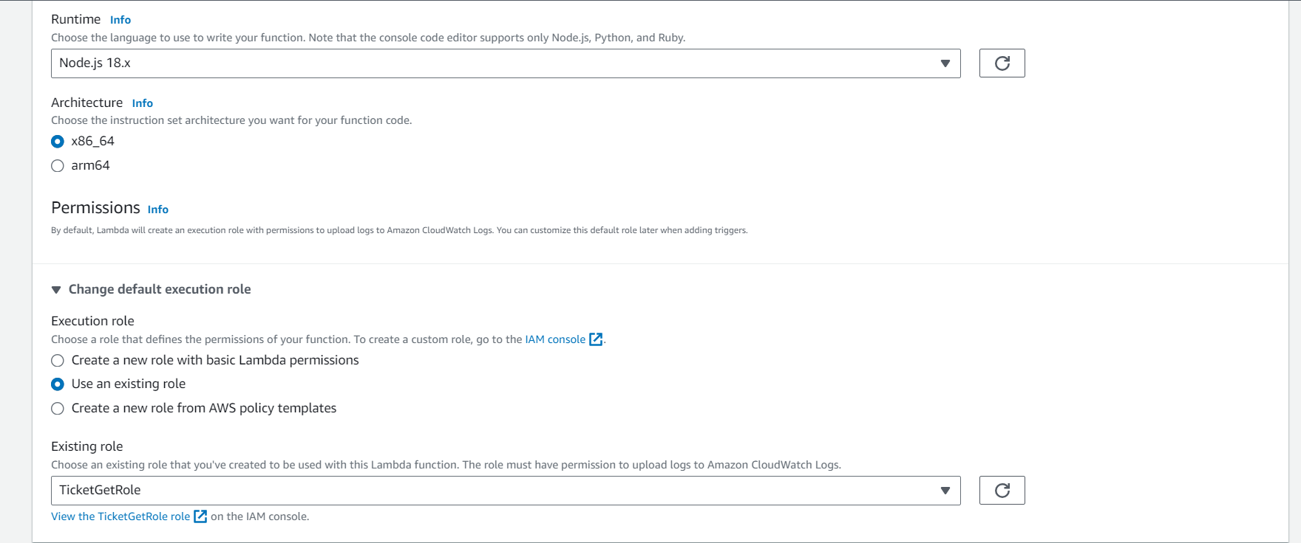

* Successfully created the TicketGetFunction

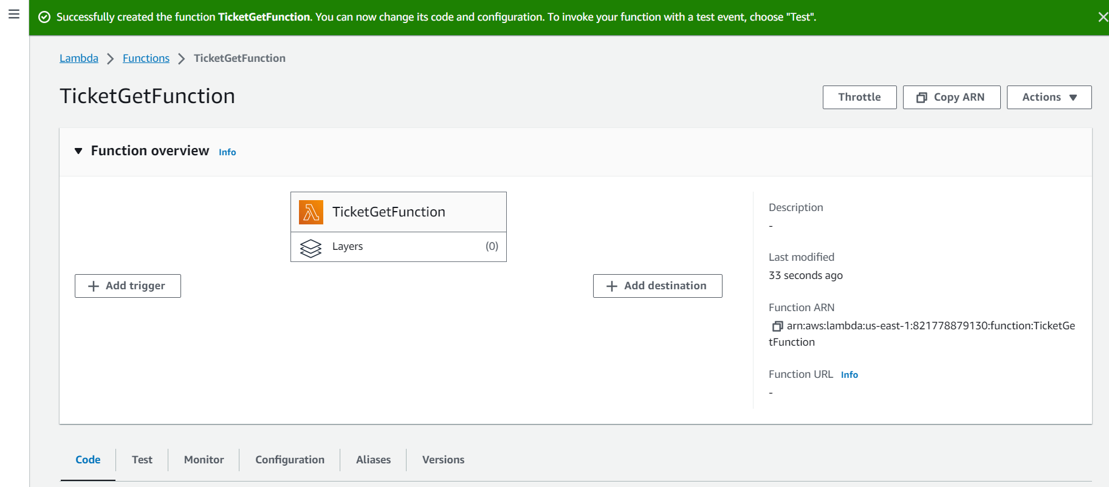

* Changing the Handler name to tickets-get.handler(runtime settings -> change handler name)

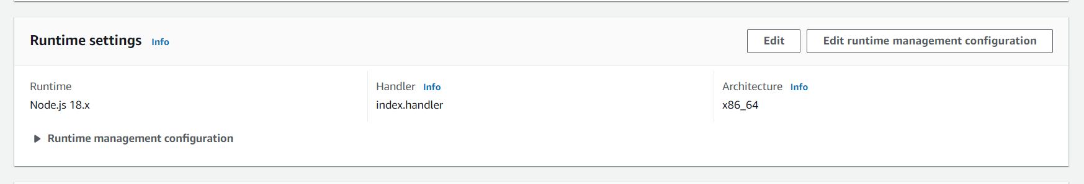

* Edited the handler information to rename the name to tickets-get.handler

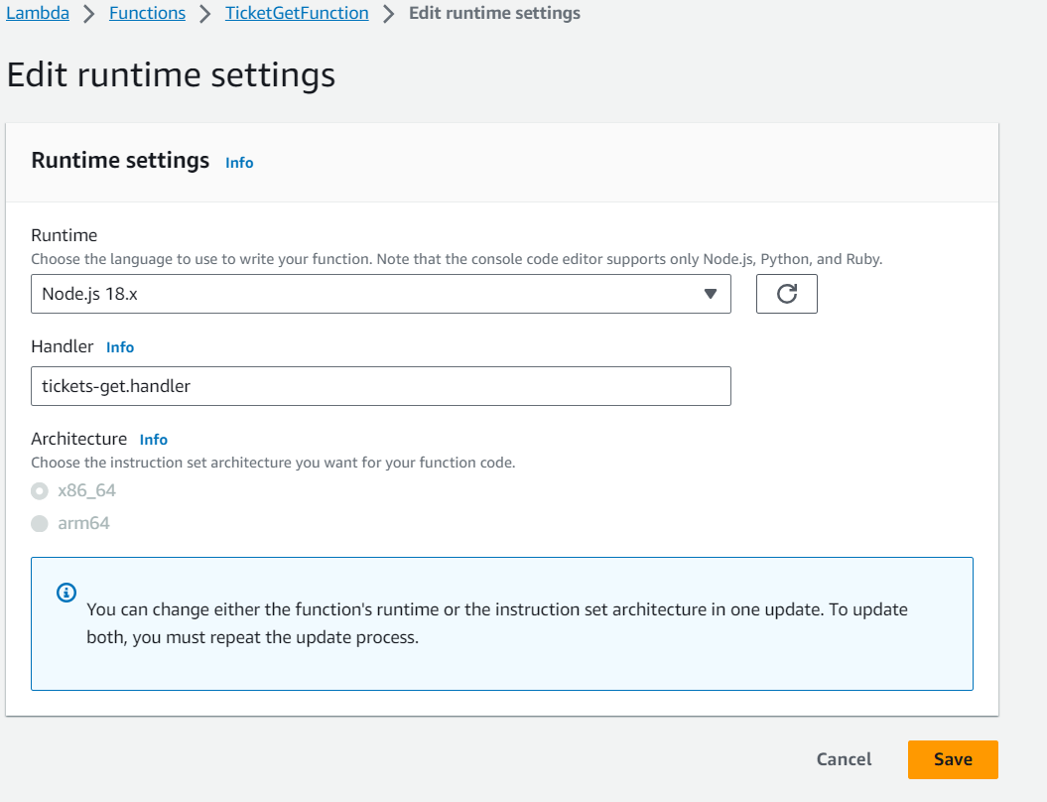

* Changing the runtime to Node.js 16.x since aws-sdk v2 is no longer supported

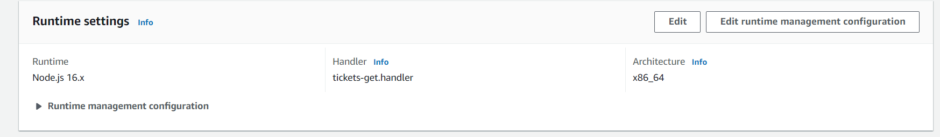

* Changed the file name to tickets-get.js

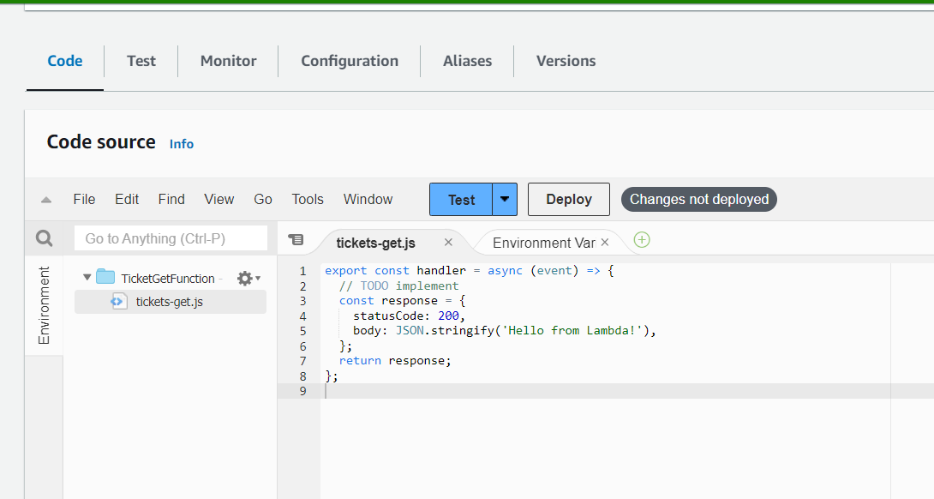

* Pasting the tickets-get.js content from GitHub into the lambda function code source

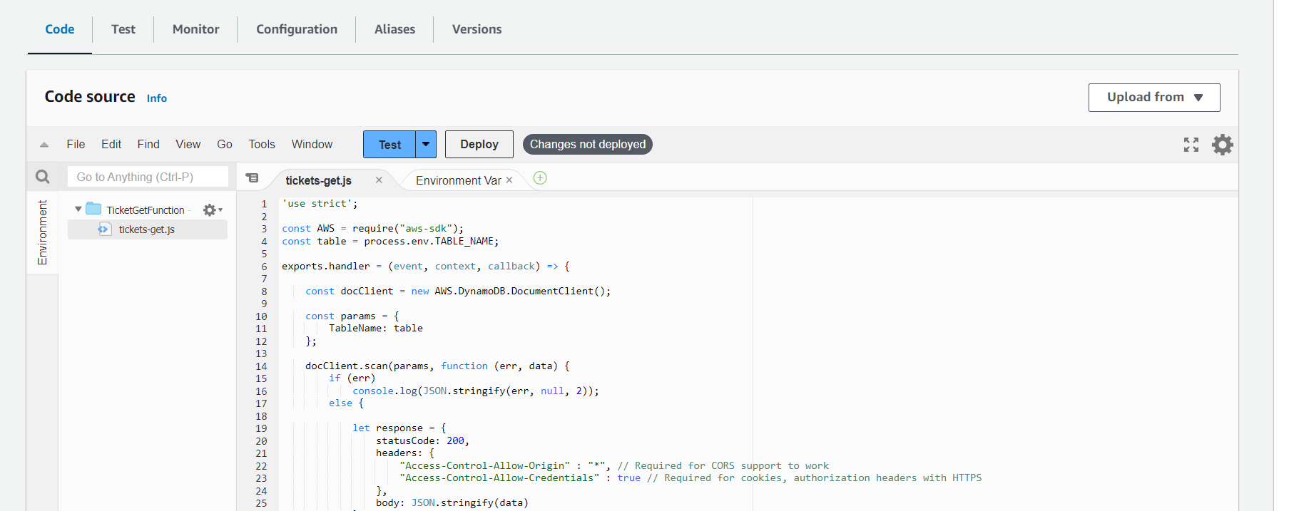

* Setting up the environment variable(Configuration->Environment variables->Edit)

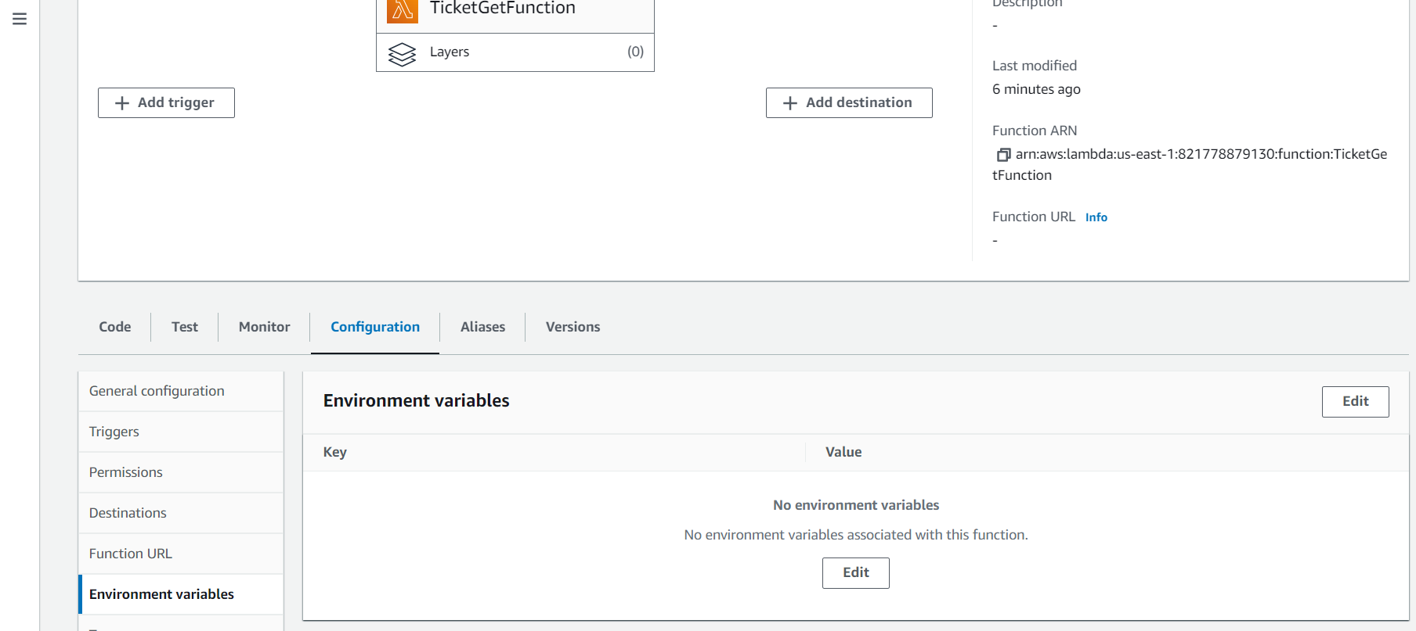

* Adding the environment variable to store the table name

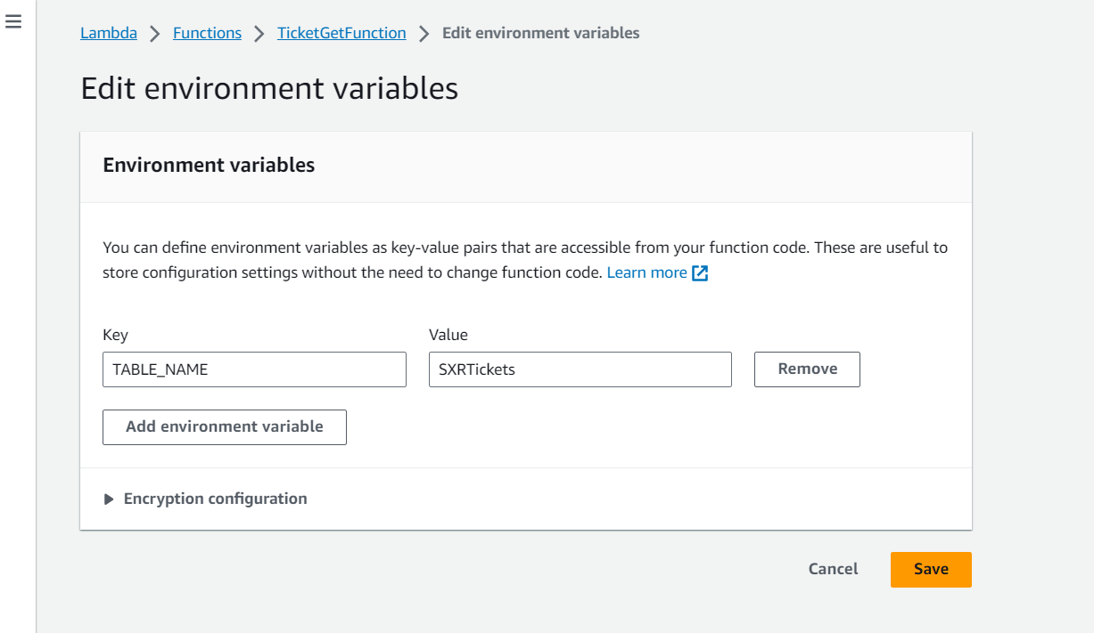

* Successfully created the environment variable

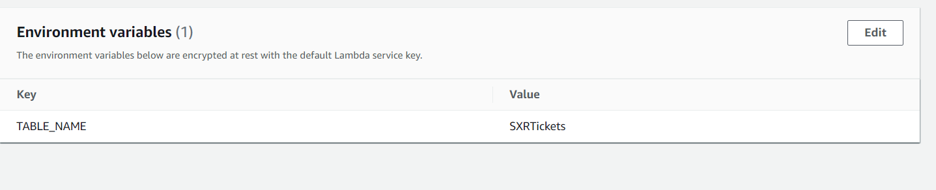

* Successfully deployed the changes to TicketGetFunction

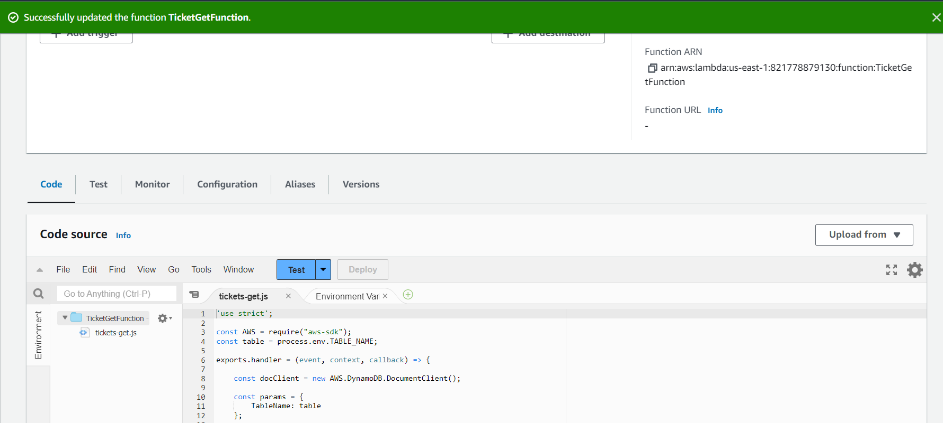

* Similarly, creating a new lambda called TicketPostFunction

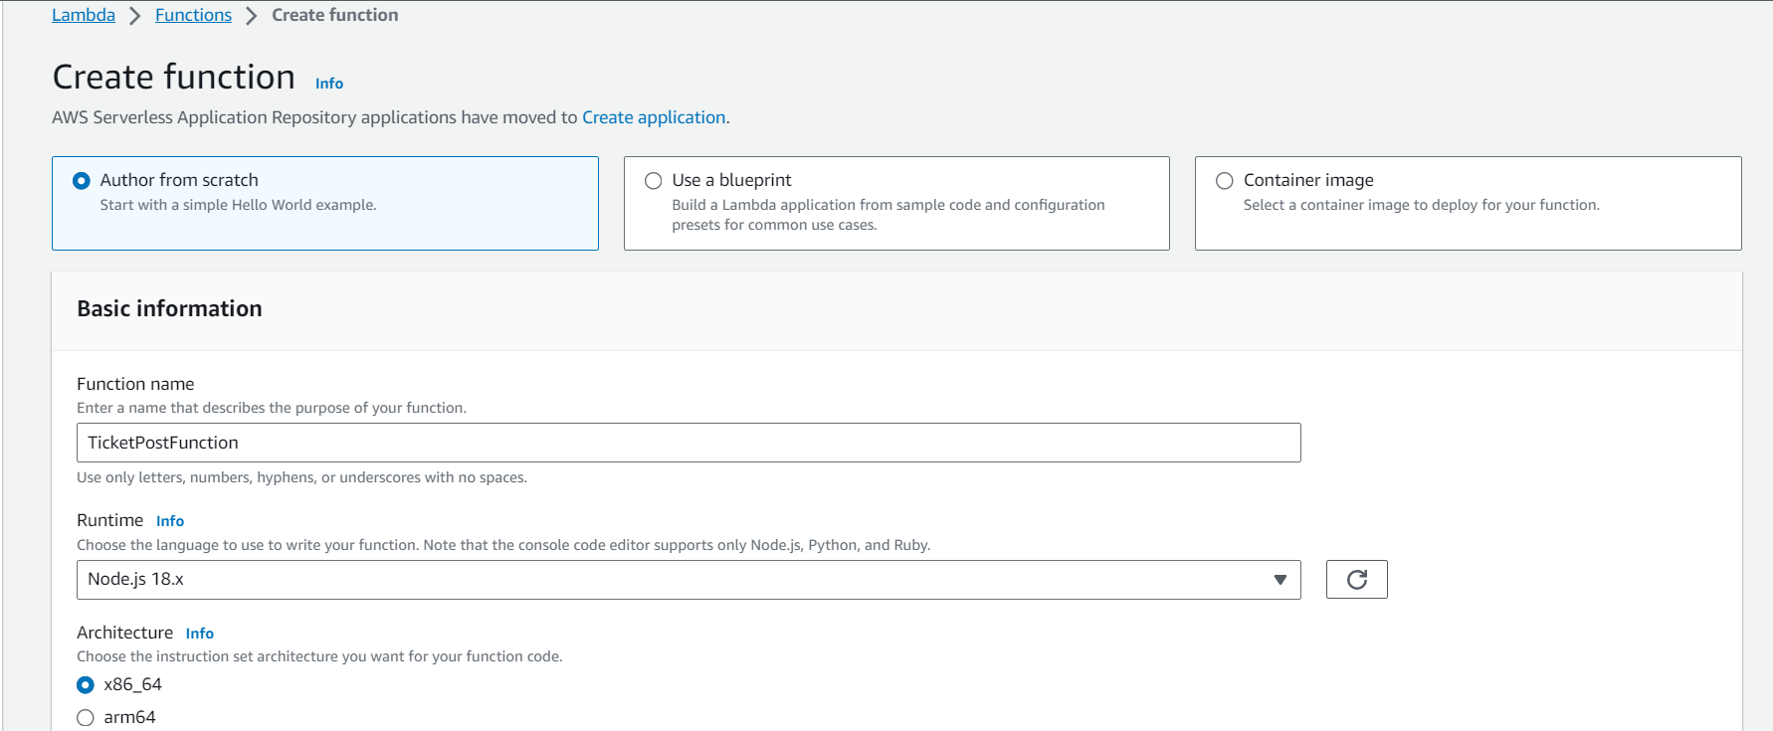

* Choosing the node.js runtime for the function with x86_64 architecture. Chose the previously created TicketPostRole as the execution role for this function

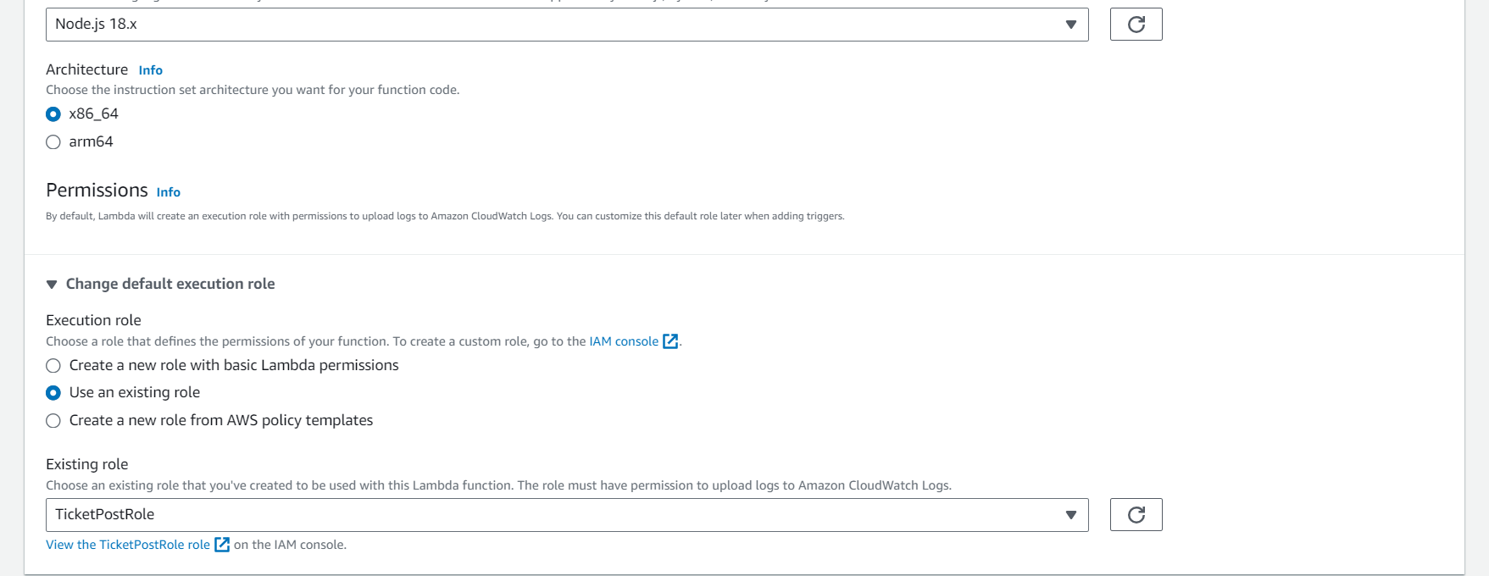

* Successfully created the TicketPostFunction

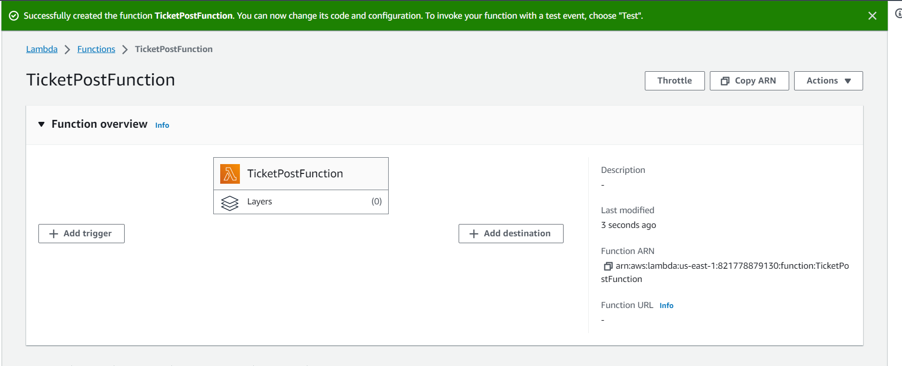

* Changing the Handler name to tickets-post.handler(runtime settings -> change handler name)



* Edited the handler information to rename the name to tickets-post.handler

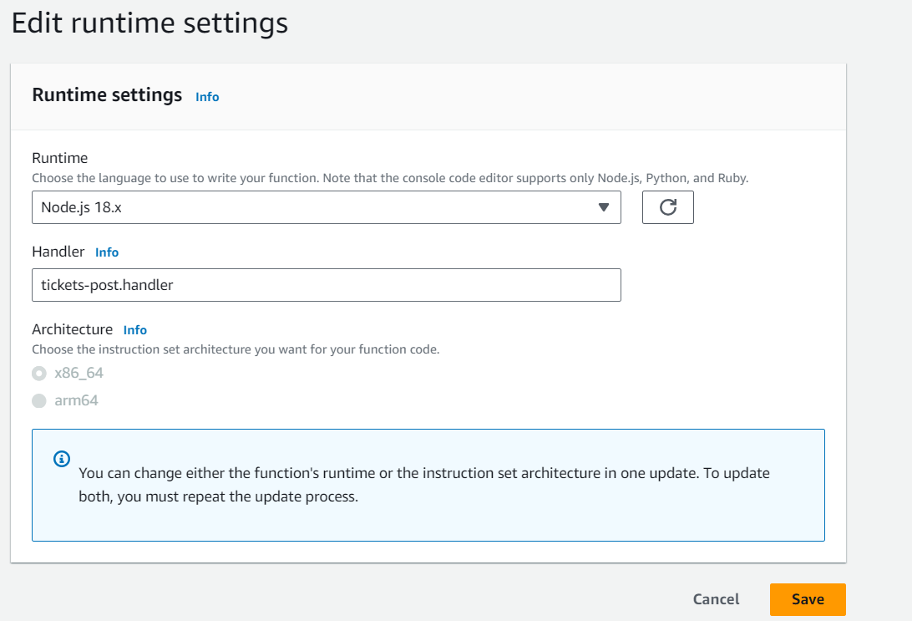

* Changing the runtime to Node.js 16.x since aws-sdk v2 is no longer supported

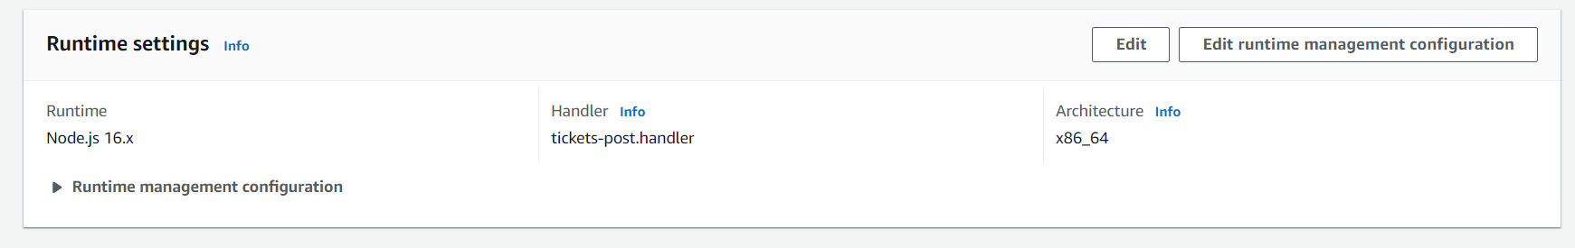

* Changed the file name to tickets-post.js

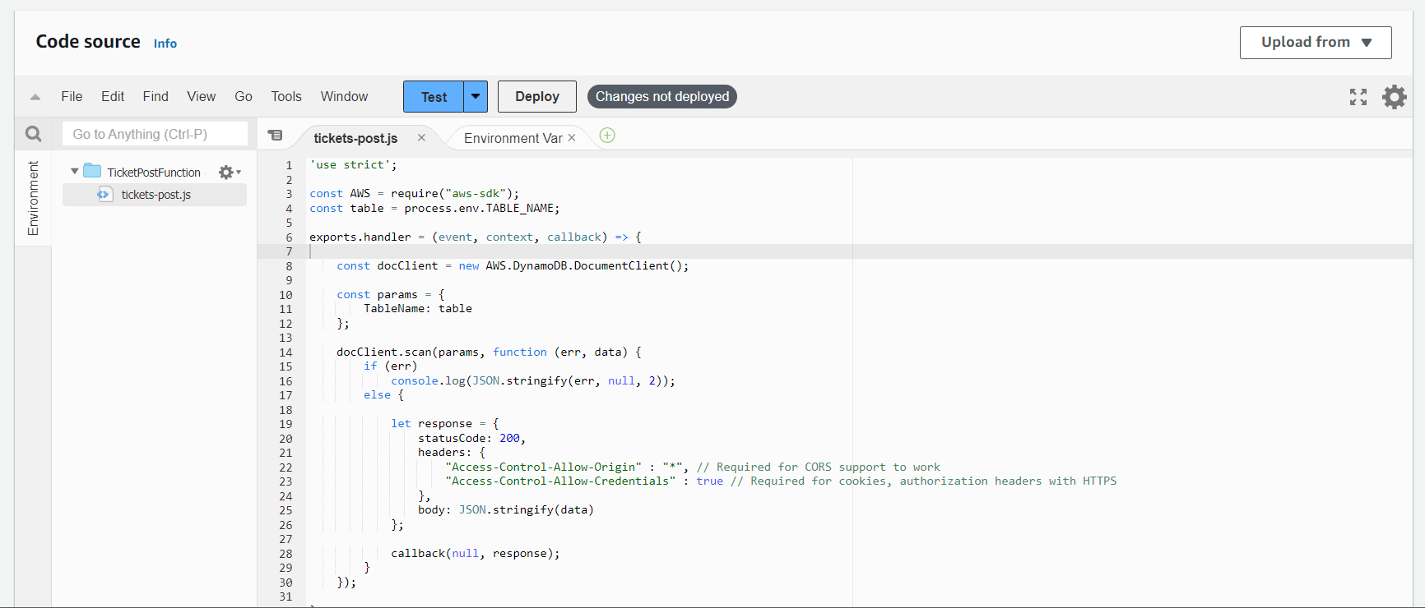

* Pasting the tickets-post.js content from GitHub into the lambda function code source

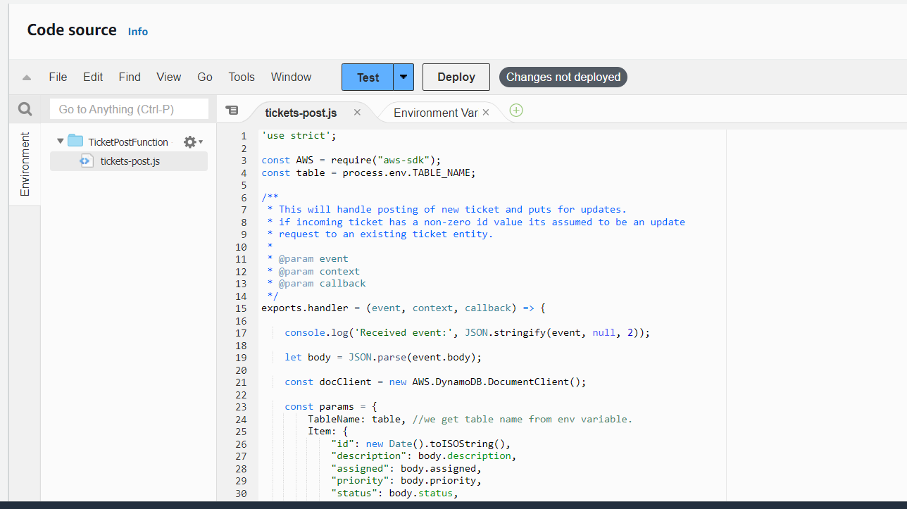

* Setting up the environment variable(Configuration->Environment variables->Edit)



* Adding the environment variable to store the table name

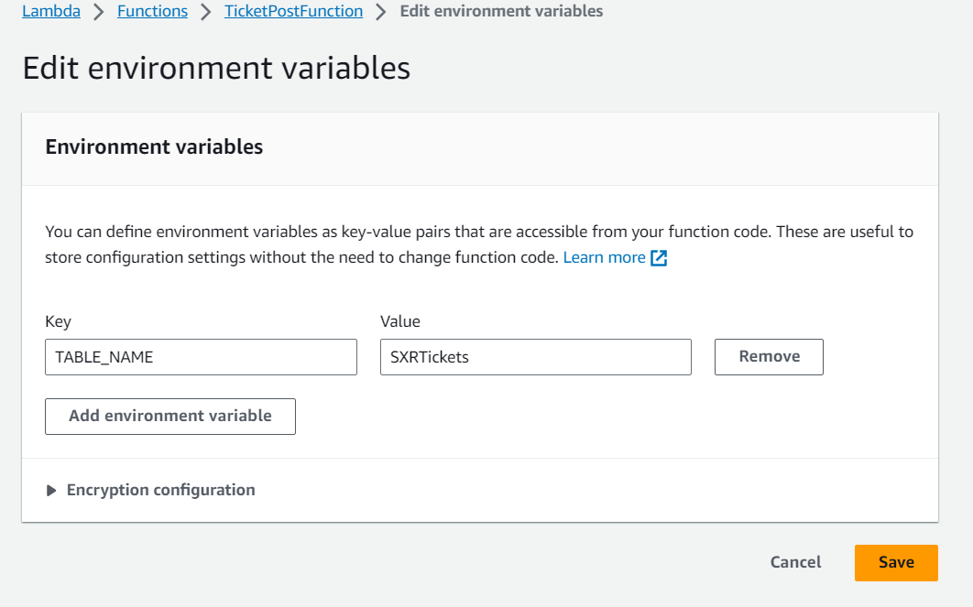

* Successfully created the environment variable

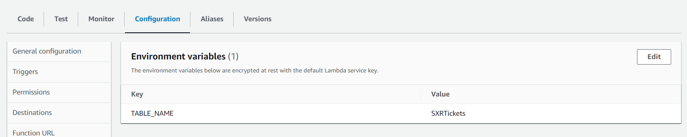

* Successfully deployed changes to TicketPostFunction

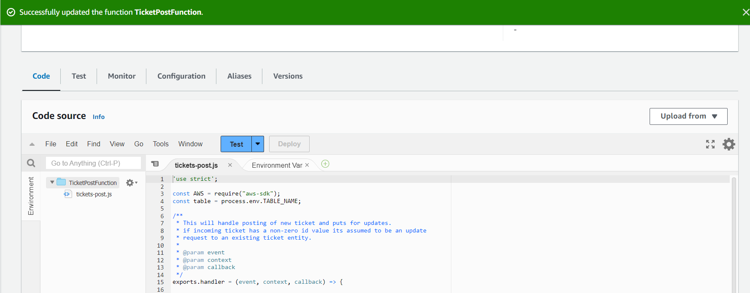

* Similarly, creating a new lambda called SXRHealthCheckFunction

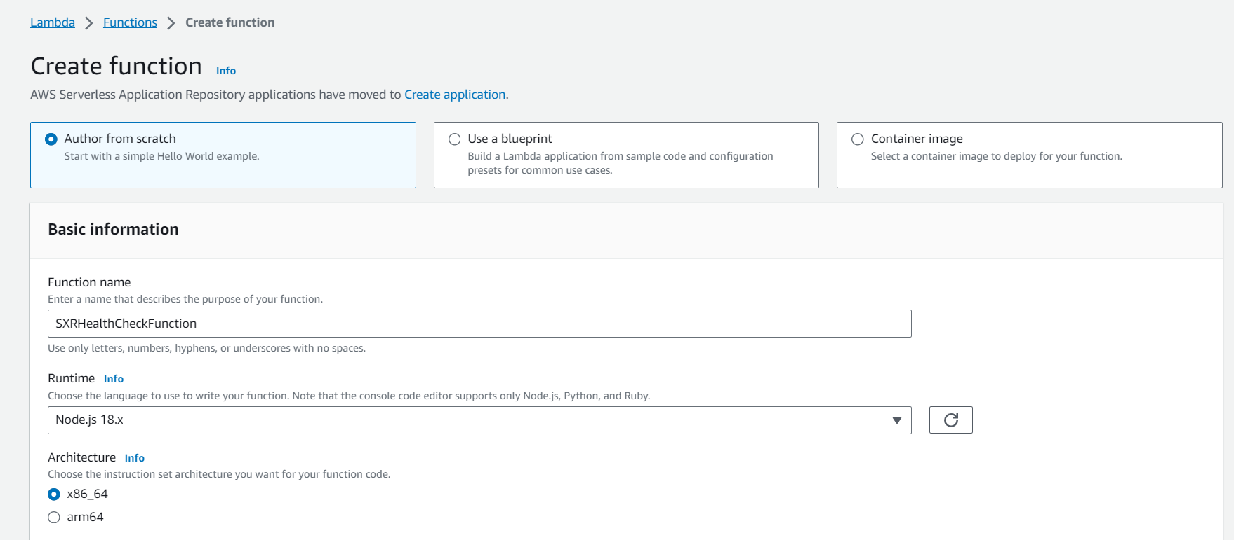

* Choosing the node.js runtime for the function with x86_64 architecture. Chose the previously created TicketGetRole as the execution role for this function

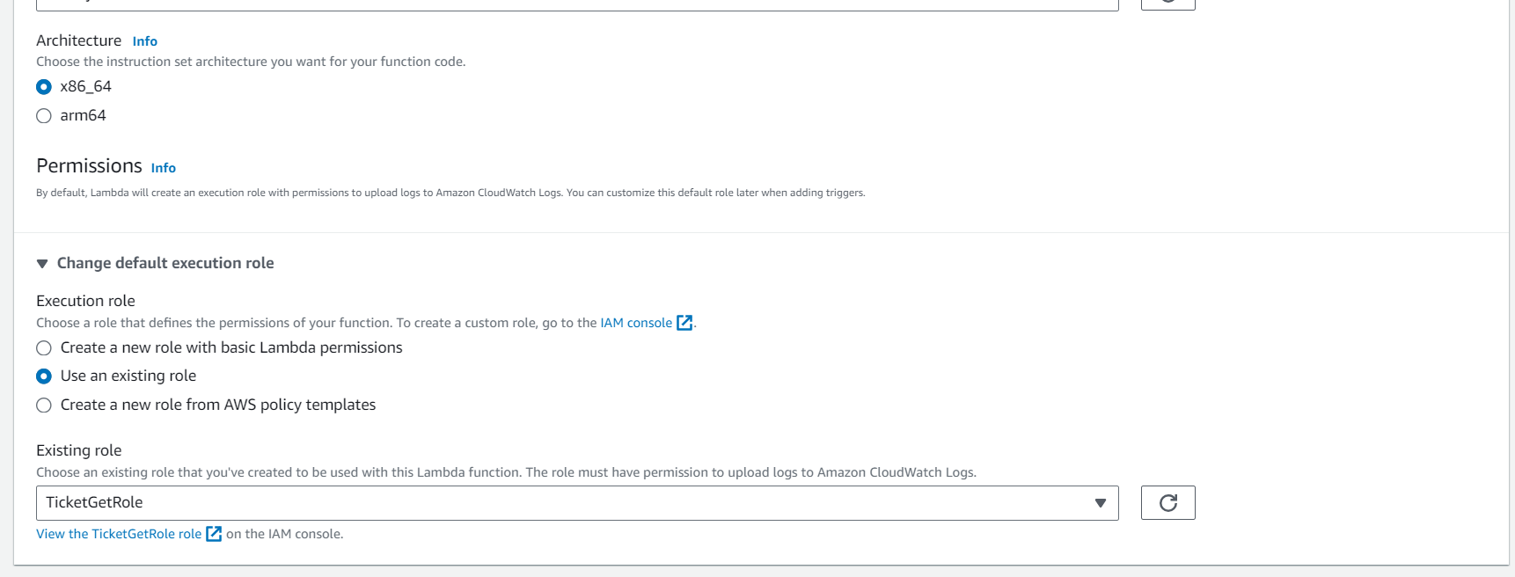

* Successfully created the SXRHealthCheckFunction

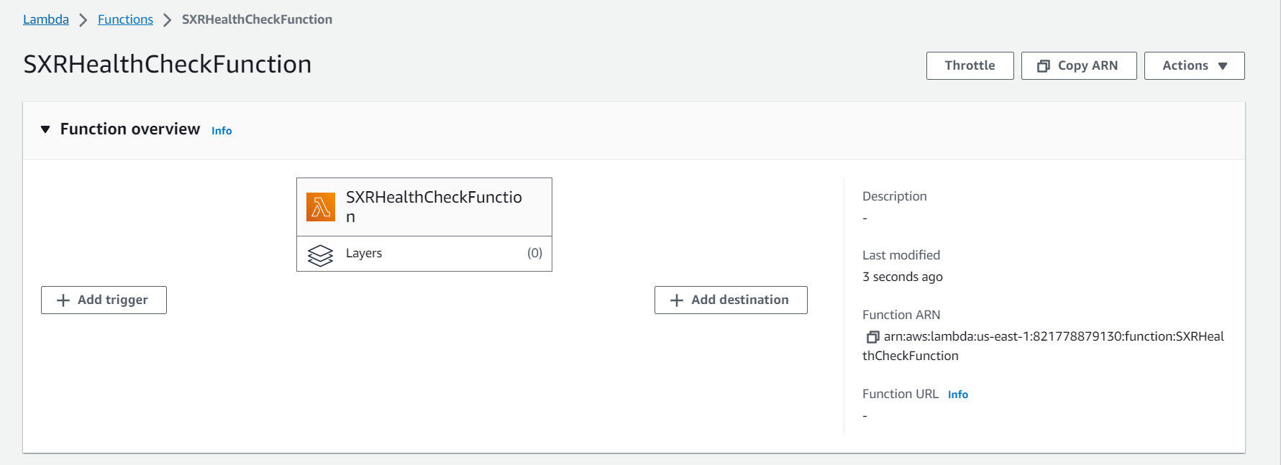

* Changing the Handler name to health-check.handler(runtime settings -> change handler name)



* Edited the handler information to rename the name to health-check.handler

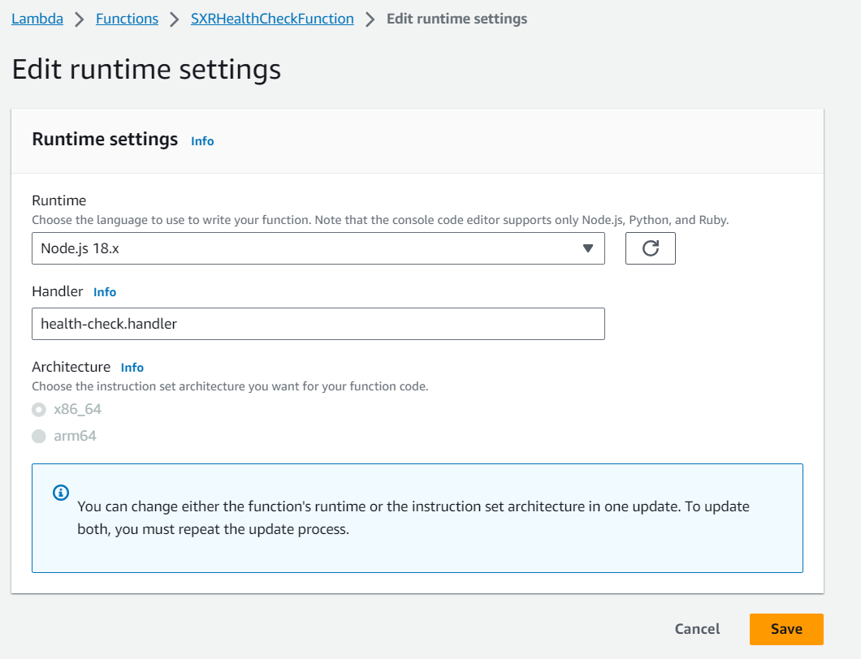

* Changing the runtime to Node.js 16.x since aws-sdk v2 is no longer supported

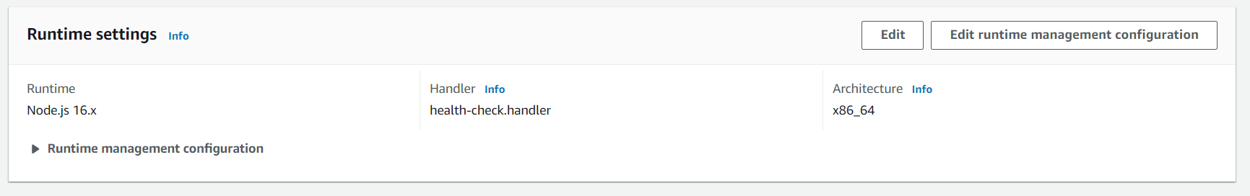

* Changed the file name to health-check.js

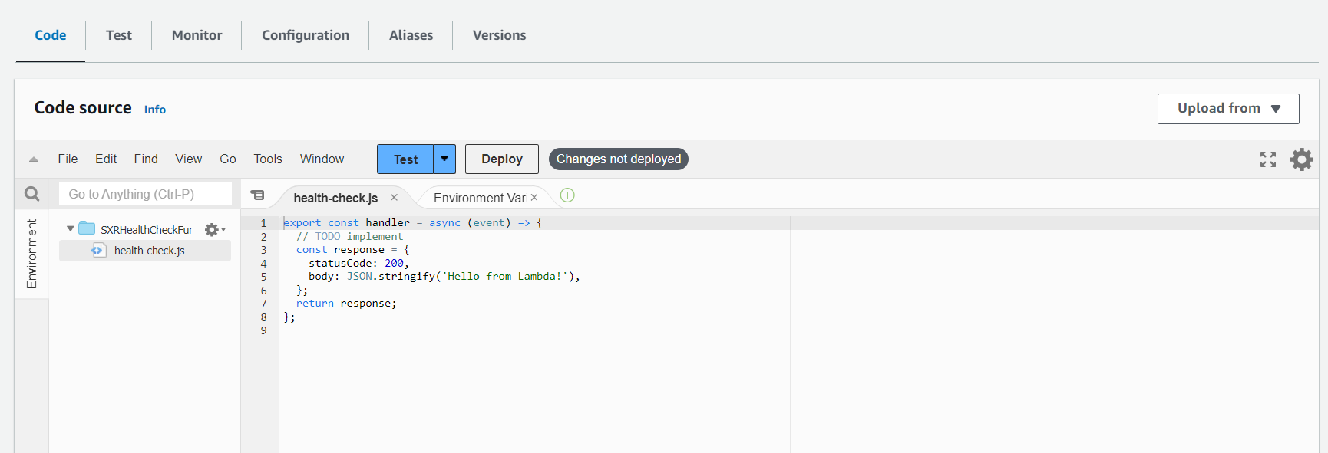

* Pasting the health-check.js content from GitHub into the lambda function code source

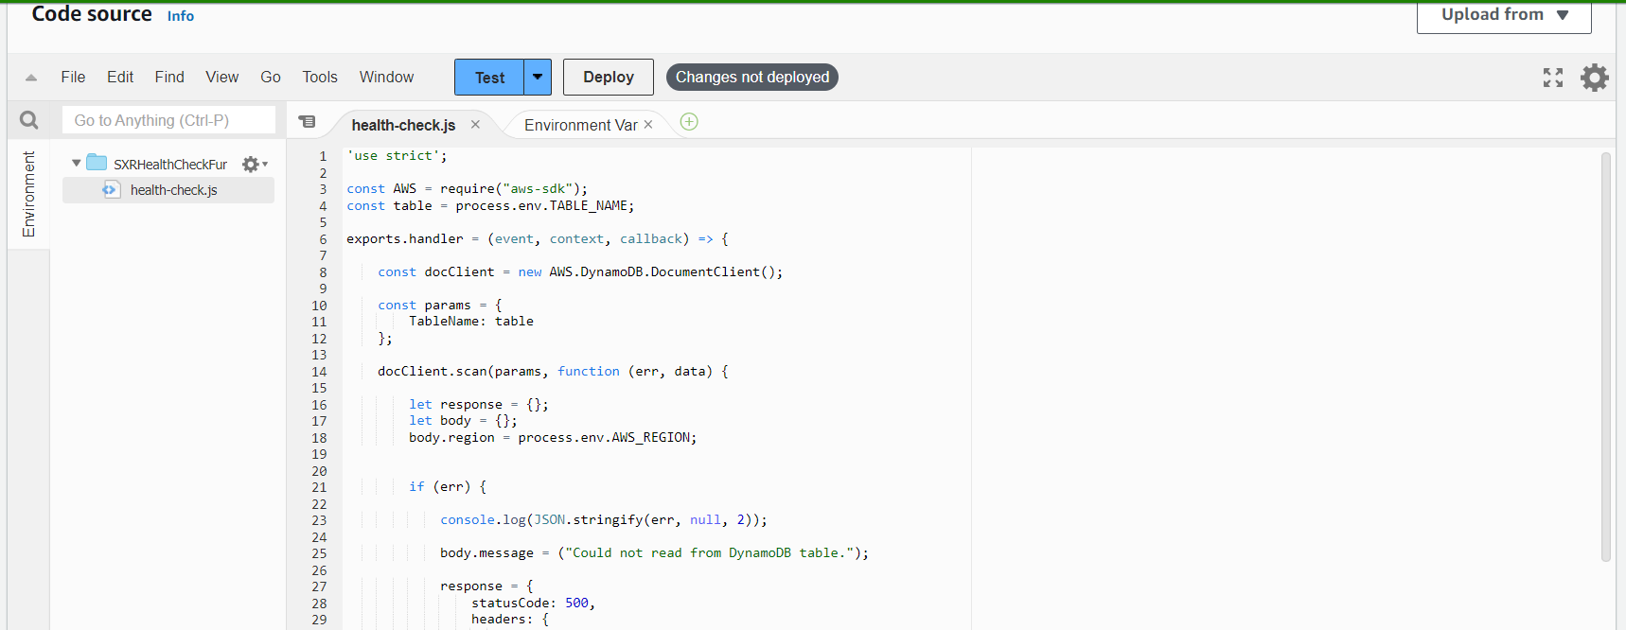

* Setting up the environment variable(Configuration->Environment variables->Edit)

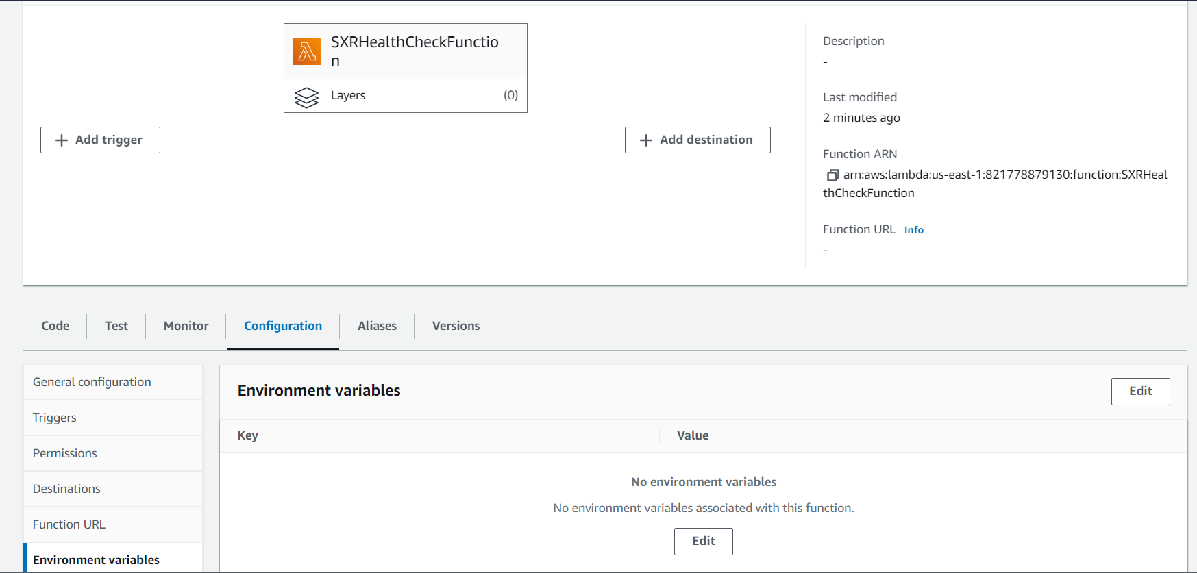

* Adding the environment variable to store the table name

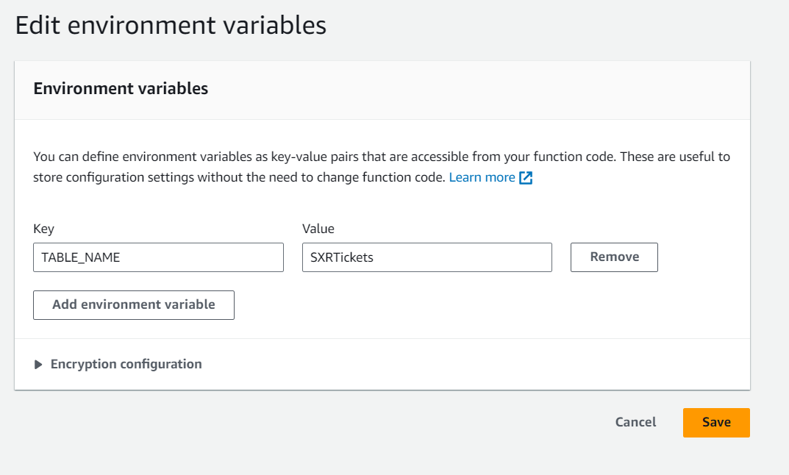

* Successfully created the environment variable



* Successfully deployed the changes to SXRHealthCheckFunction

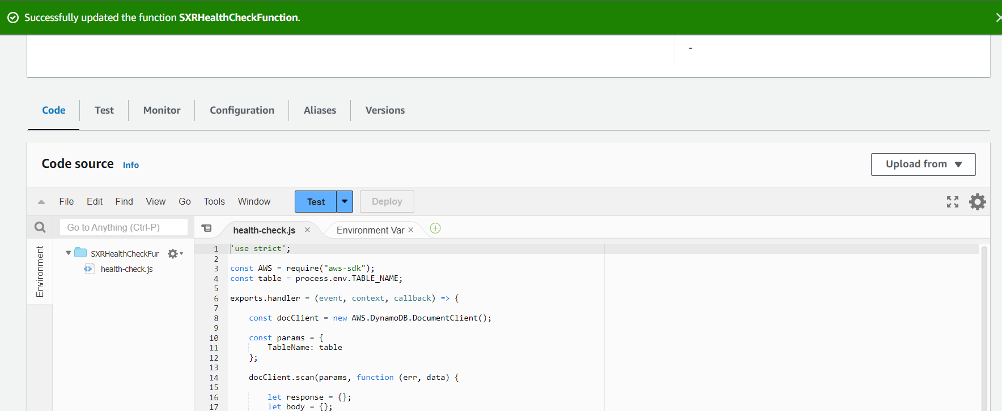

* Successfully created the 3 lambda functions

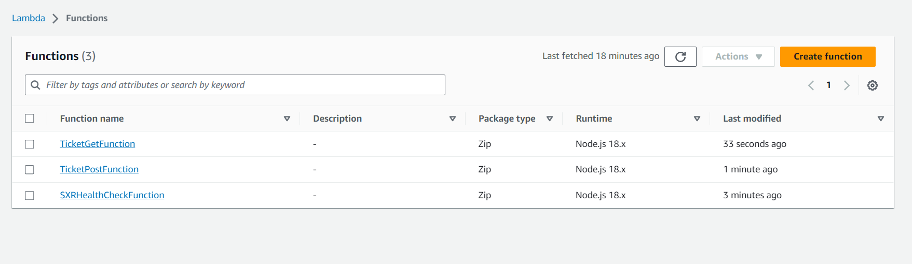

* Building an API Gateway using the HTTP API

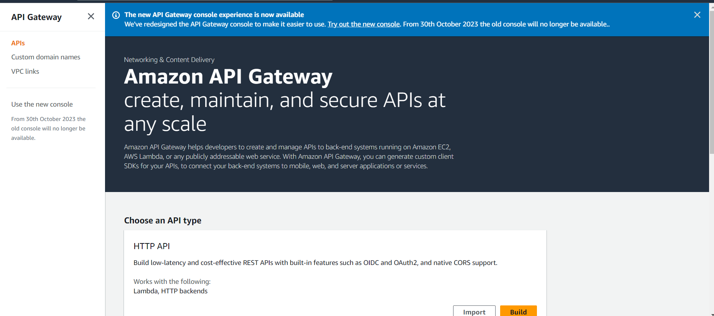

* Creating a new API called wild-ryders-api

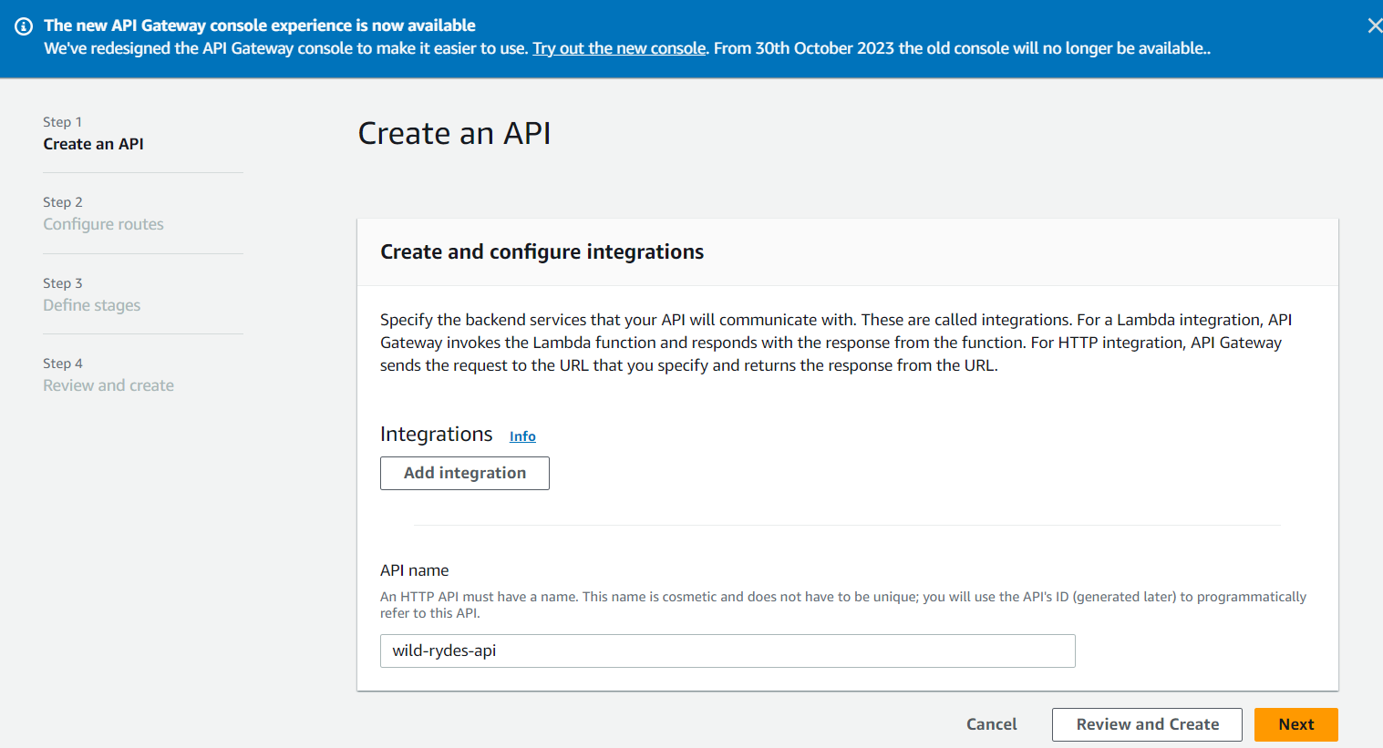

* Integrating all the previously created Lambda functions

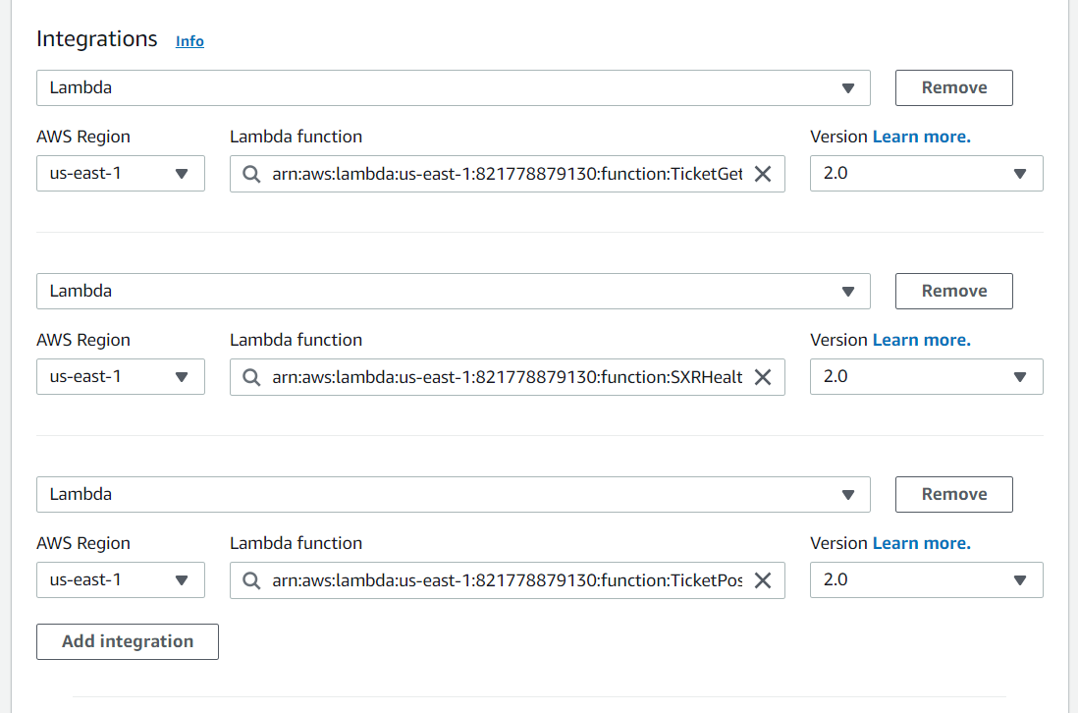

* As a next step, we configured the routes
  + GET method for TicketGetFunction with resource path as /ticket
  + POST method for TicketPostFunction with resource path as /ticket
  + GET method for SXRHealthCheckFunction with resource path as /health

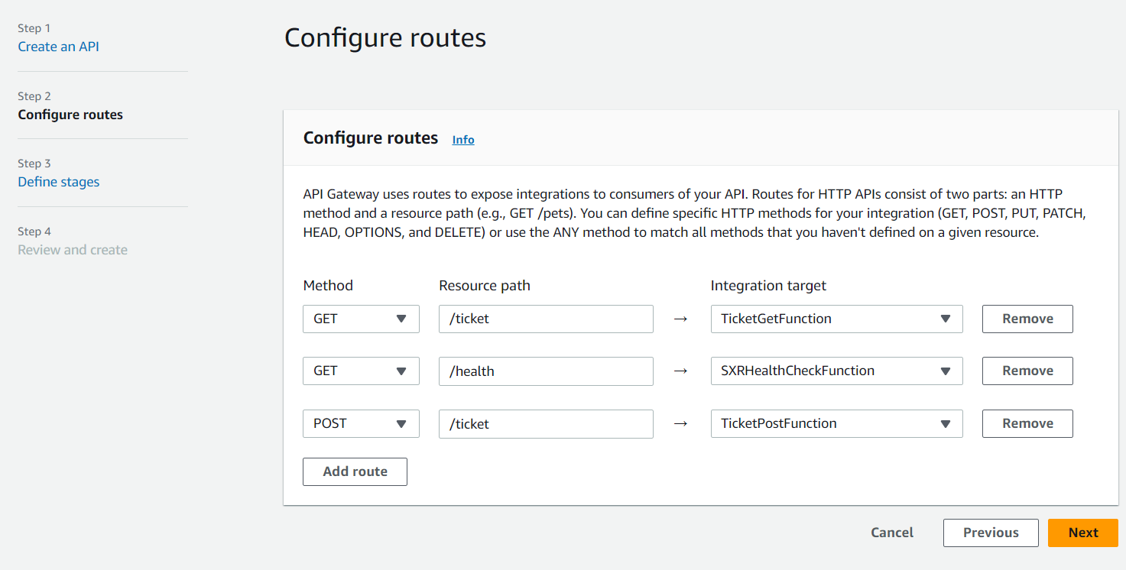

* Defining the stages by giving the stage name

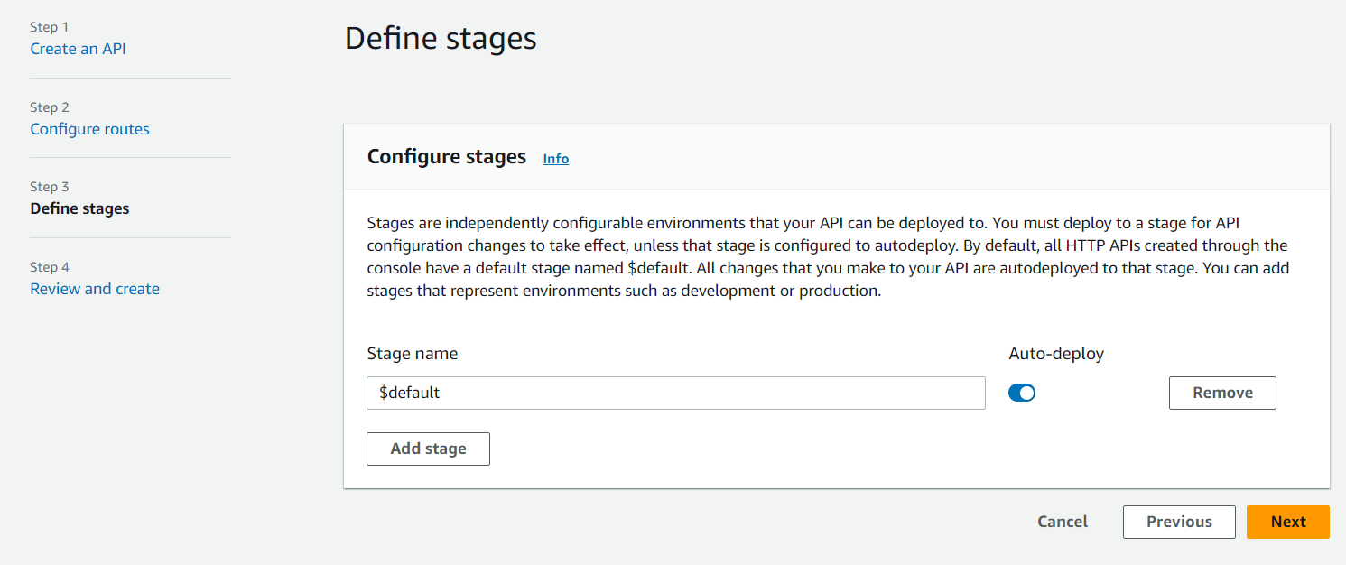

* Successfully created the API Gateway

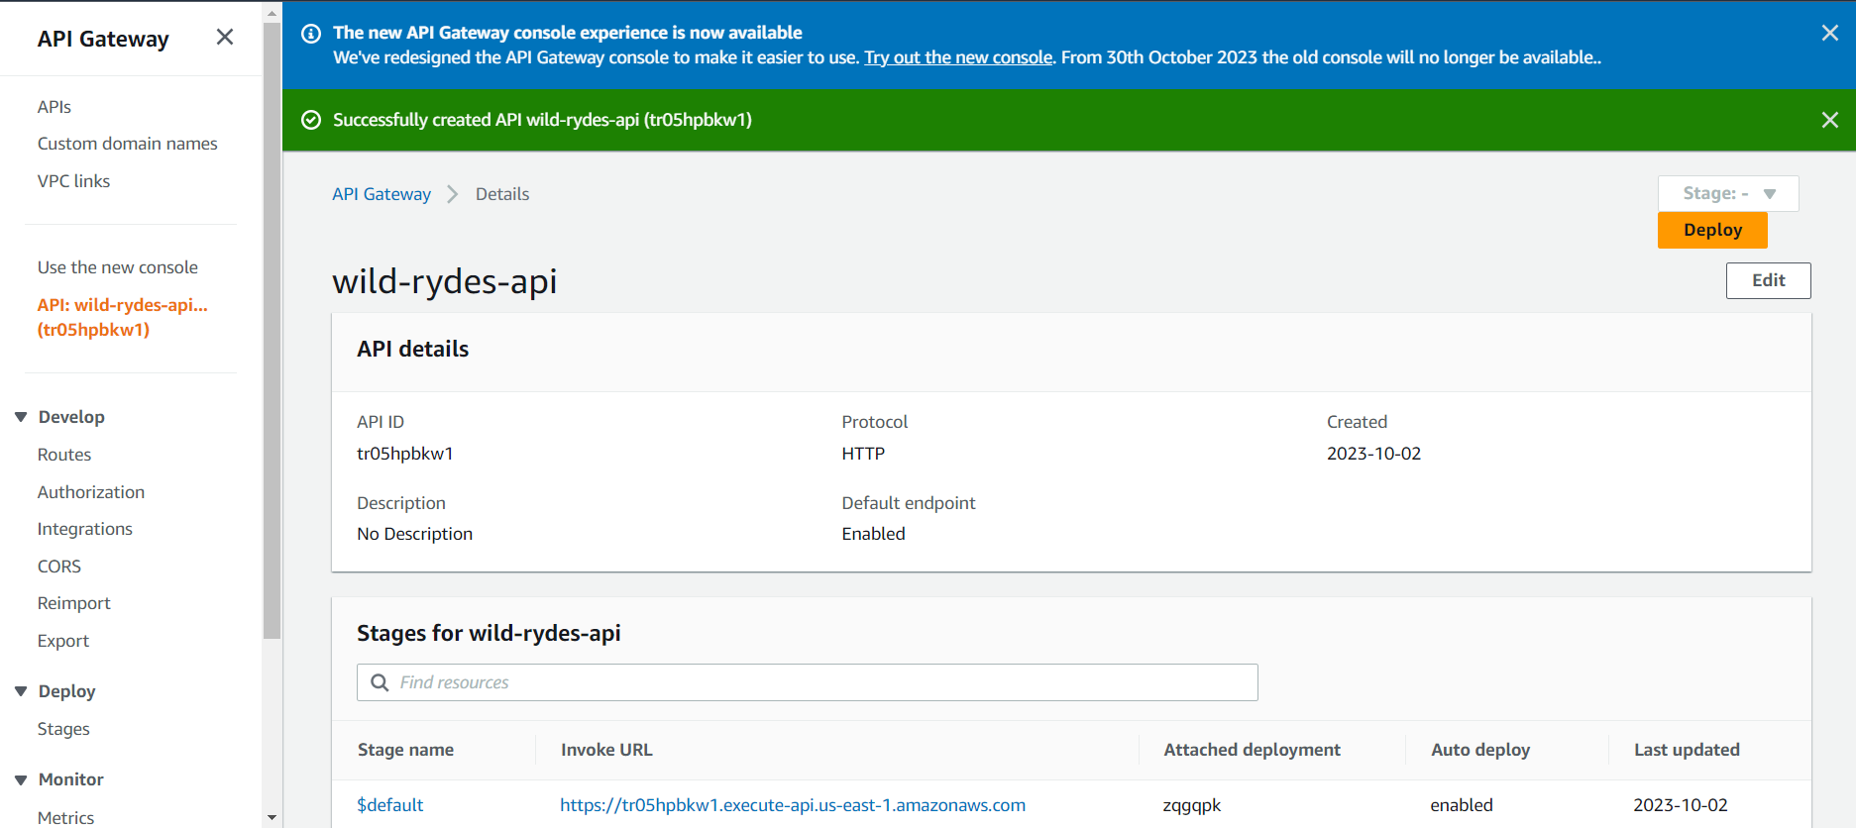

* Configuring the CORS settings to test the API endpoints

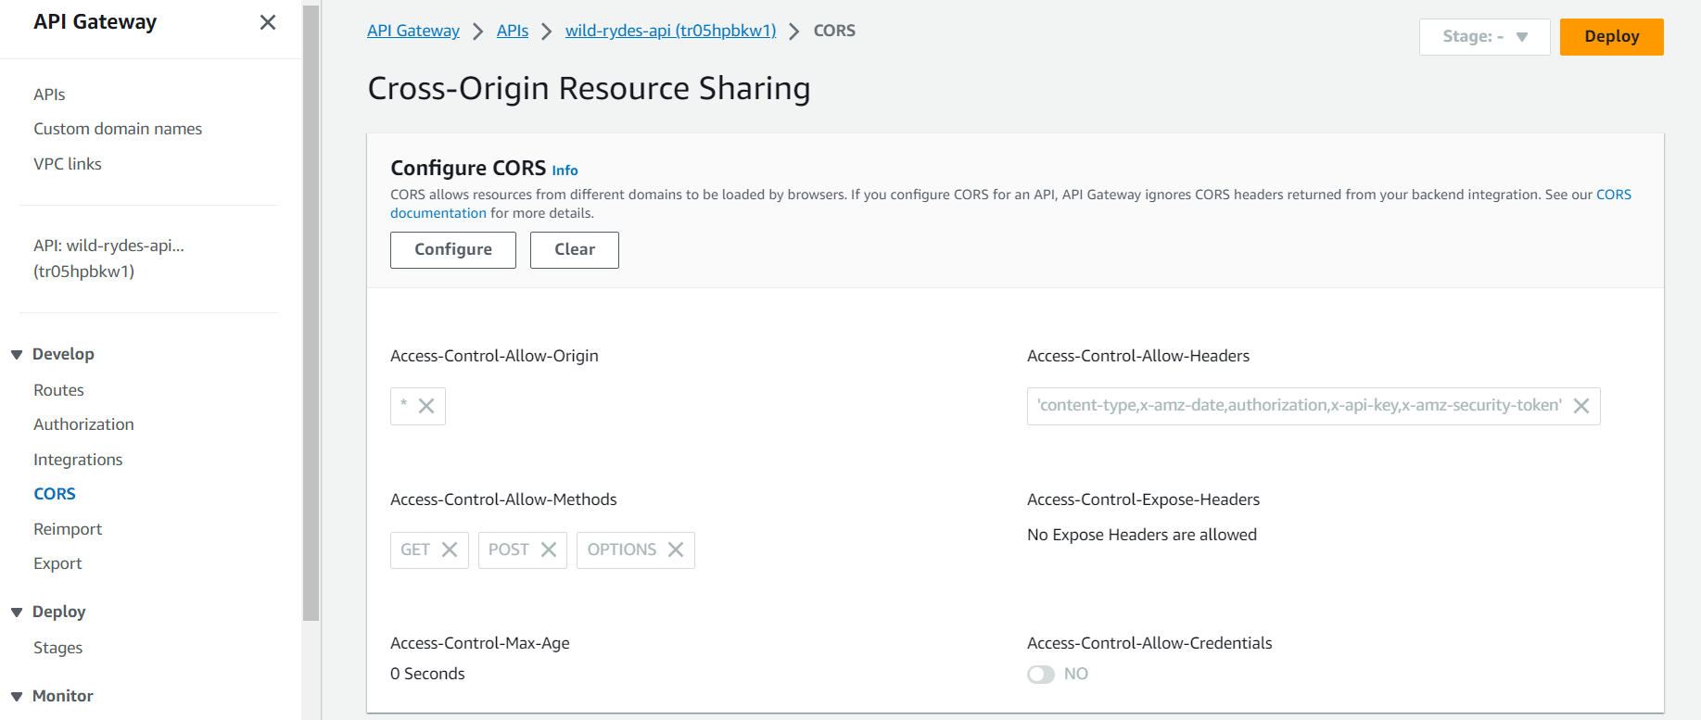

* Creating production stage to deploy the API

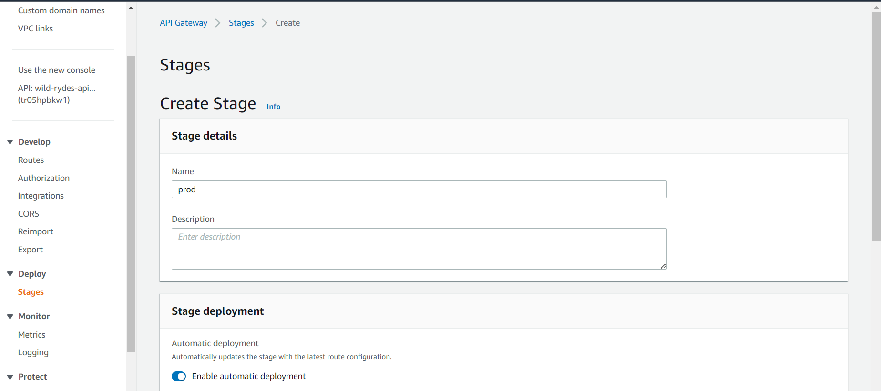

* Successfully created the prod stage with automatic deployment

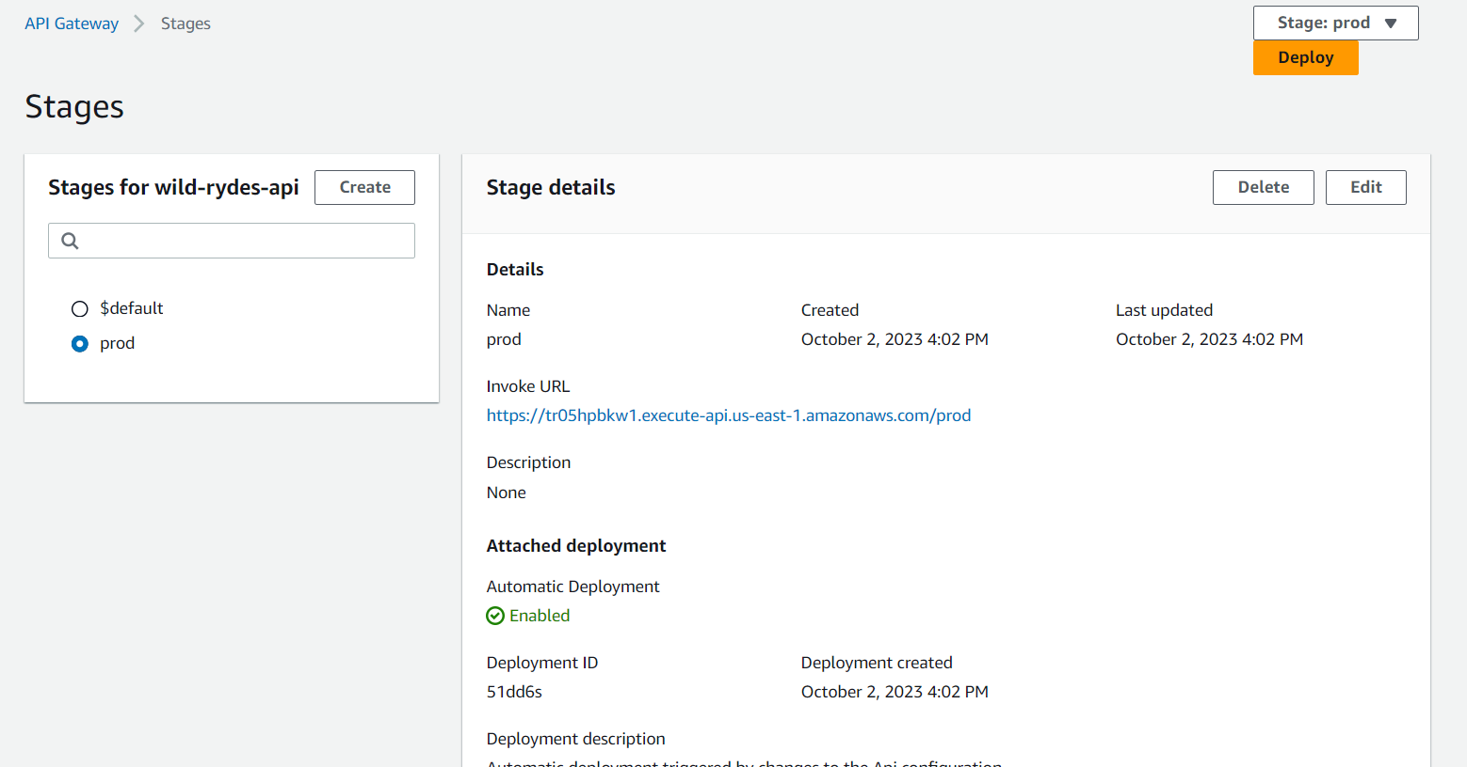

* Testing the end-point for health

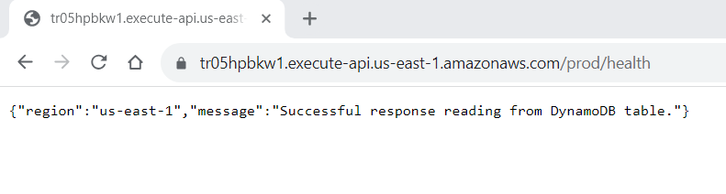

* Testing the end point for ticket

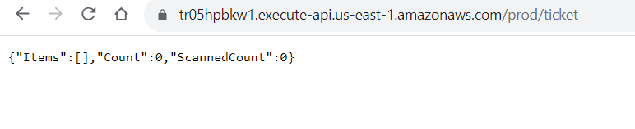

* Creating the lambda functionsagain in Singapore region

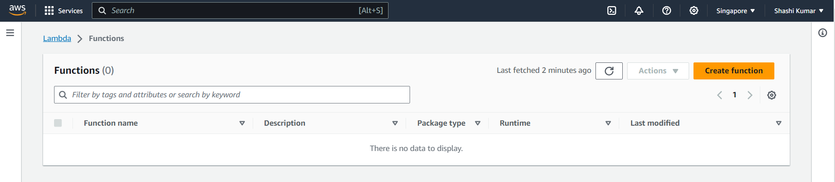

* Creating a new function called TicketGetFunction with Node.js 16.x runtime and x86_64 architecture

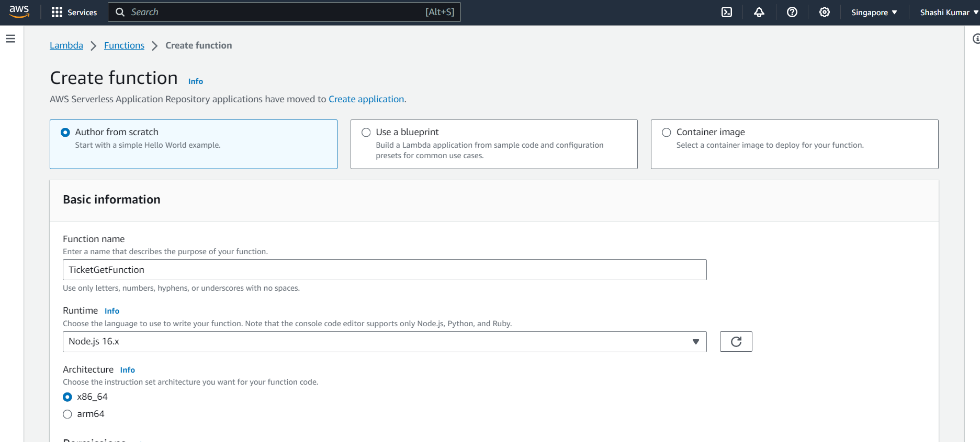

* Using the previously created role called as TicketGetRole as the execution role

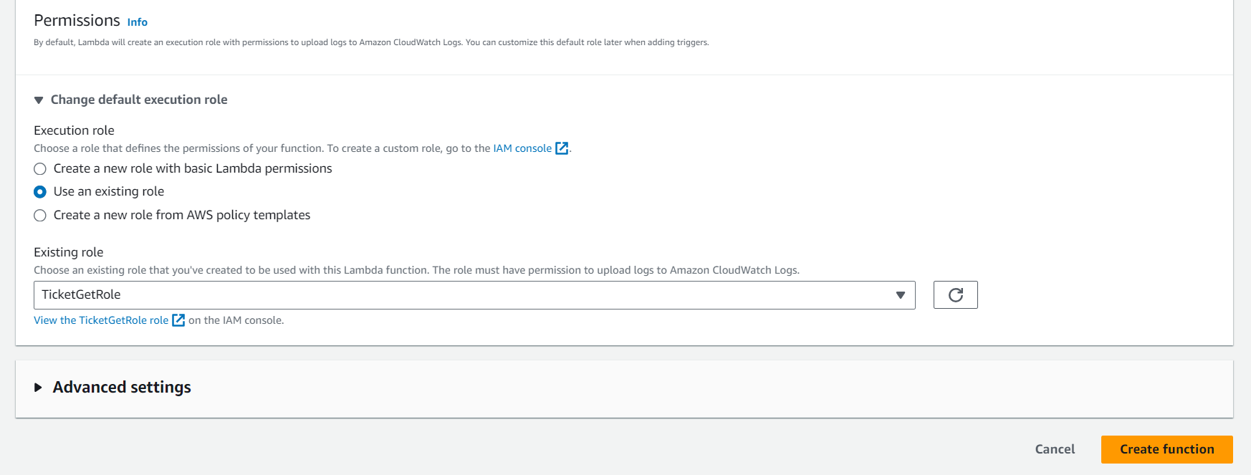

* Successfully created the function called TicketGetFunction

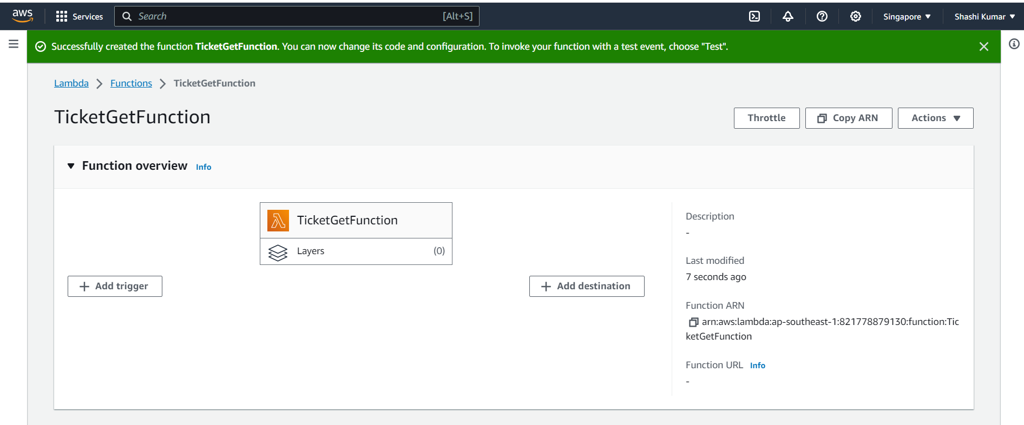

* Changing the handler name under runtime settings to tickets-get.handler

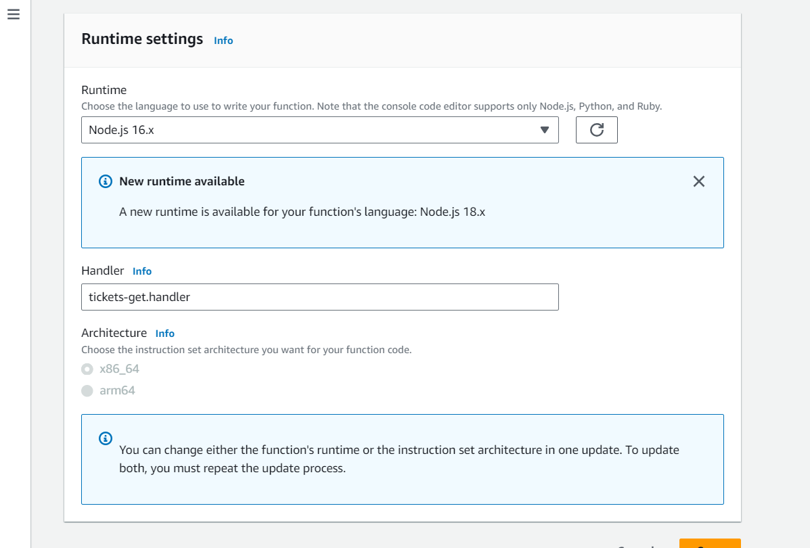

* Renamed the file as tickets-get.js and copied the script from the GitHub repository

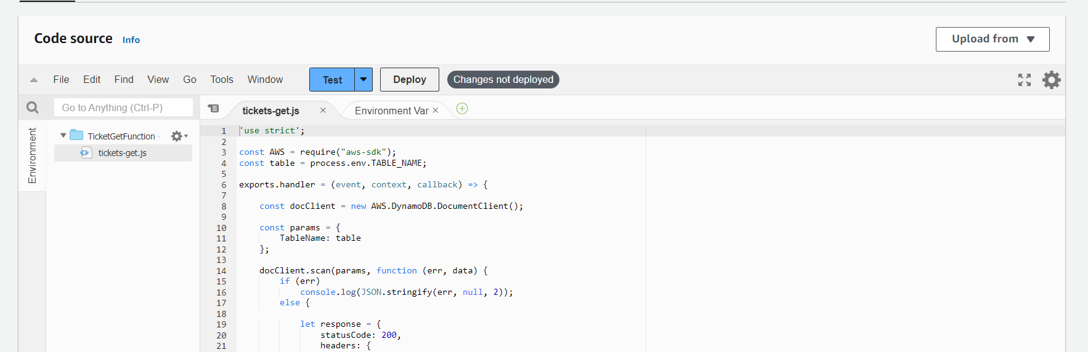

* Adding the environment variable under configuration

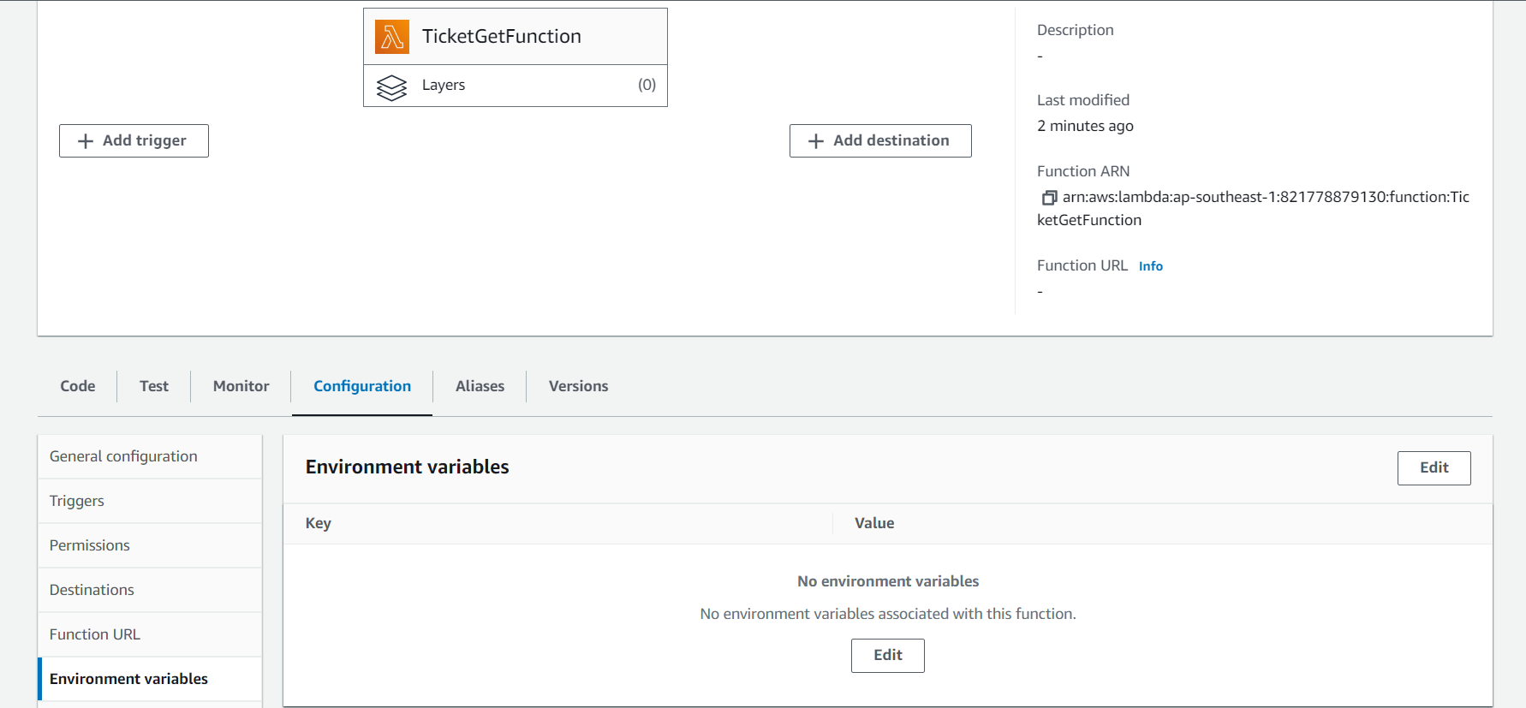

* Added the environment variable called TABLE_NAME with value SXRTickets

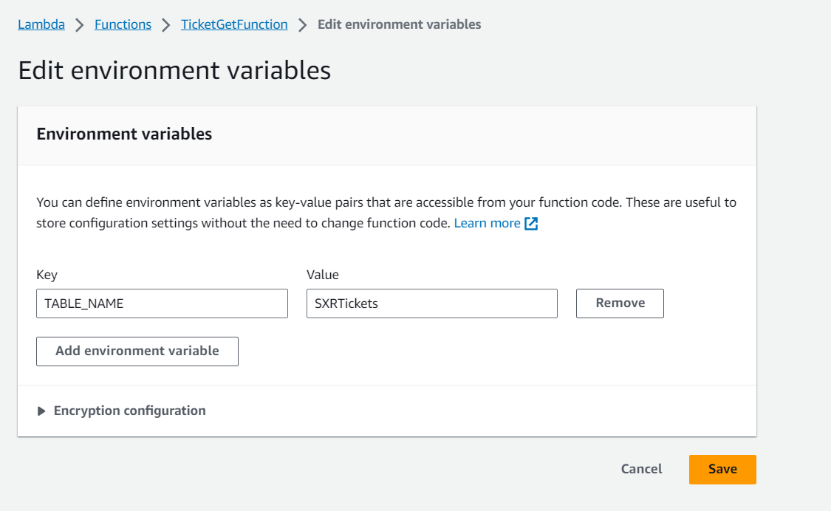

* Successfully created the environment variable



* Successfully deployed the code to the lambda function

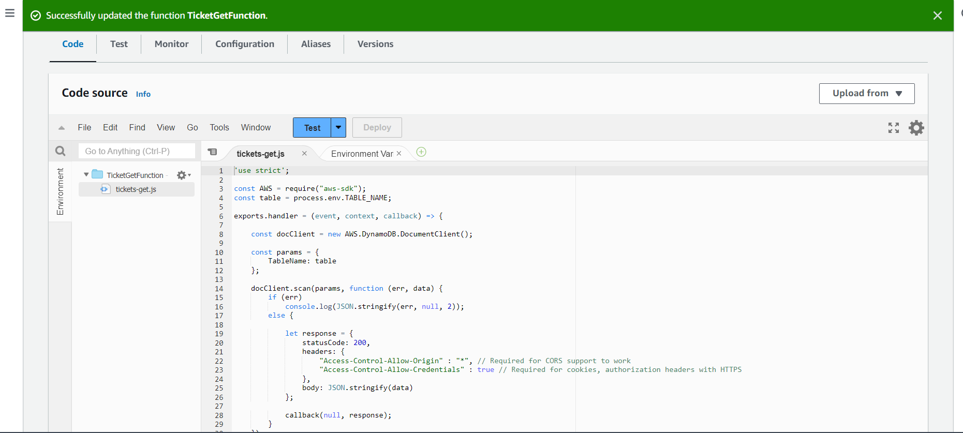

* Creating a new function called TicketPostFunction with Node.js 16.x runtime and x86_64 architecture

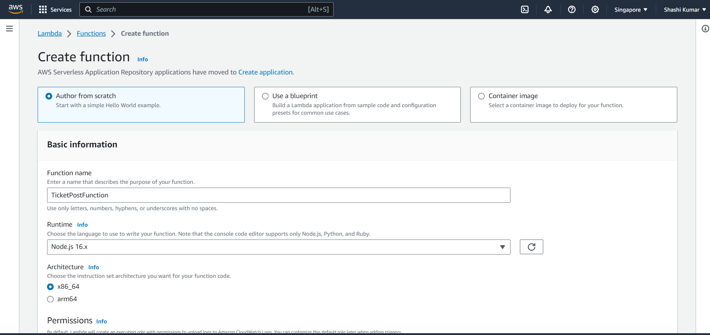

* Using the previously created role called as TicketPostRole as the execution role

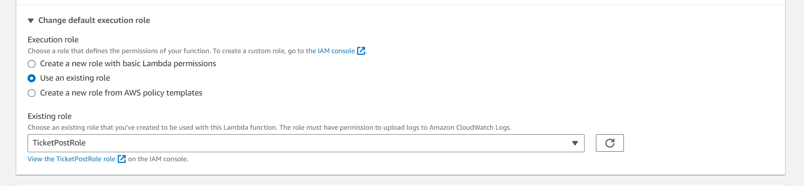

* Successfully created the function called TicketGetFunction

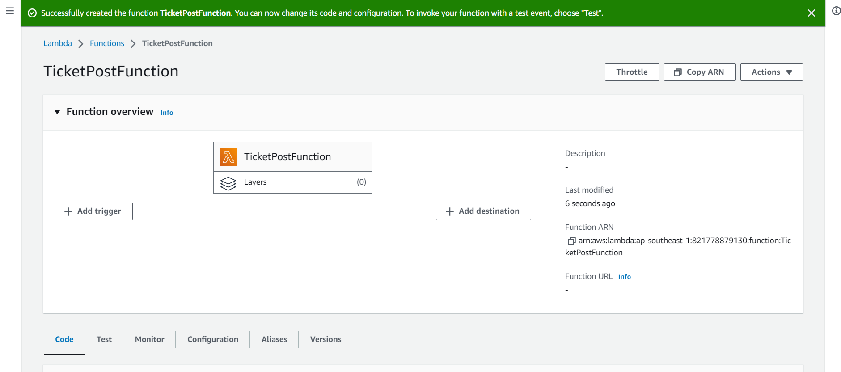

* Changing the handler name under runtime settings to tickets-post.handler

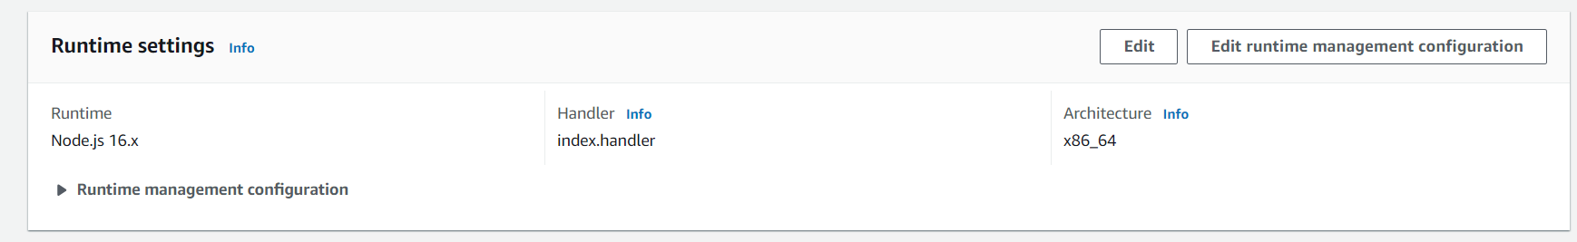

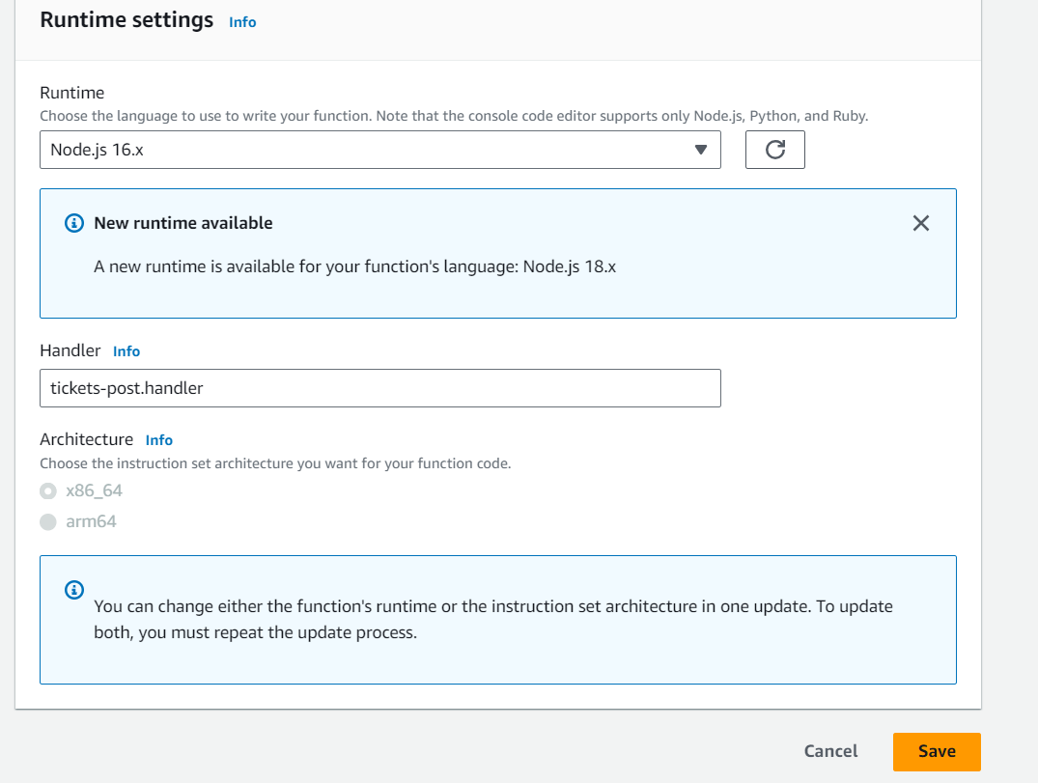

* Renamed the file as tickets-post.js and copied the script from the GitHub repository

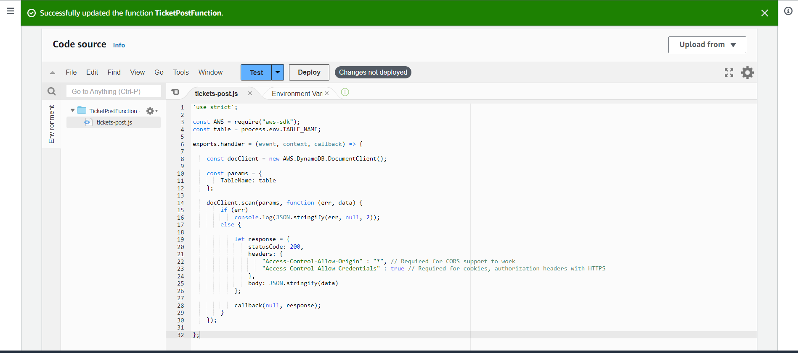

* Adding the environment variable under configuration

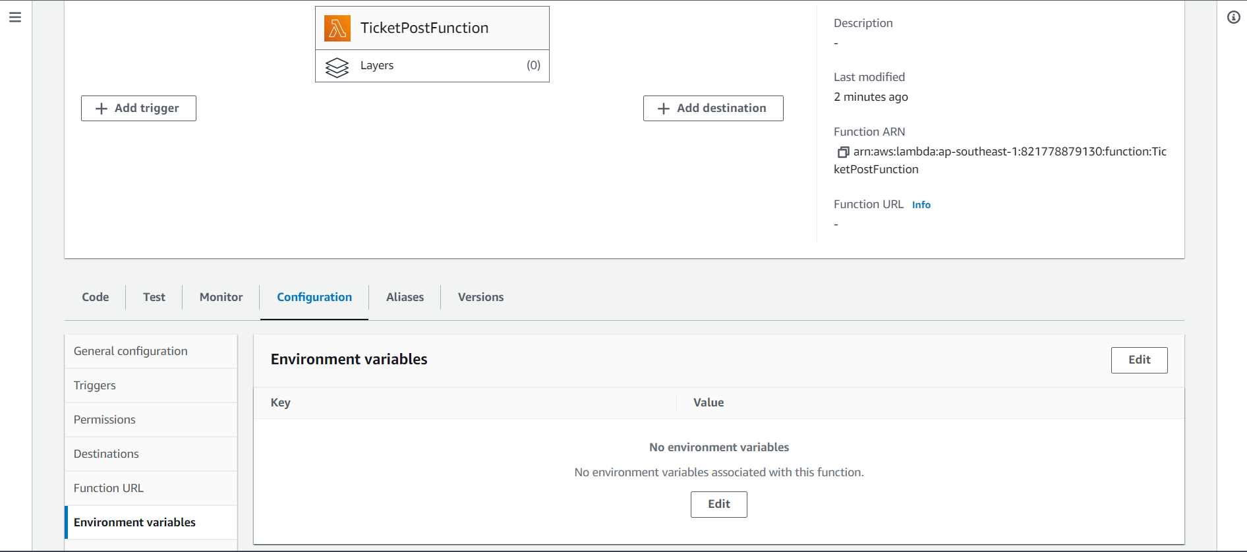

* Added the environment variable called TABLE_NAME with value SXRTickets



* Successfully created the environment variable



* Successfully deployed the code to the lambda function

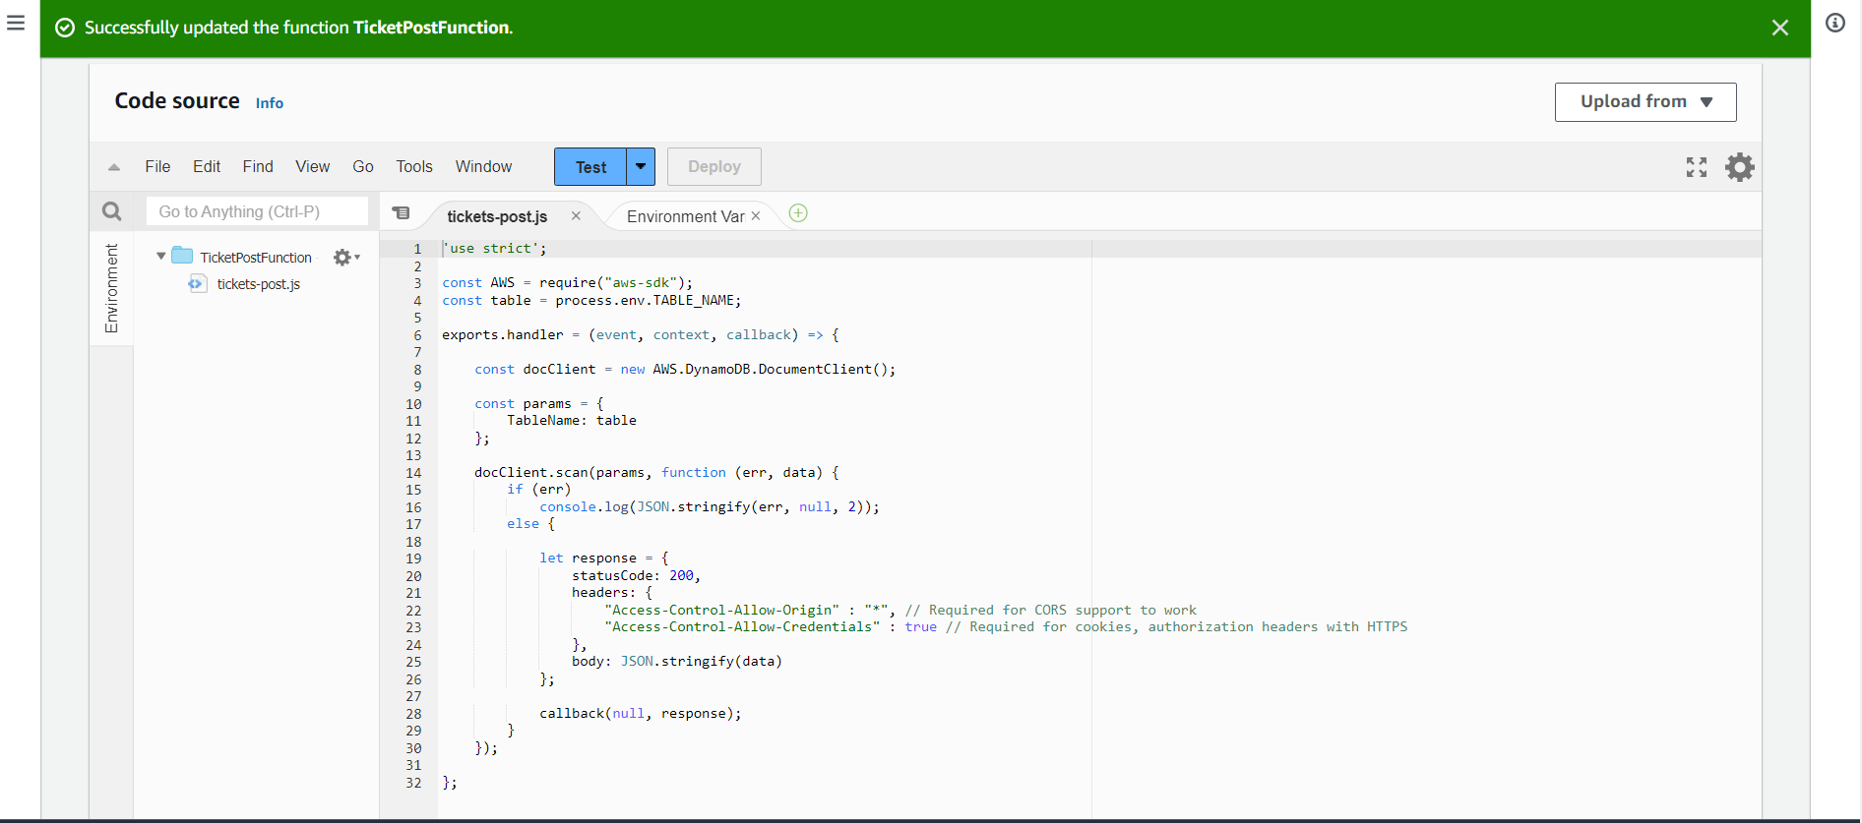

* Creating a new function called SXRHealthCheckFunction with Node.js 16.x runtime and x86_64 architecture

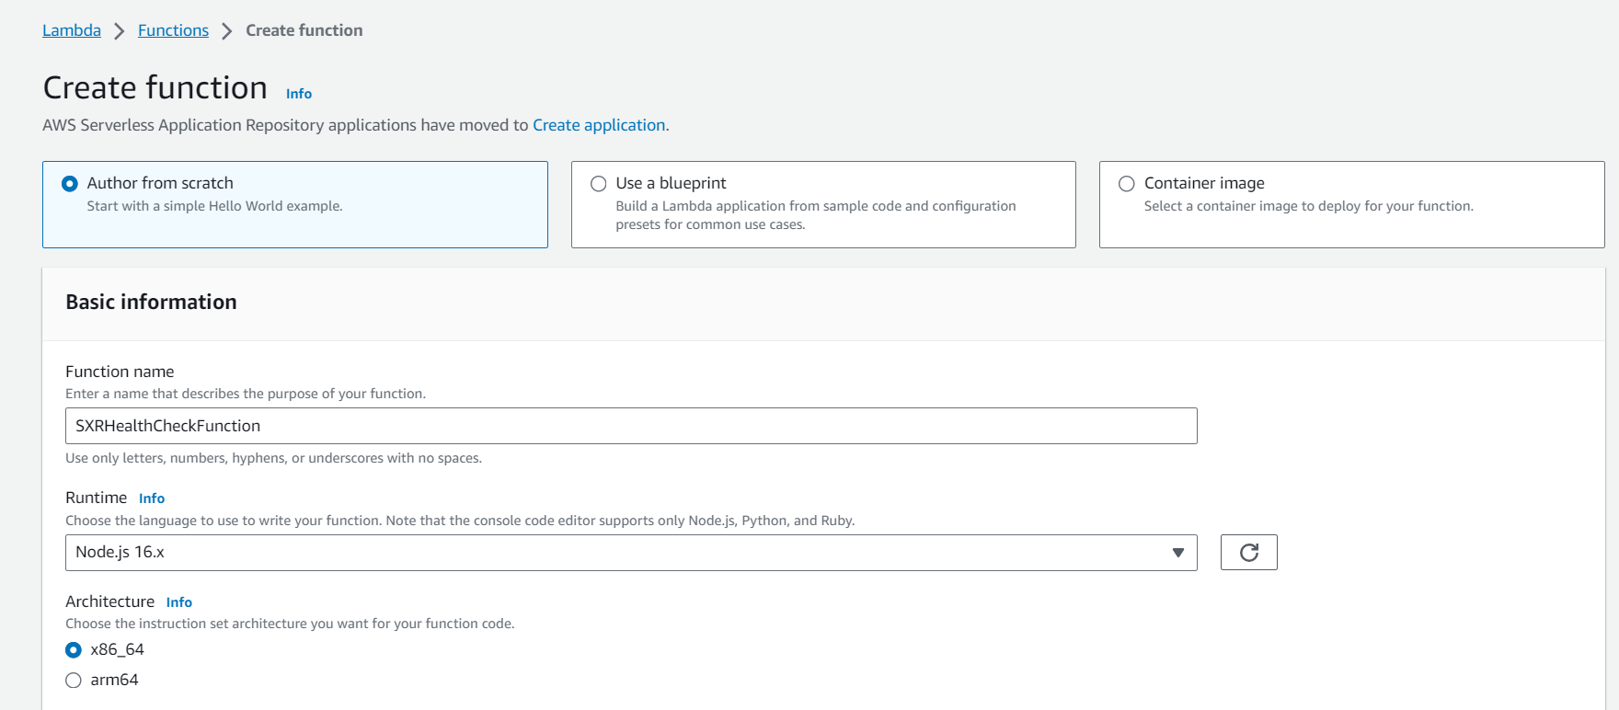

* Using the previously created role called as TicketGetRole as the execution role

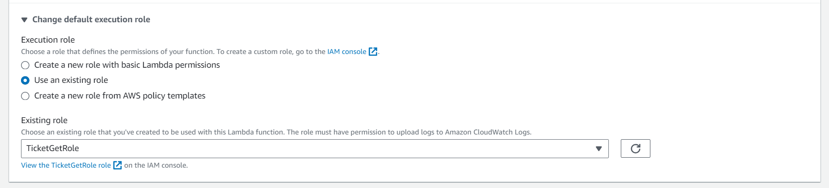

* Successfully created the function called SXRHealthCheckFunction

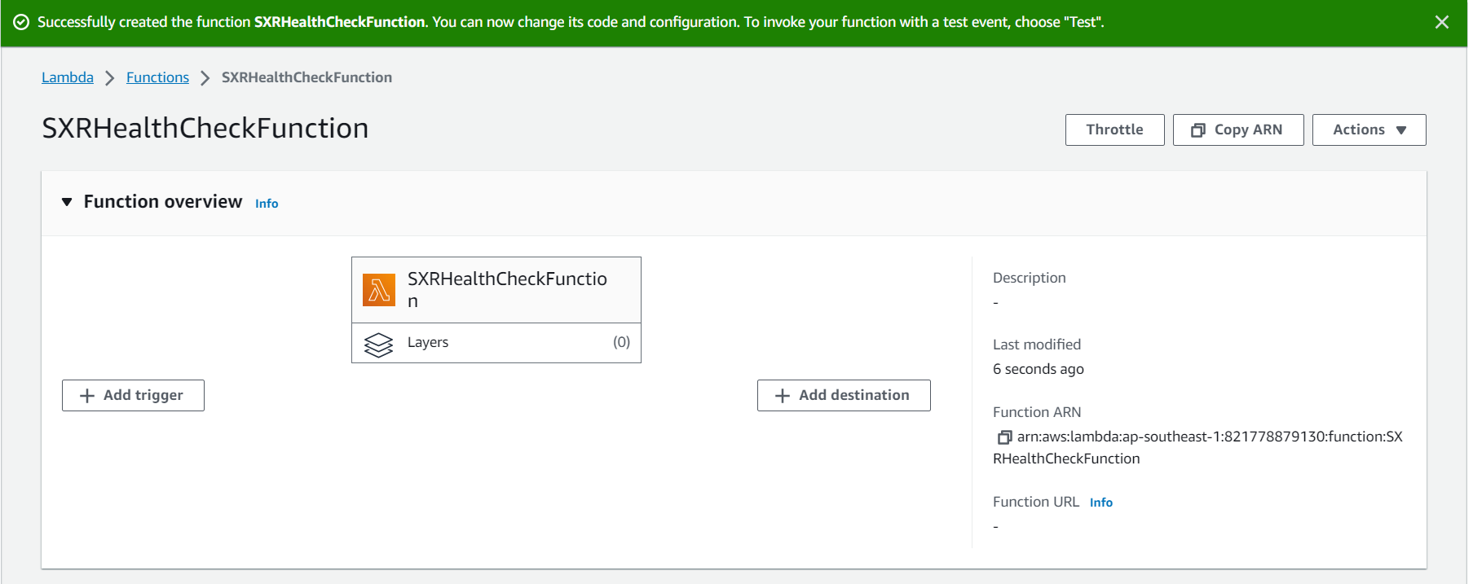

* Changing the handler name under runtime settings to health-check.handler

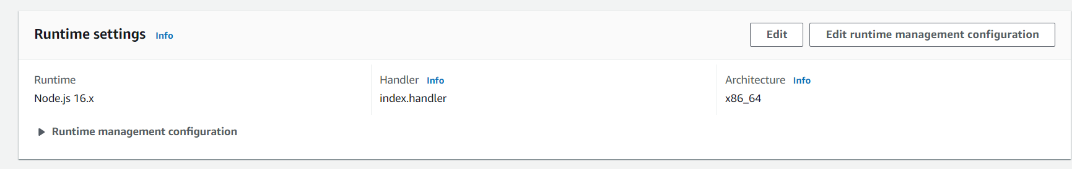

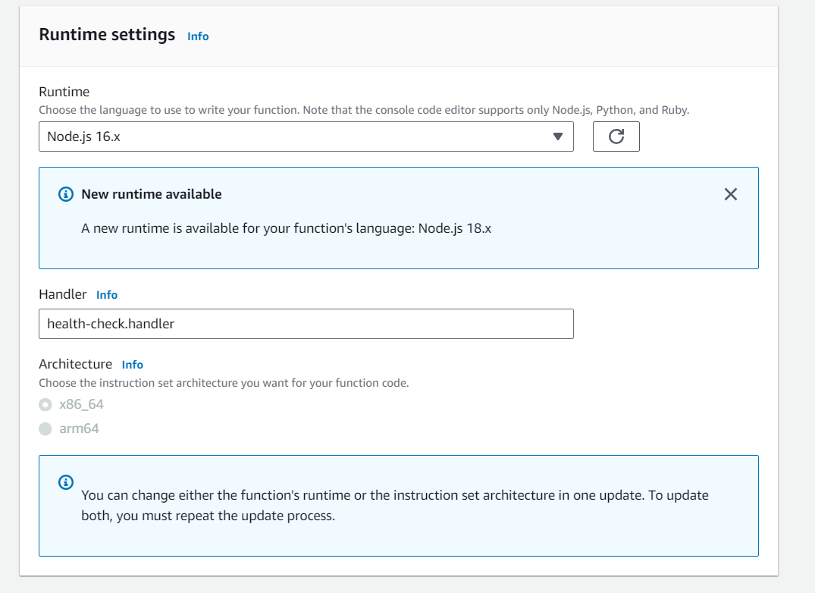

* Renamed the file as health-check.js and copied the script from the GitHub repository

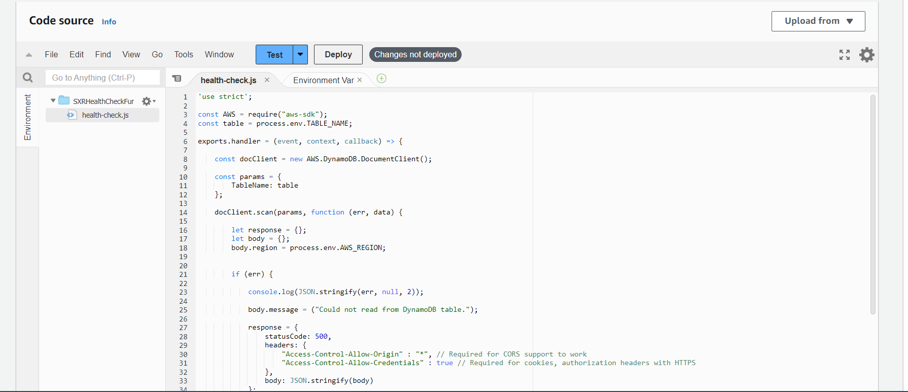

* Adding the environment variable under configuration

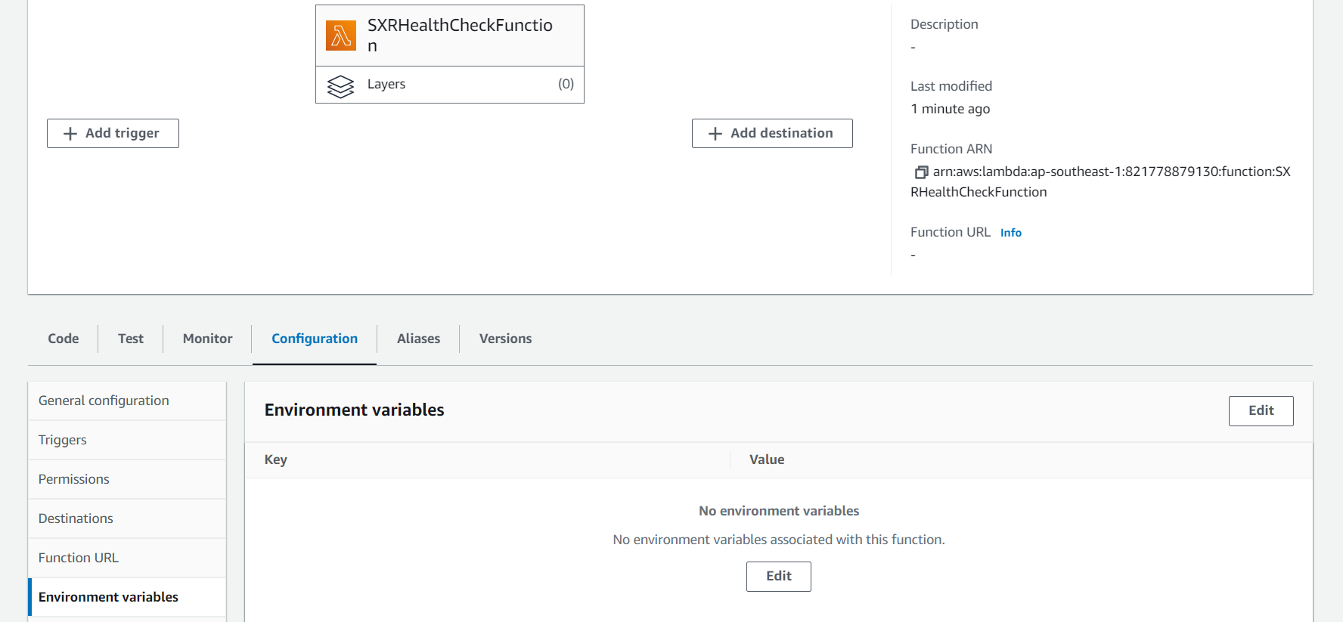

* Added the environment variable called TABLE_NAME with value SXRTickets



* Successfully created the environment variable



* Successfully deployed the code to the lambda function

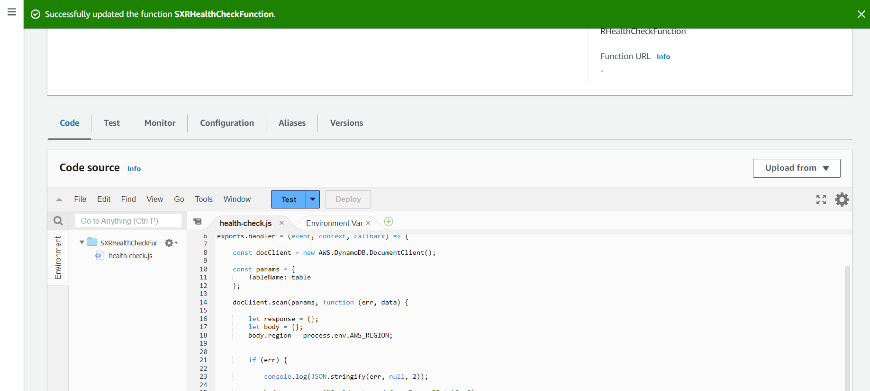

* Created the three lambda functions in Singapore region

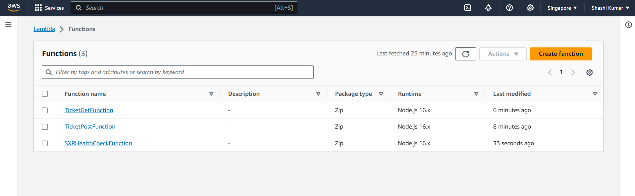

* Creating the HTTP API gateway in the Singapore region to all the lambda functions

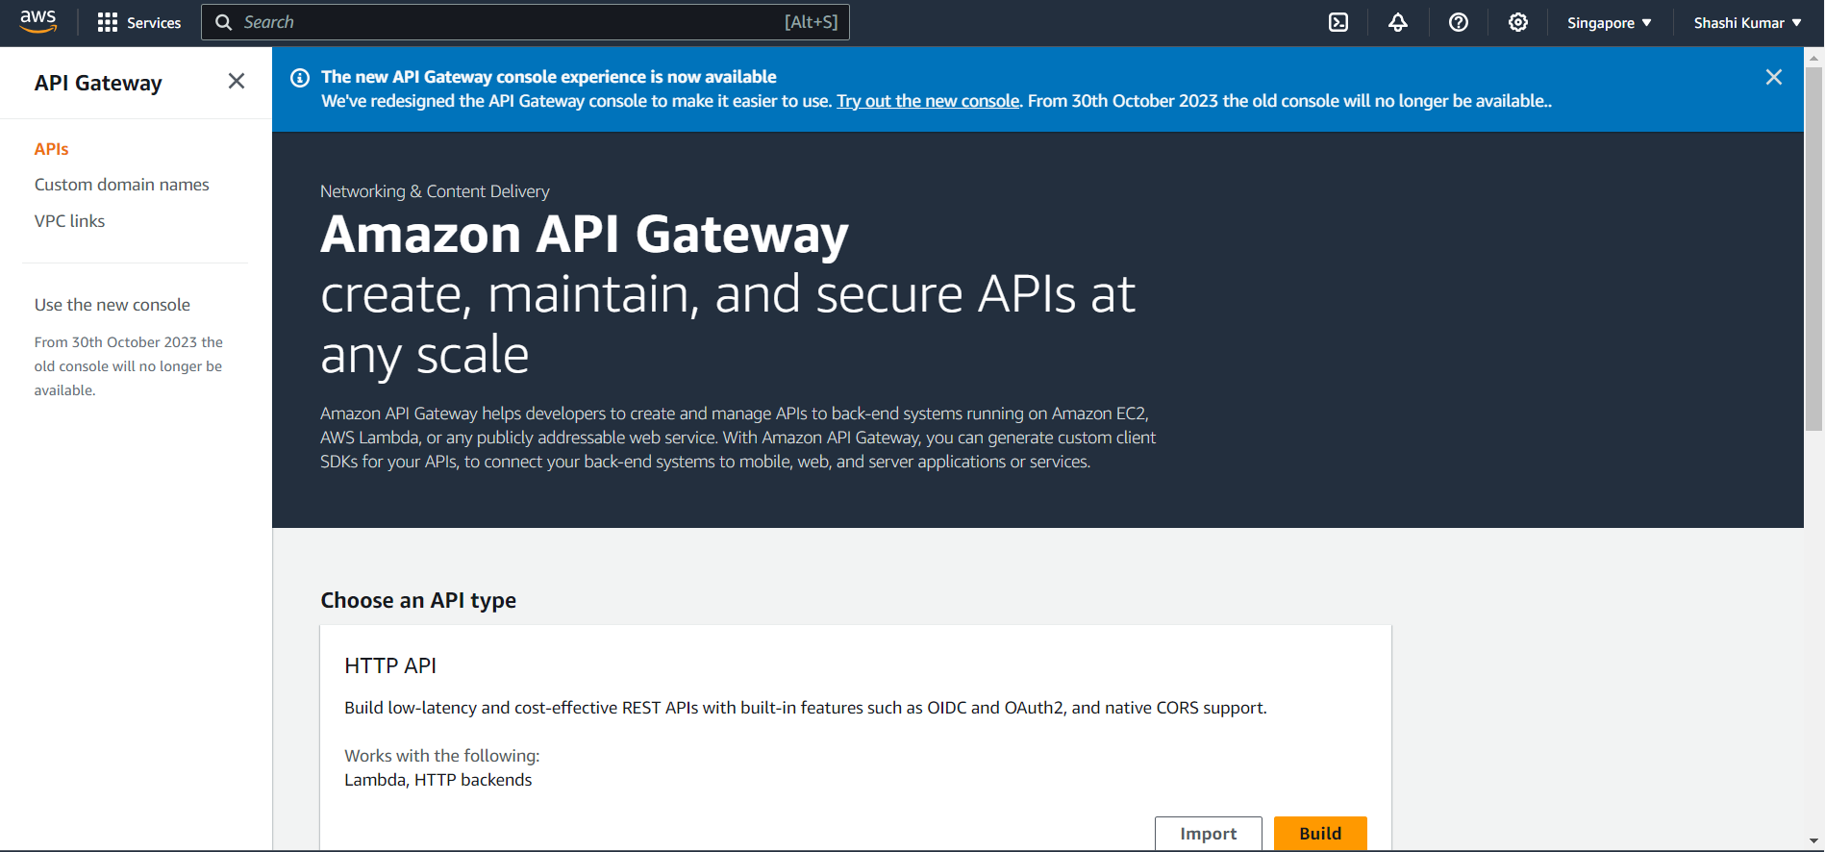

* Creating the API called wild-rydes-api

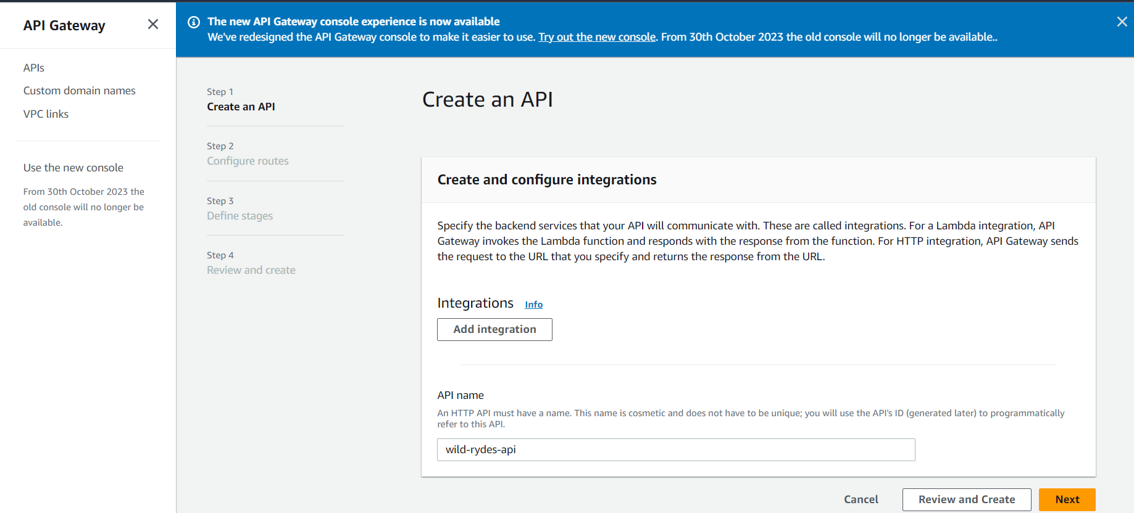

* Configuring the integrations to point to the three lambda functions created

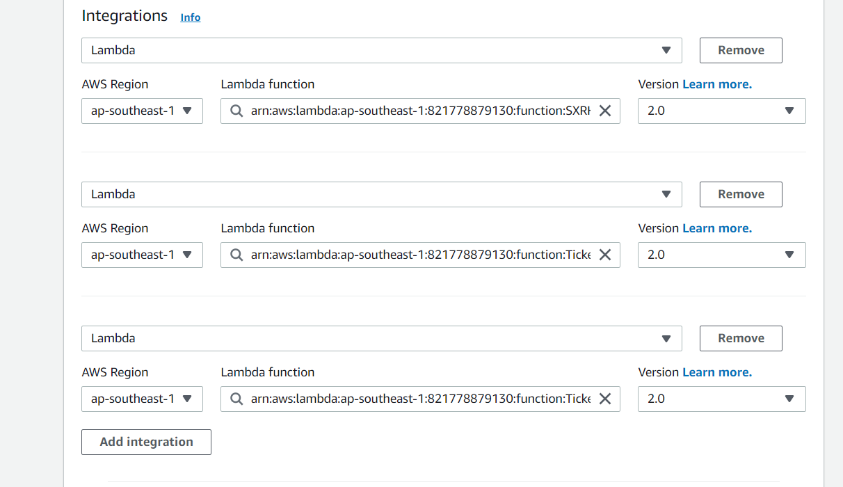

* Configuring the resource paths/routes and setting the appropriate API call methods

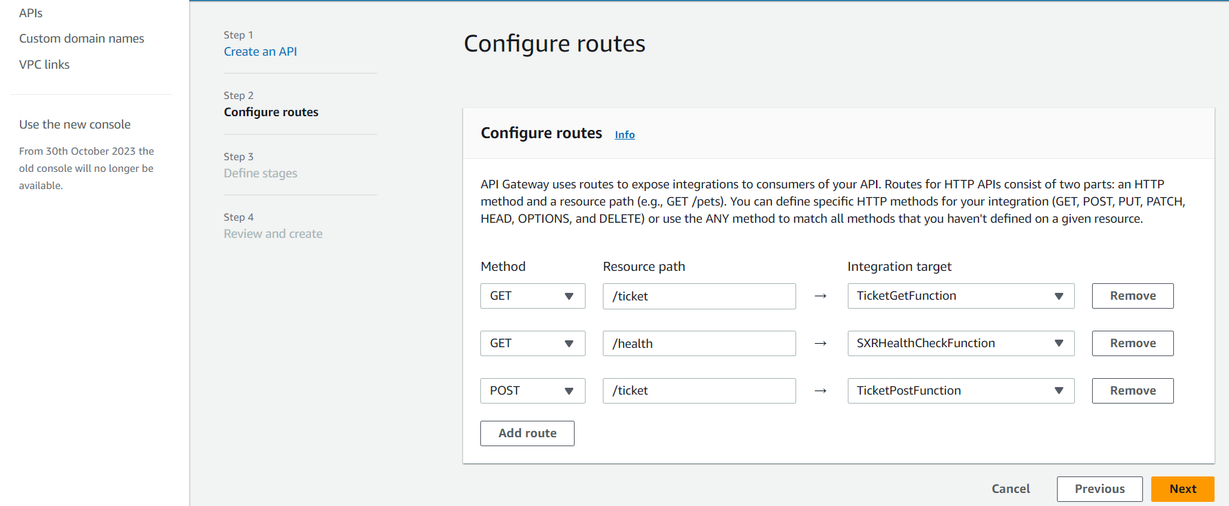

* Defining and configuring the stage as prod

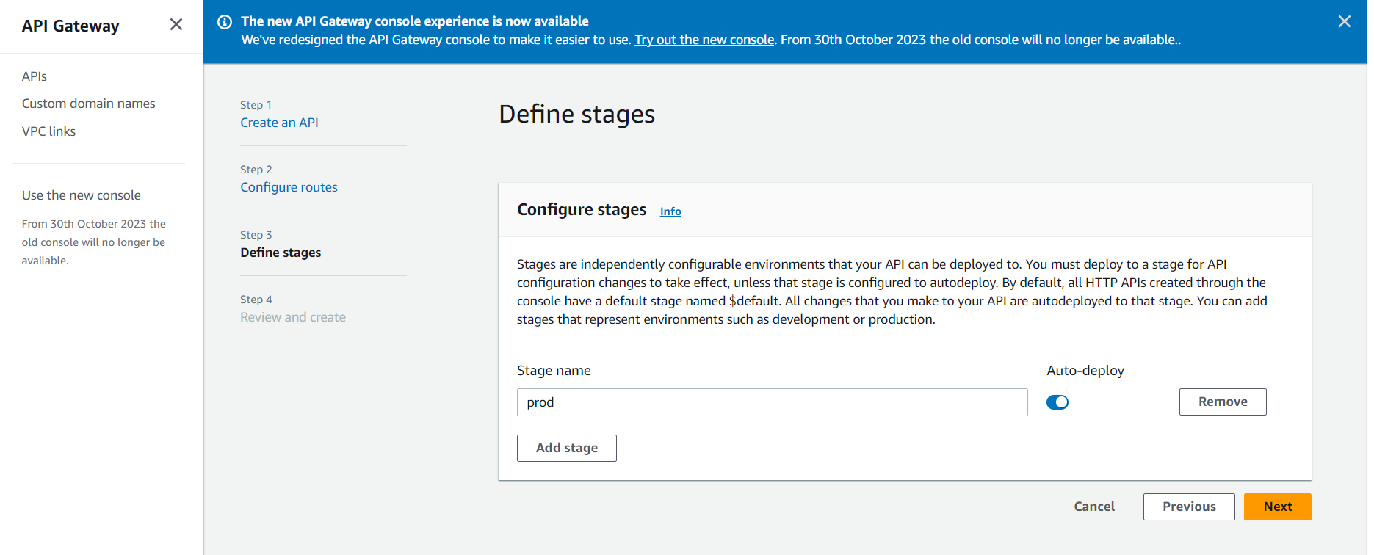

* Successfully created the AWS API Gateway

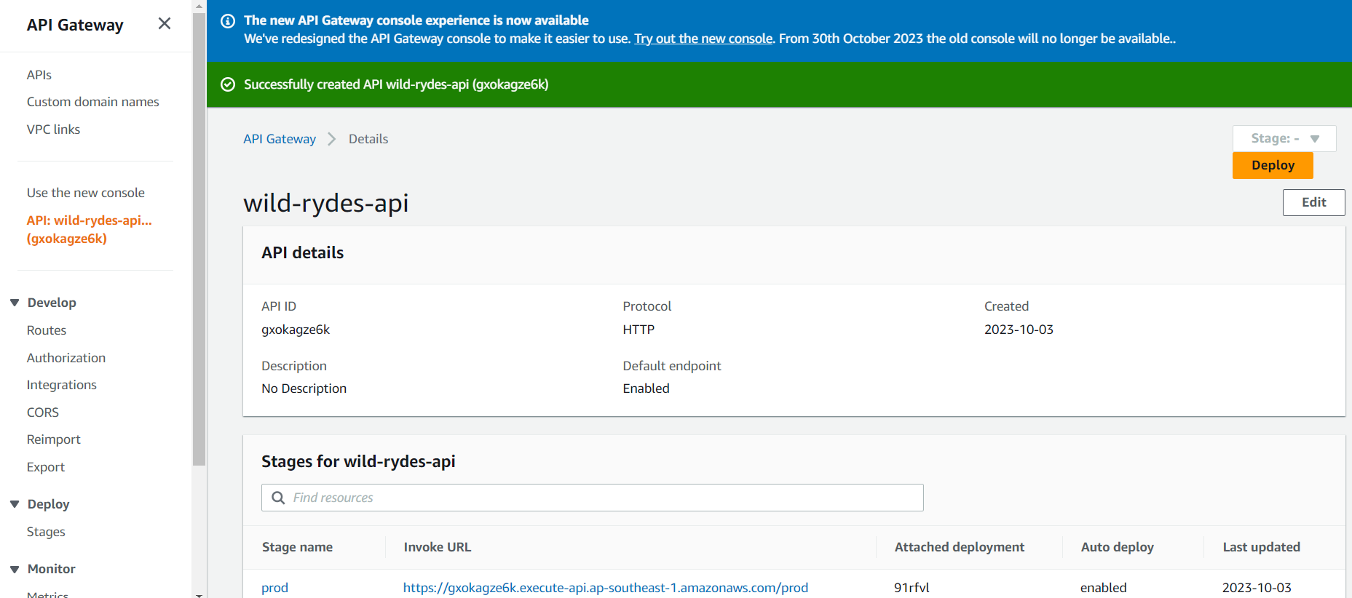

* Configuring the CORS settings to test the API endpoints

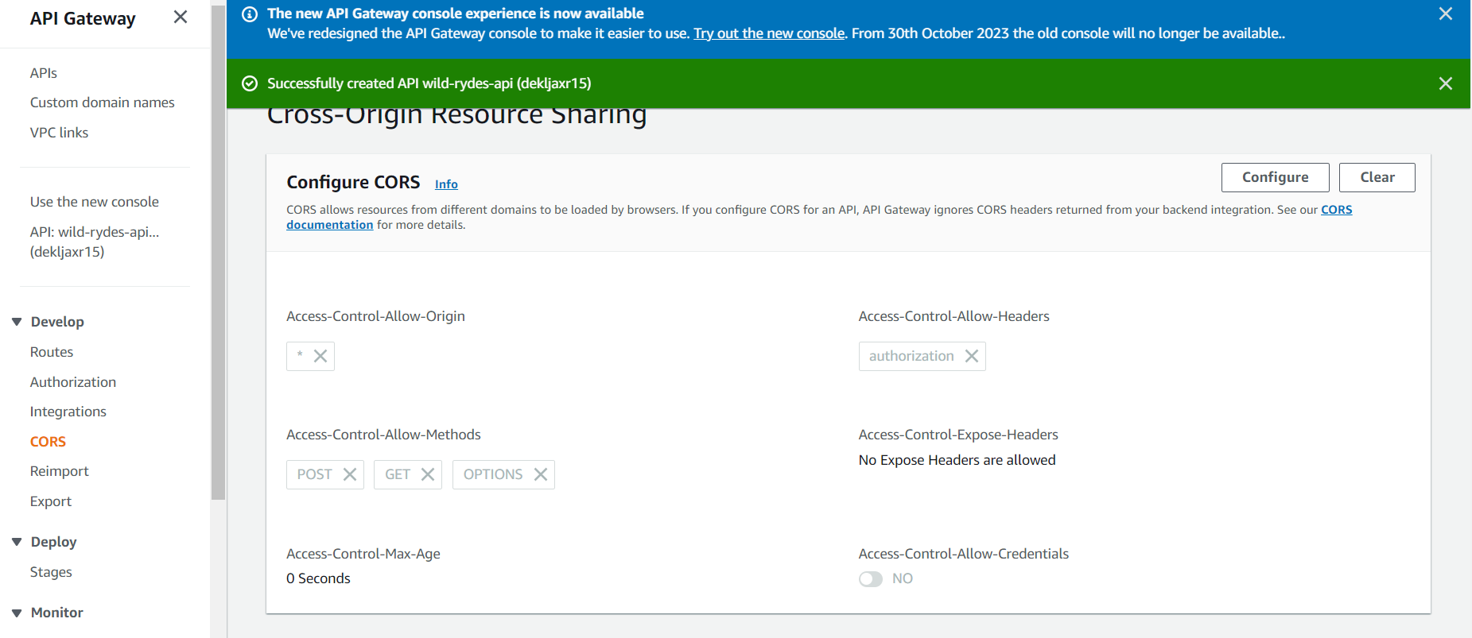

* Testing the health lamda function using the API

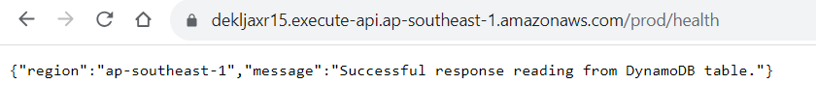

* Testing the ticket lambda functions using the API

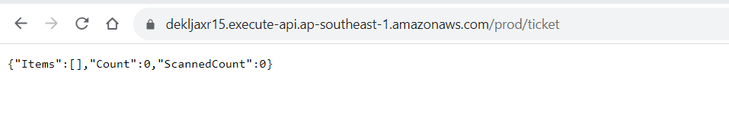**Step 3:** Build a UI layer

Building the UI layer to expose this functionality to the users by deploying in the primary region i.e., US East (N. Virginia)

* Creating user pool on Amazon Cognito

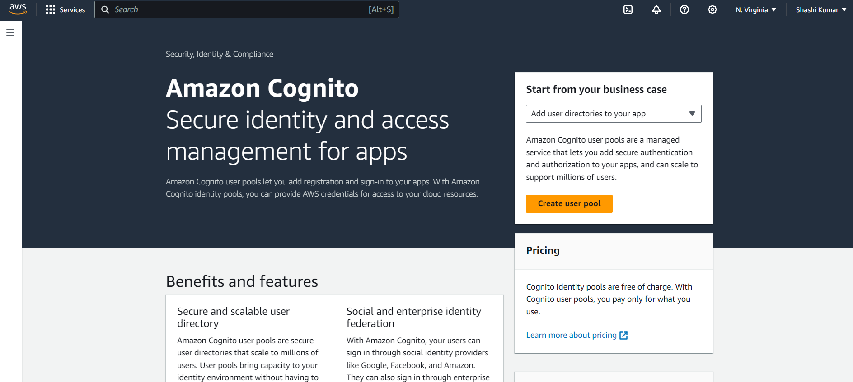

* In Cloud9, navigate to the 2_UI folder



* Using Cloudformation deploy CLI command to deploy the template using Cloud9

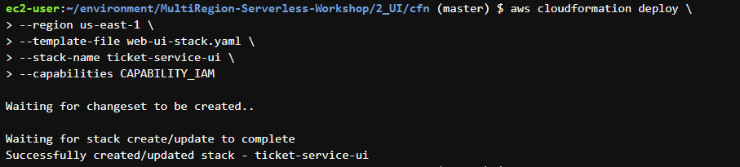

* Successfully created the resources (website bucket and Cognito Identity pool) from template: web-ui-stack.yaml

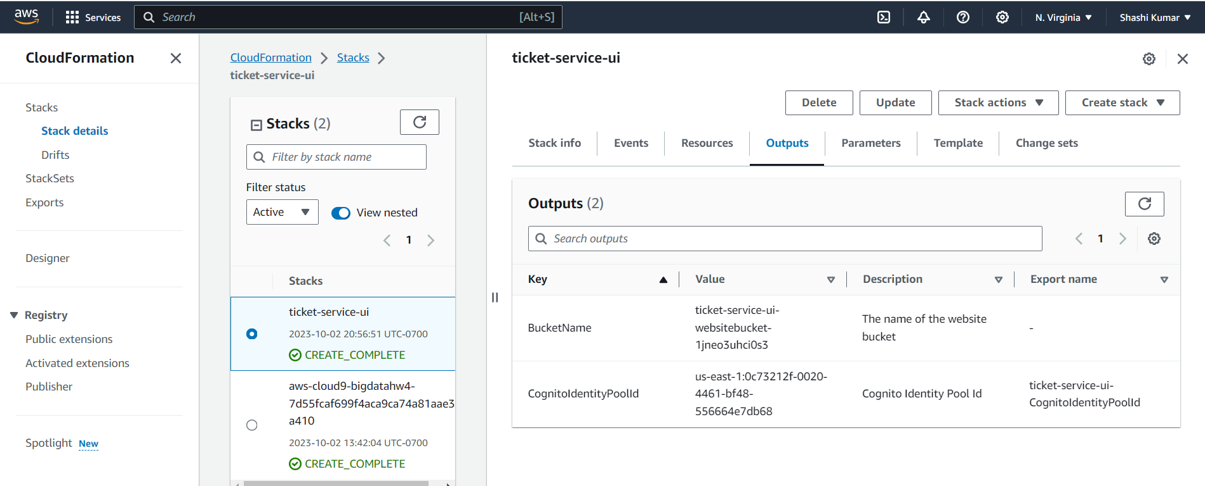

* Successfully created Cognito identity pool

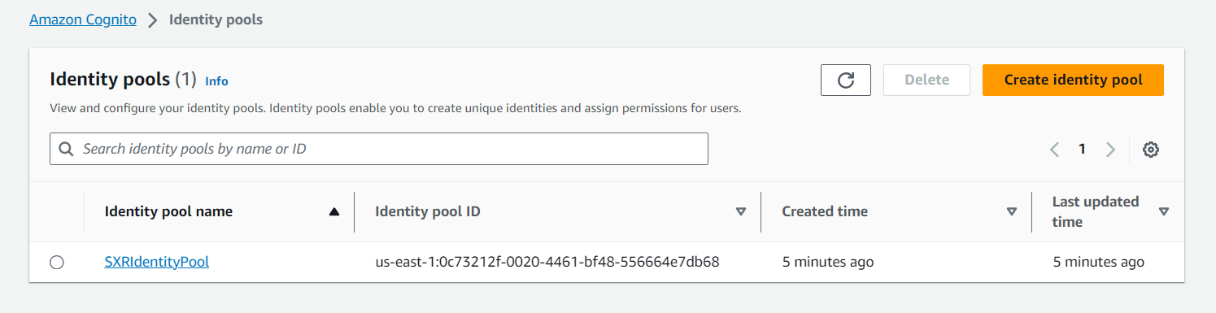

* creating a Cloudfront distribution for the S3 bucket that we created above

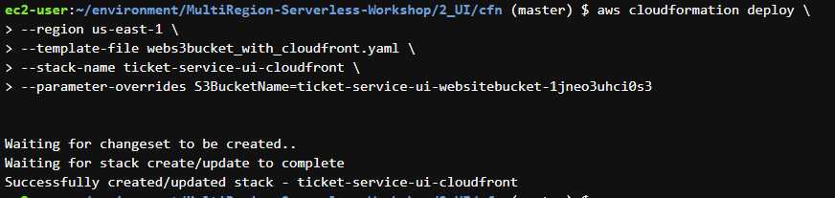

* Successfully created the cloudfront distribution for S3 bucket

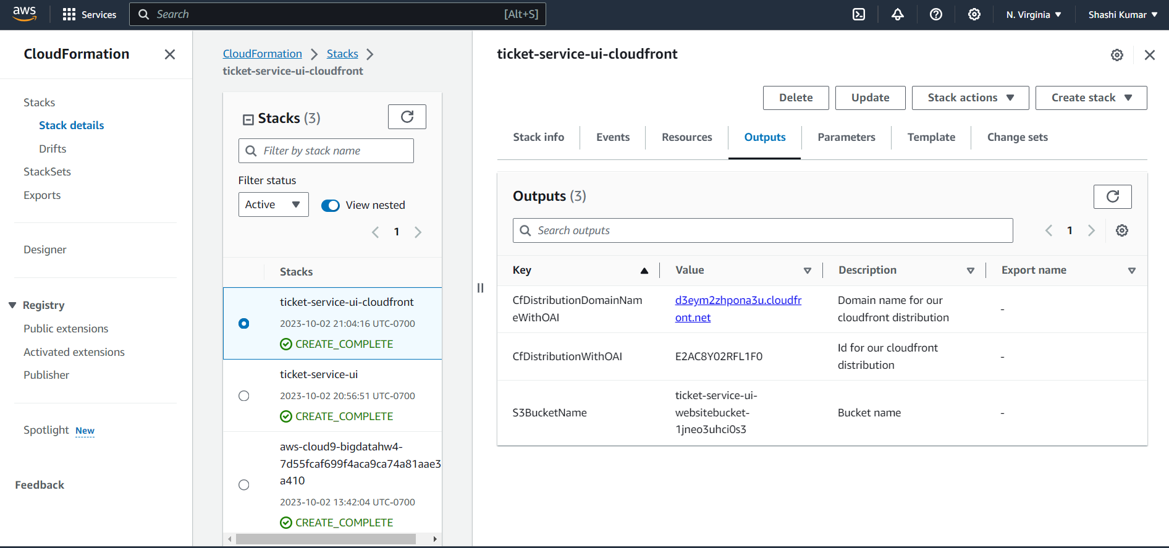

* Creating facebook developer account

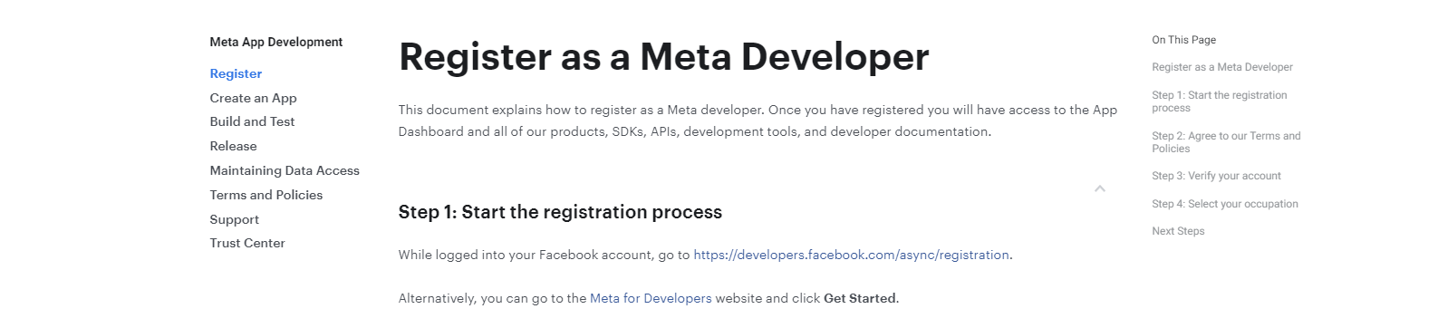

* Successfully created Facebook developer account to create apps

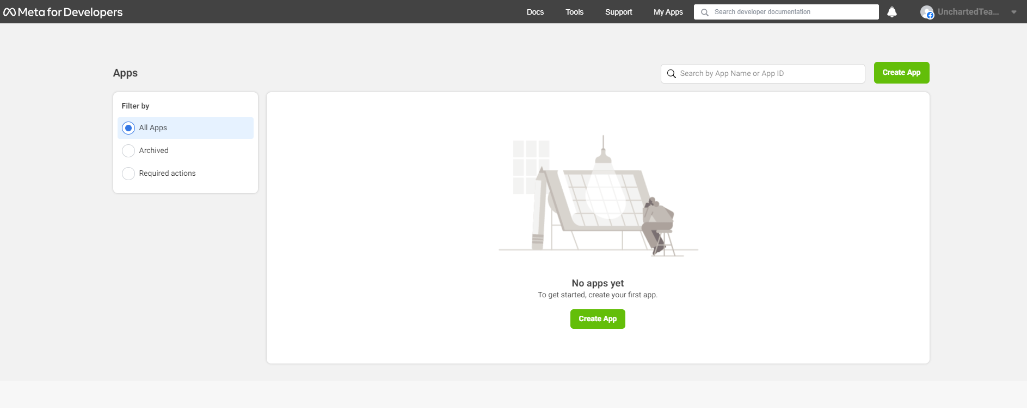

* Choosing the option to let people login to the app using thor facebook account

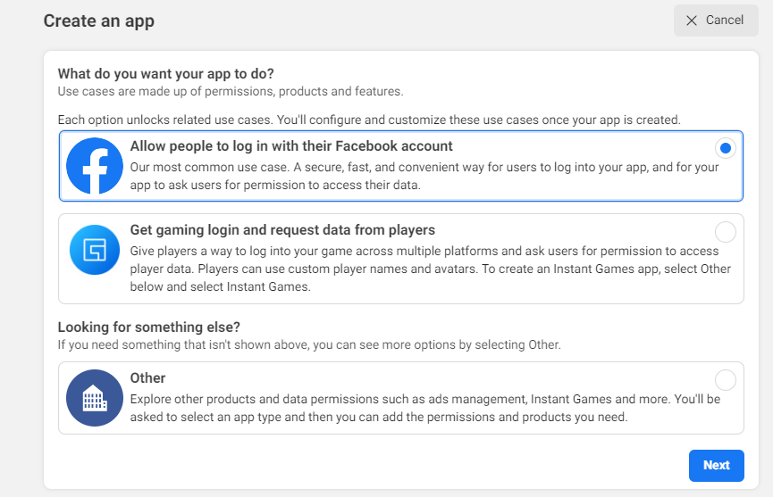

* Creating the Facebook developer app called UnchartedApp

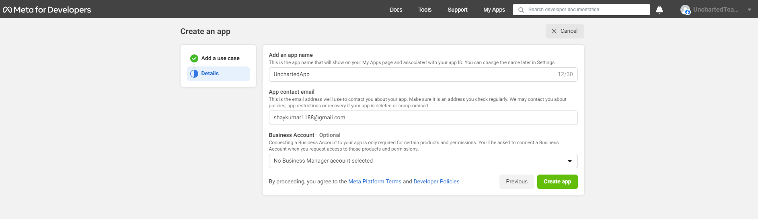

* Configuring details like app name, and app contact email

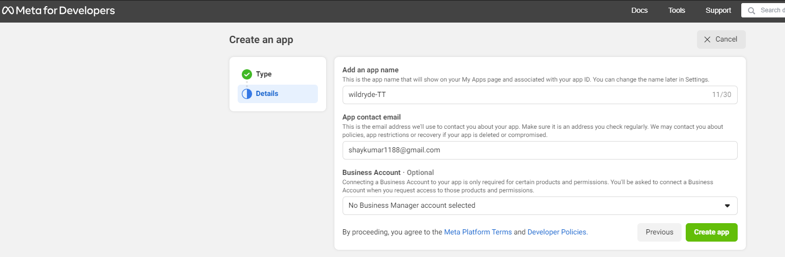

* Successfully created the app using facebook developer account

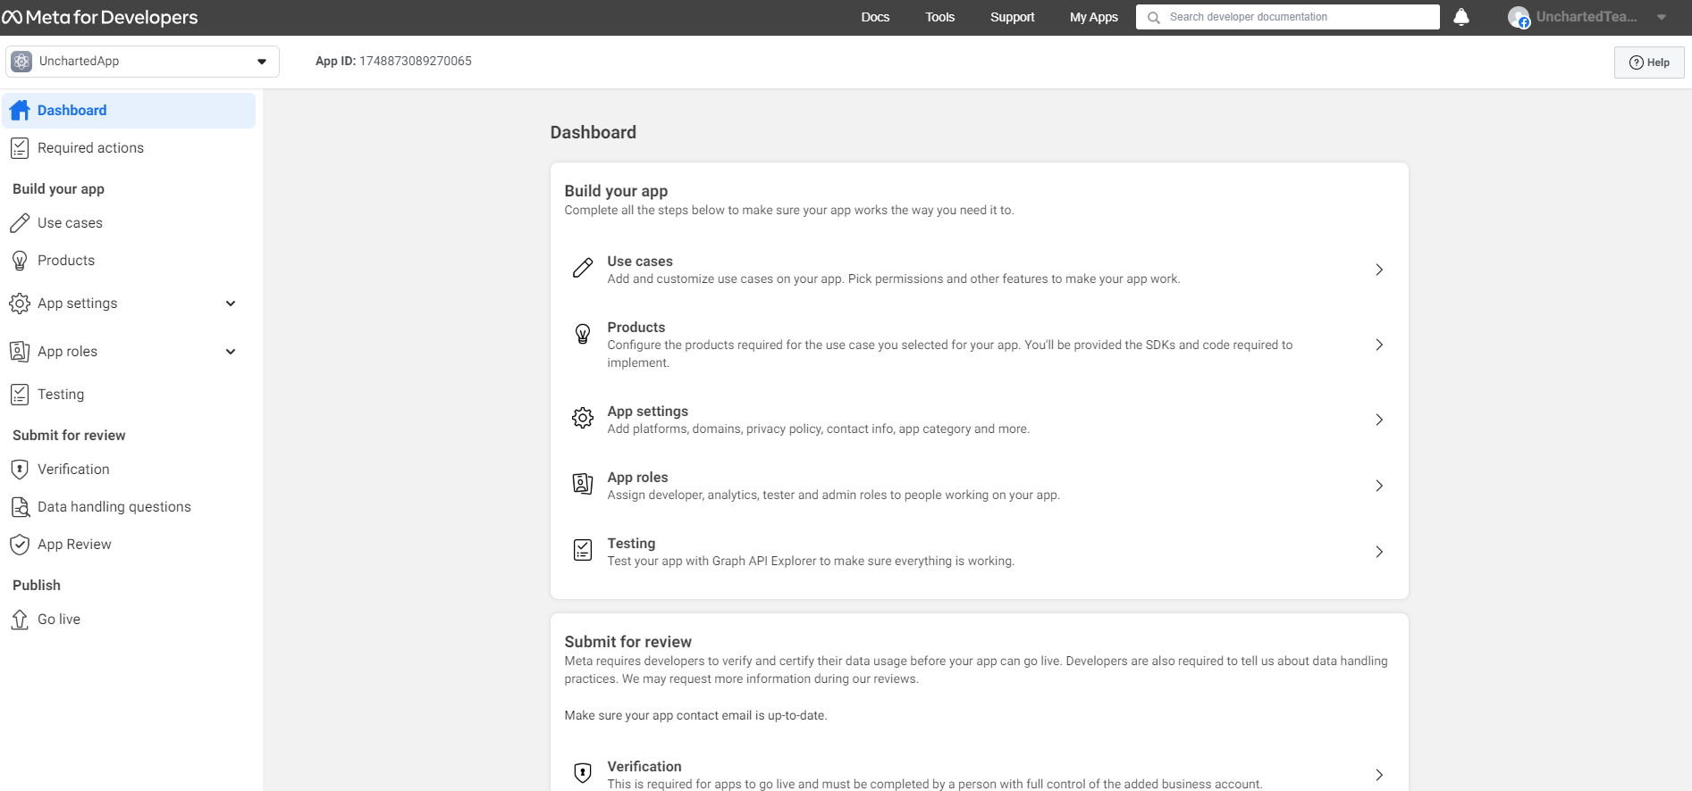

* Selecting App settings->Basic to see the app details

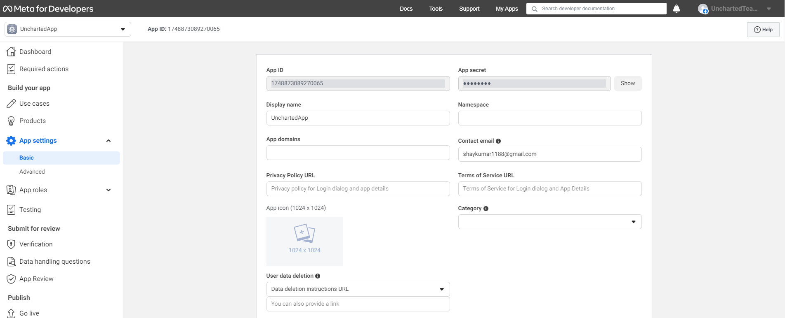

* Adding the new platform in the basic section and choosing website as the platform

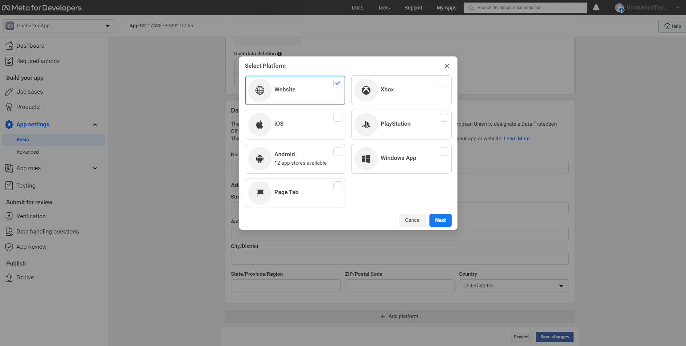

* Getting the Cloudfront URL from CloudFront portal

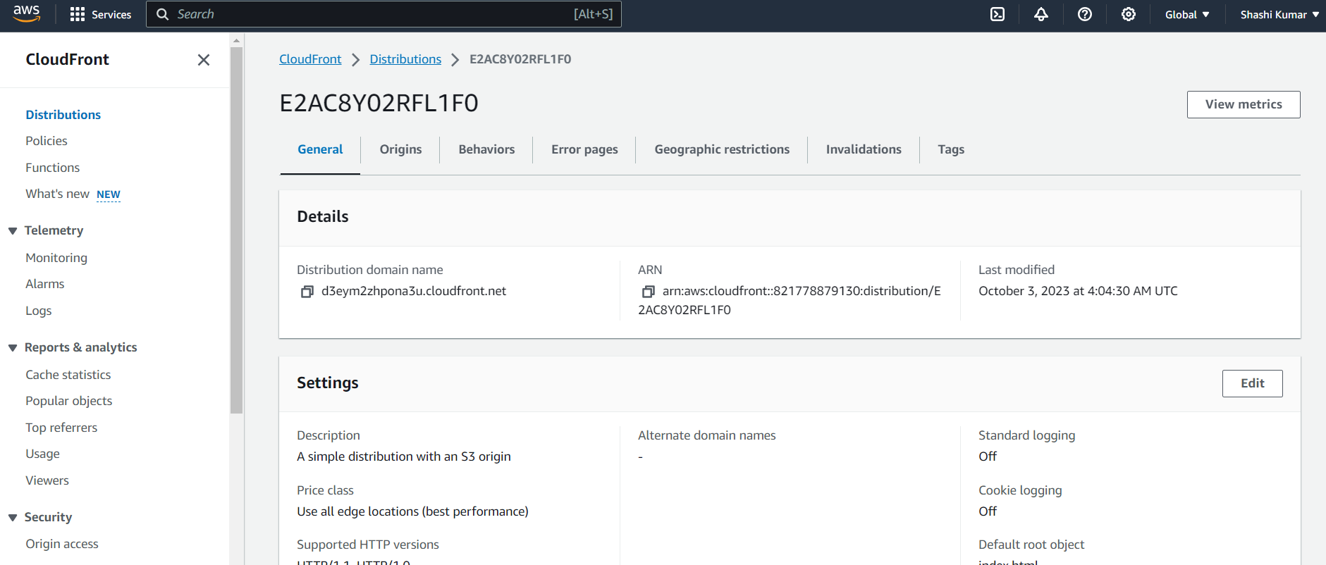

* Adding the above URL to the facebook app

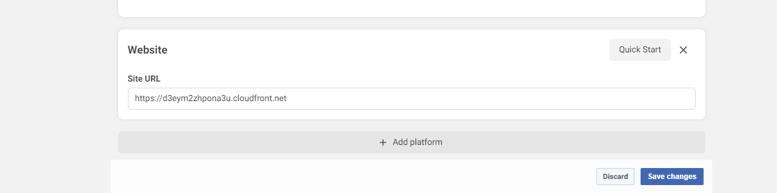

* Configuring the Cognos identity pool by adding an identity provider (Cognos->User access)

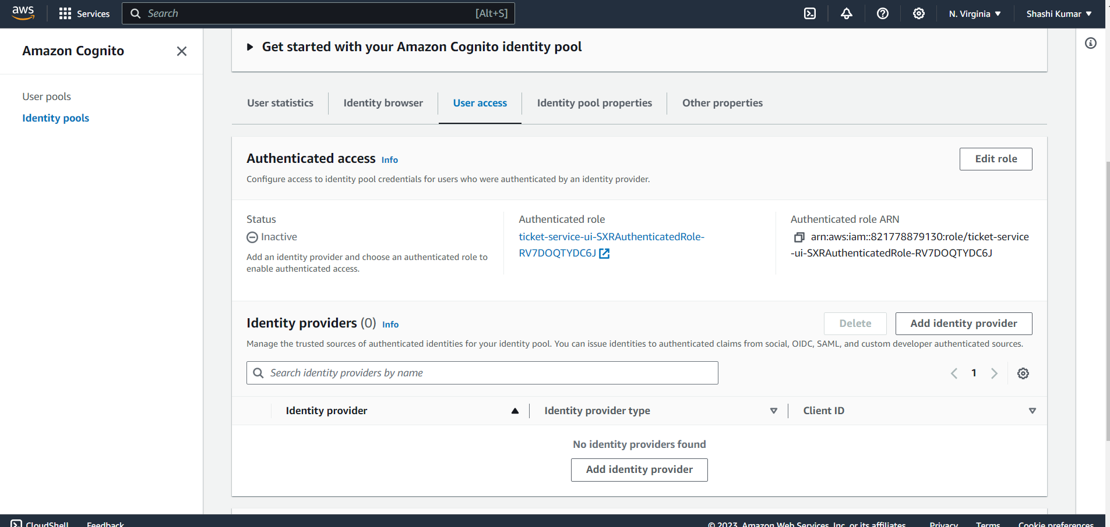

* Adding the identity provider as Facebook

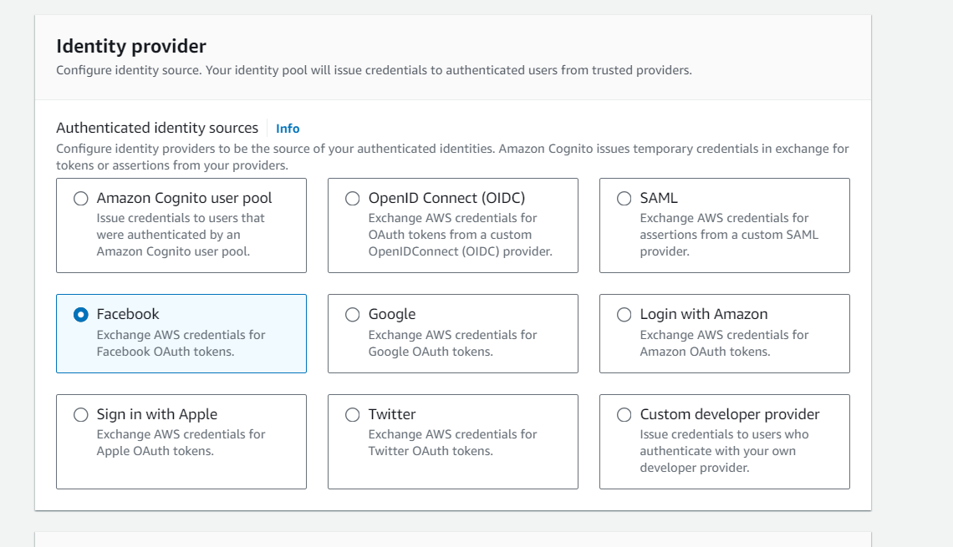

* Set up Facebook federation with the created identity pool

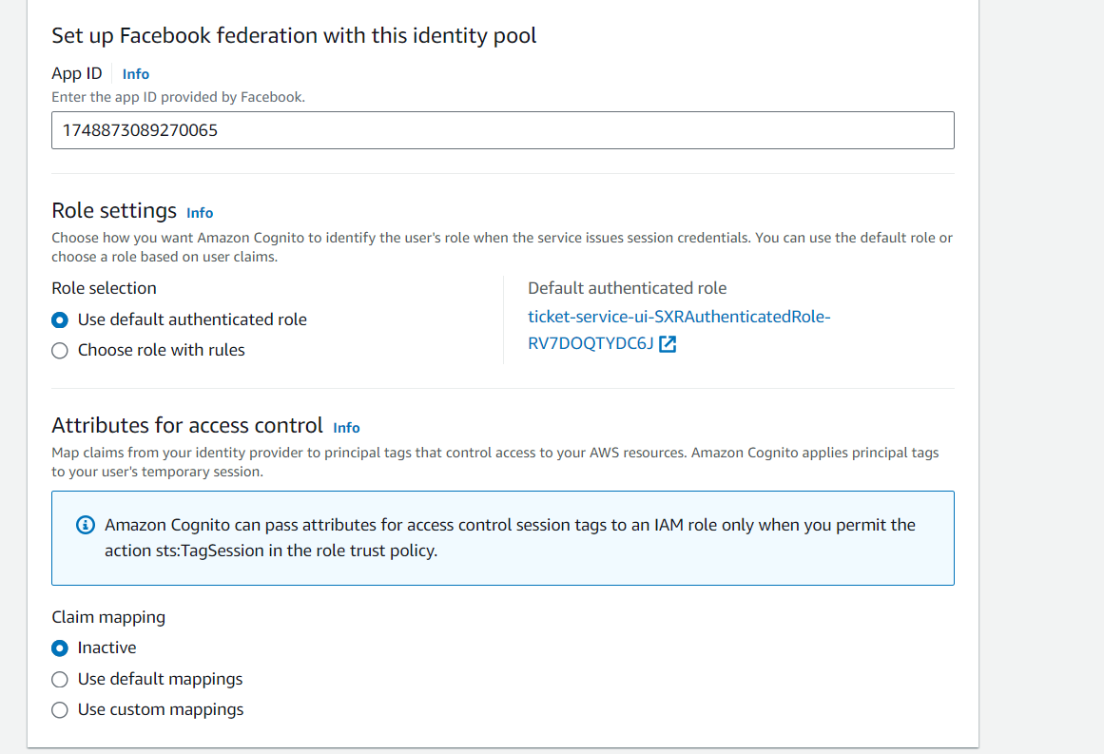

* Successfully added facebook as identity provider

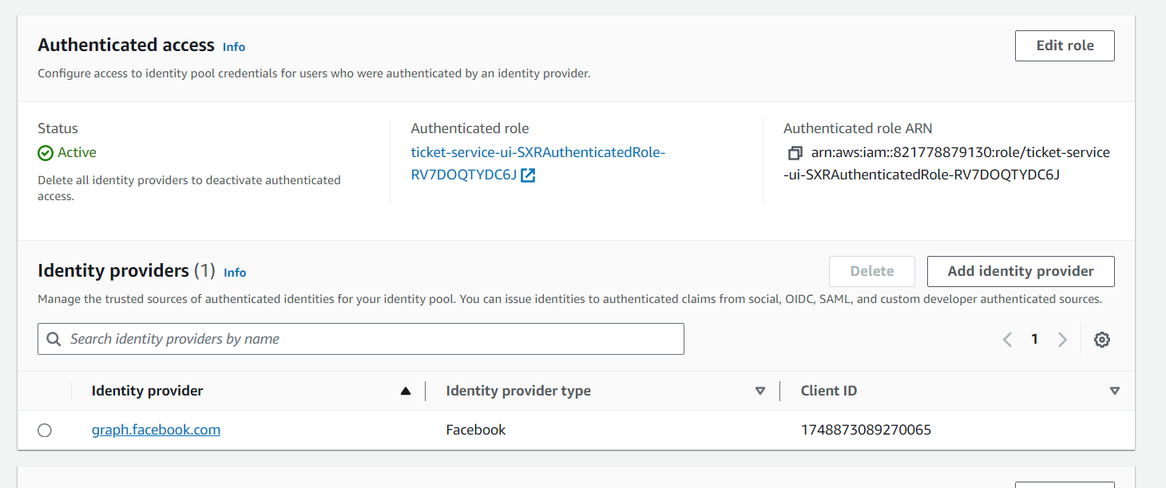

* Adding the region, cognitoIdentityPoolId,facebookAppId, and ticketAPI URL to the environment.ts file under 2_UI/src/environments folder

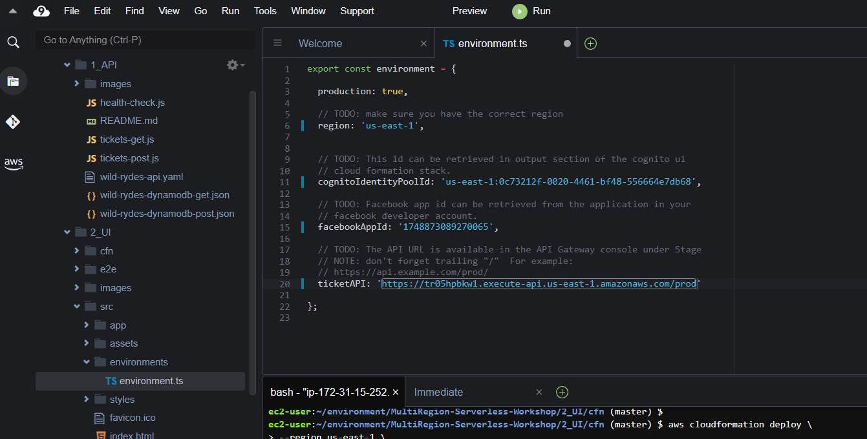

* Building Angular project by making 2_UI as the current directory and running npm install command to install npm package and then run npm run build command



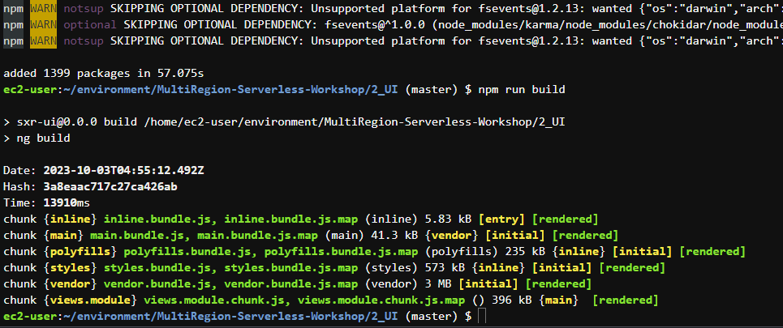

* Building the above project created dist/ folder with all the components of the compiled application

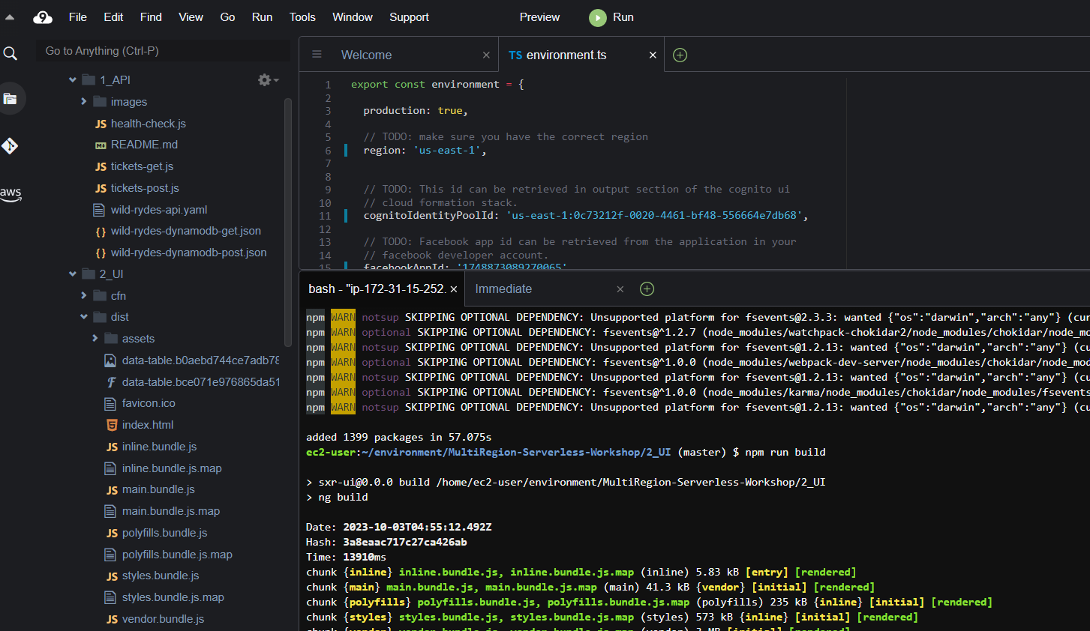

* Uploading the UI components to the S3 bucket

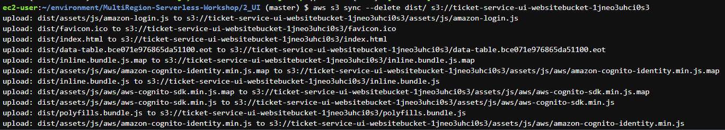

* Updating the App domain field and Privacy Policy URL in the Facebook app with the Cloudfront URL and choosing category as Education

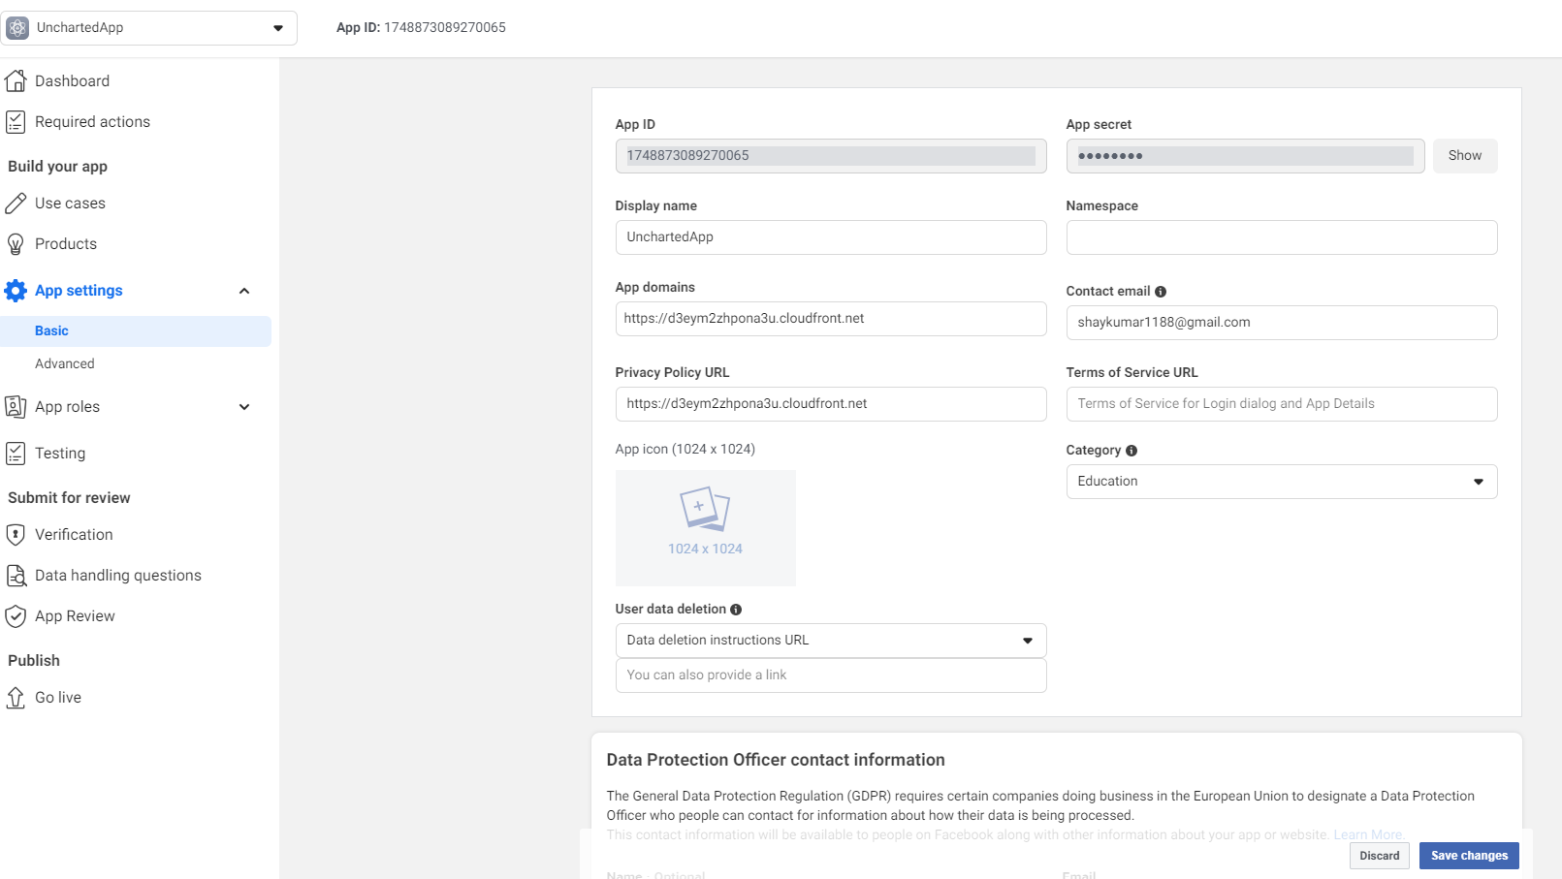

* Successfully deployed a UI for users on S3

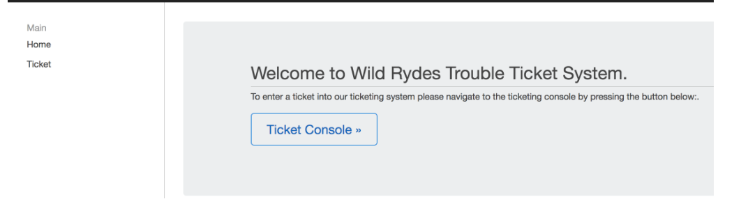

4. Replicate to a second region

* Creating Amazon Route 53 for handling fail-over

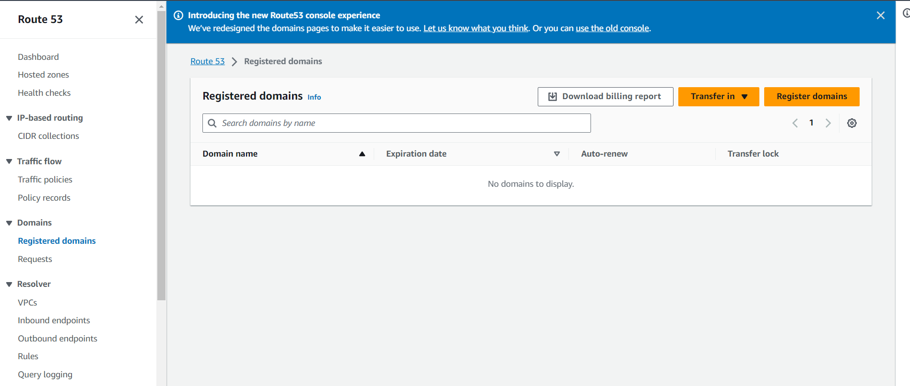

* Purchasing a domain name in Route53

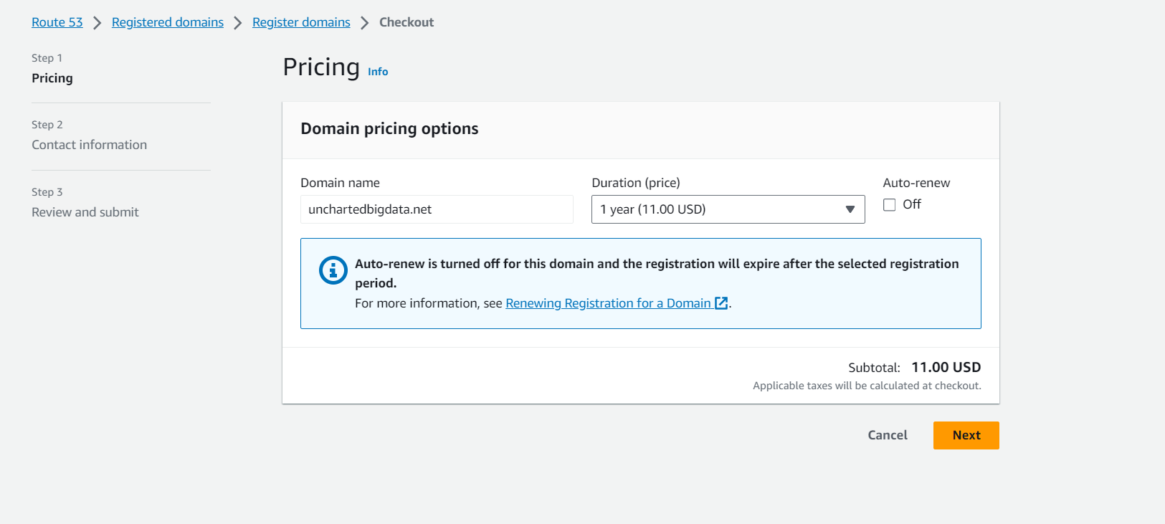

* Registering with contact information

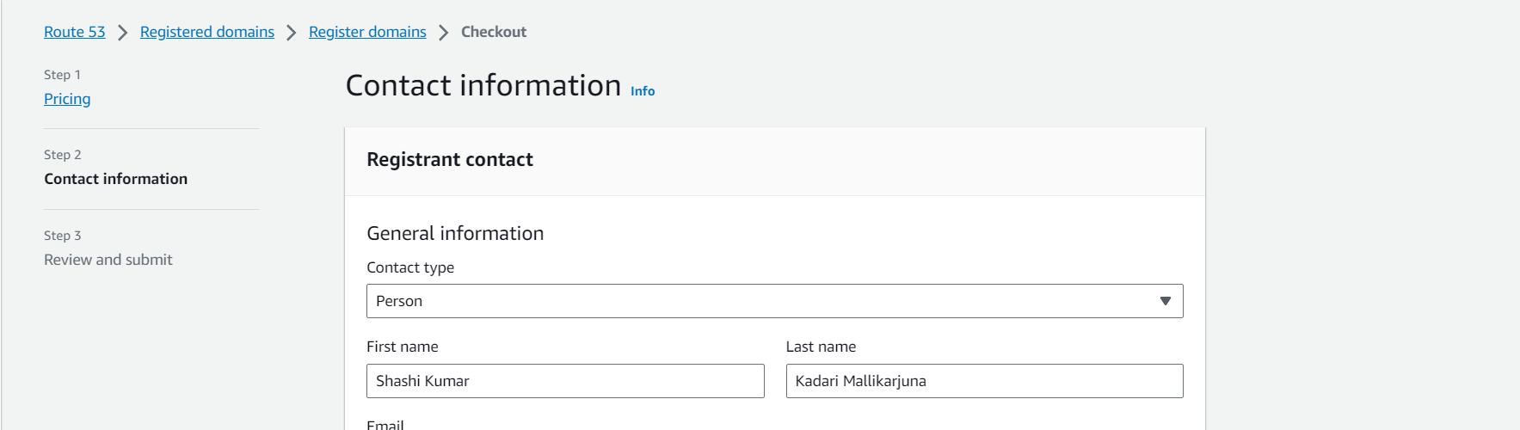

* Creating the new domain in Route53

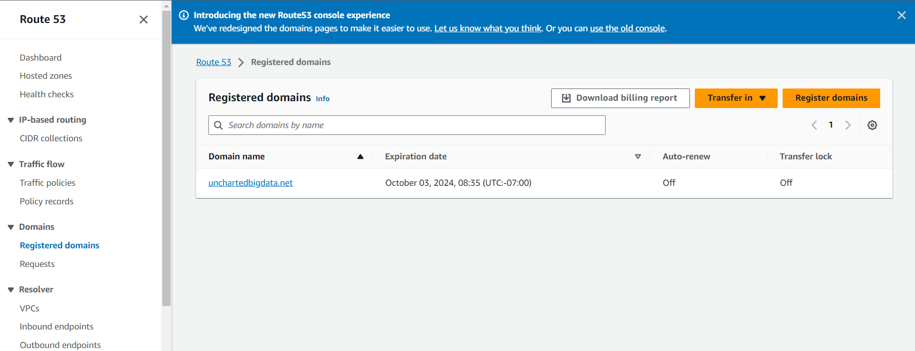

* Using AWS Certificate Manager for SSL certificate in order to configure our domain name with API Gateway

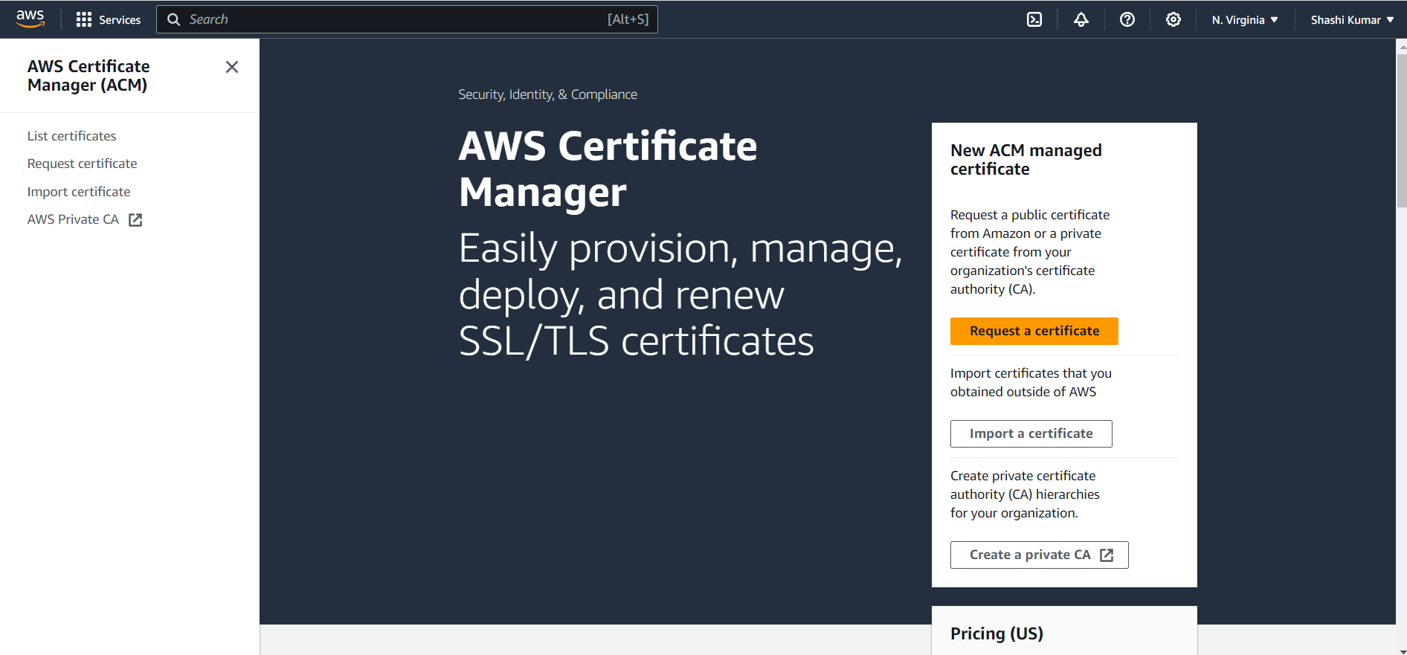

* Creating the SSL certificate for the domain

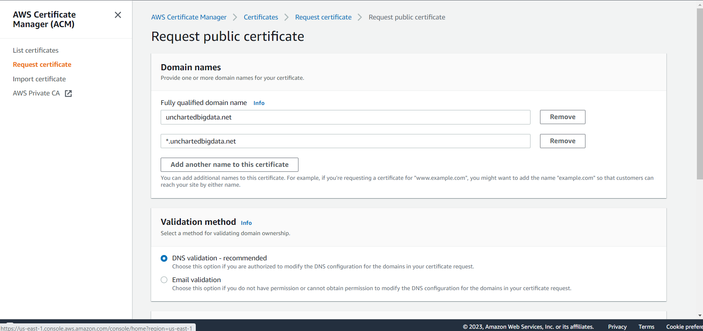

* Successfully created the certificate and creating records in Route 53

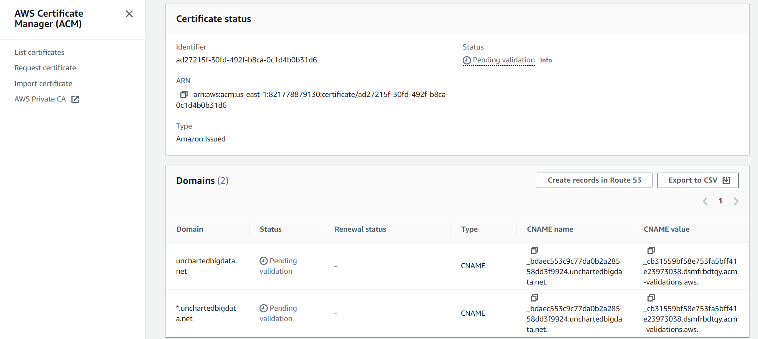

* Changing the TTL to 60 sec on Route 53 for this cmake value from the SSL certificate

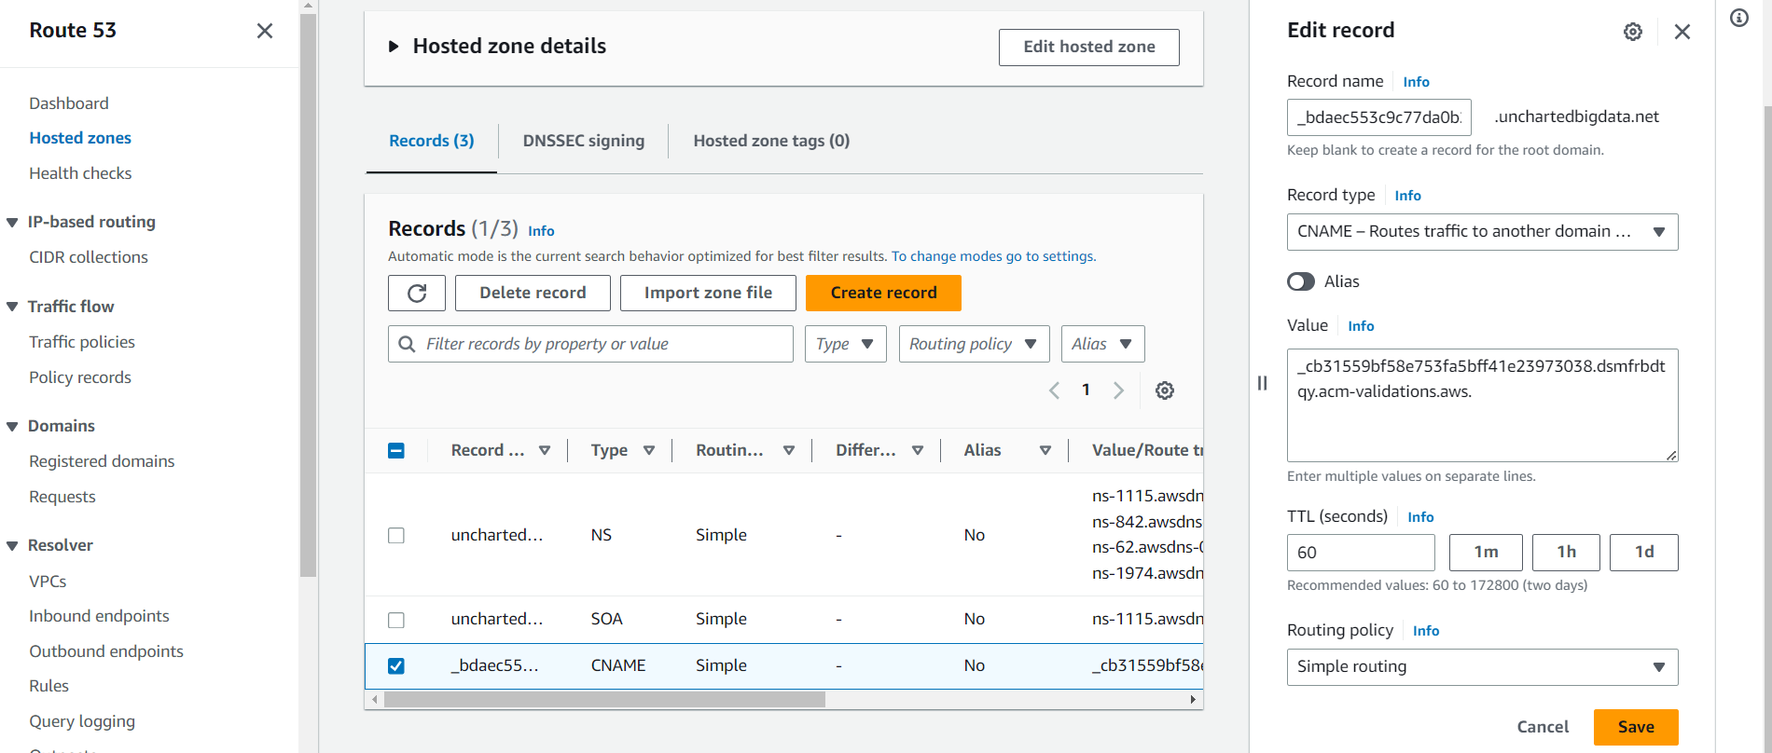

* Creating a new certificate in Singapore region

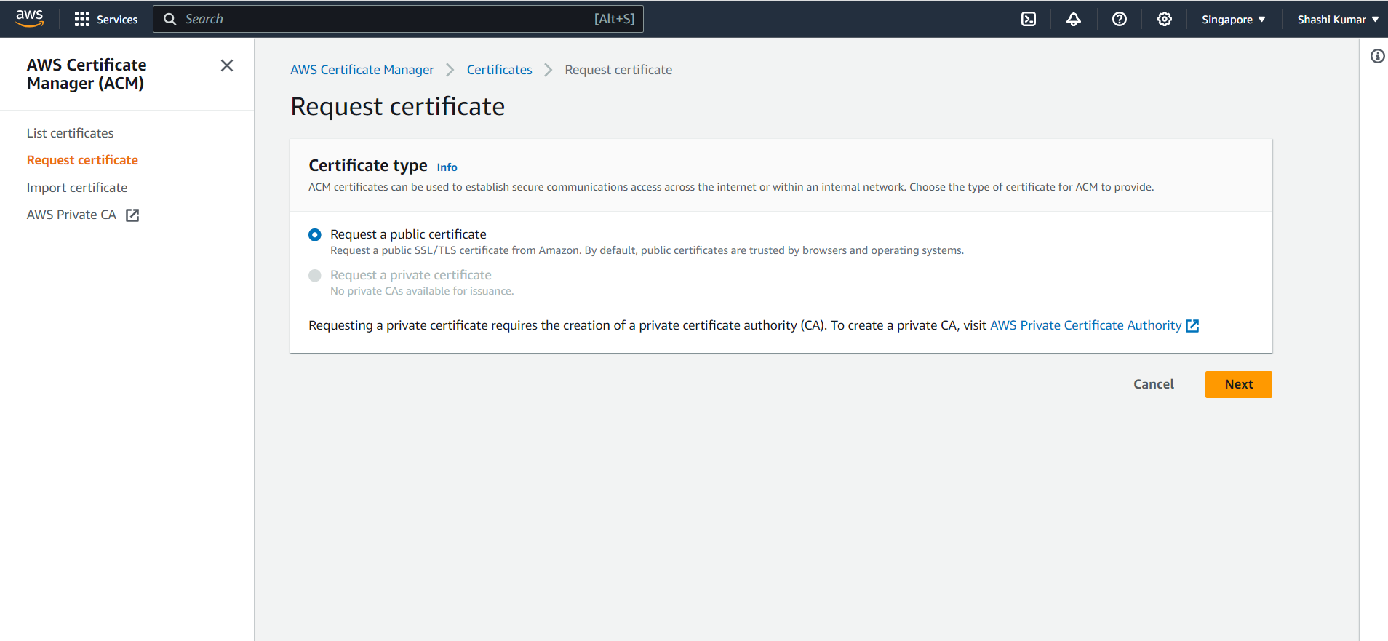

* Providing the domain name and choosing DNS validation for the SSL certificate creation

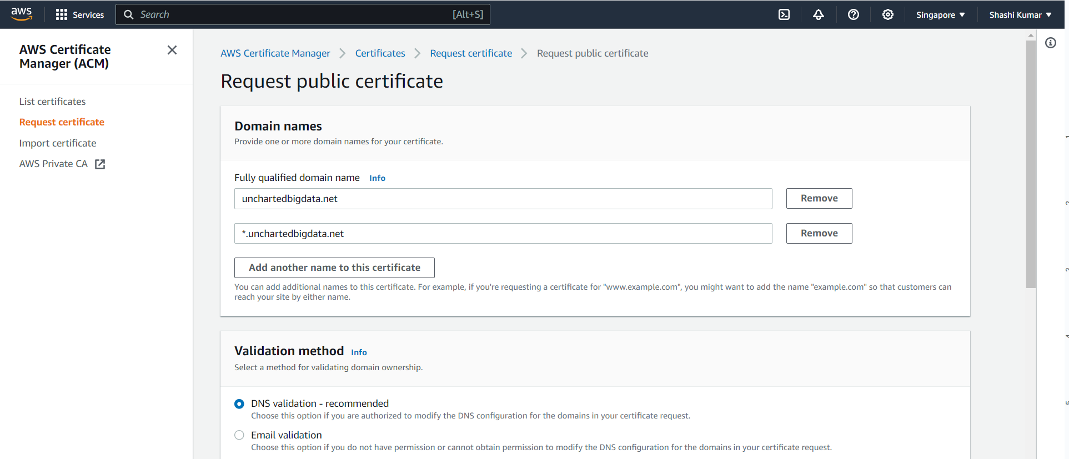

* Successfully created the SSL certificate in singapore region and adding it to Route 53

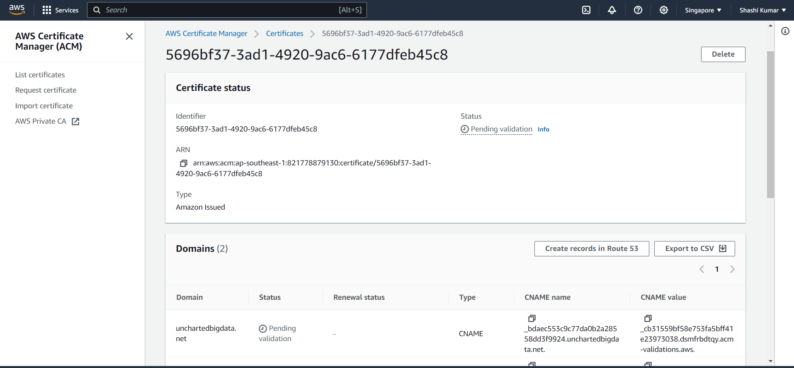

* Successfully added the certificate to Route 53 and the status is issued

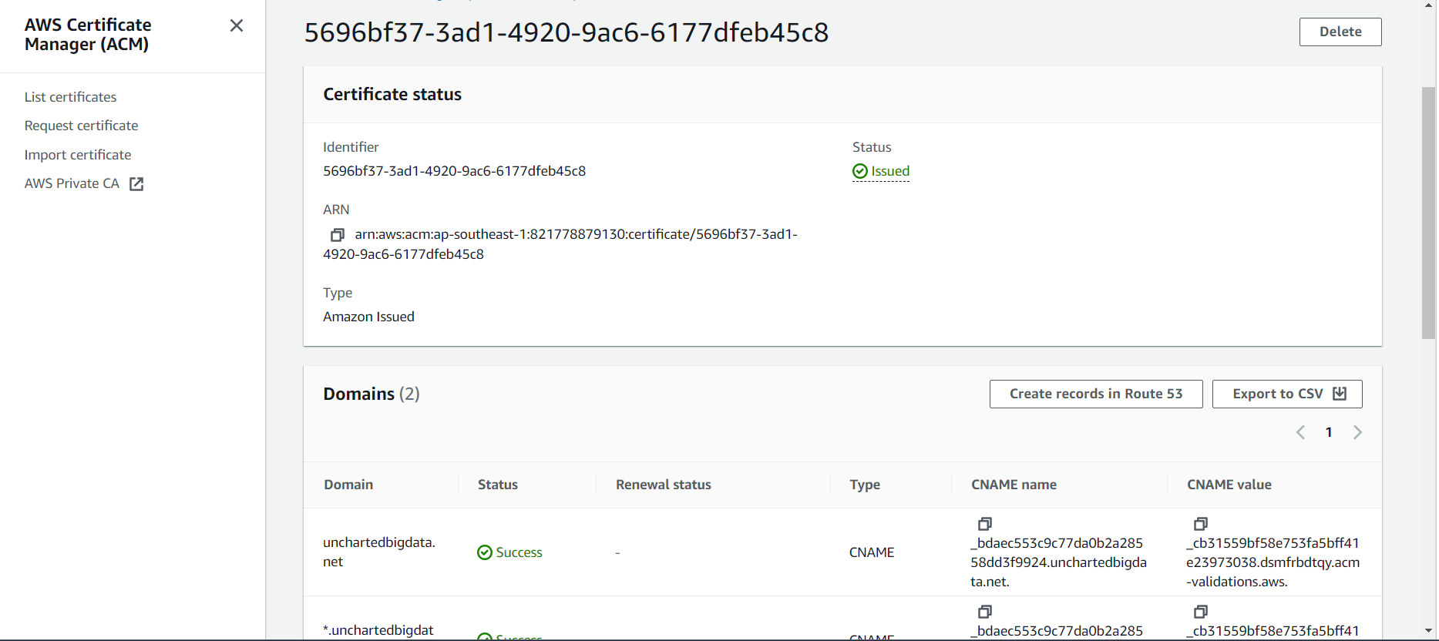

* Creating a custom domain name in AWS API Gateway in singapore region

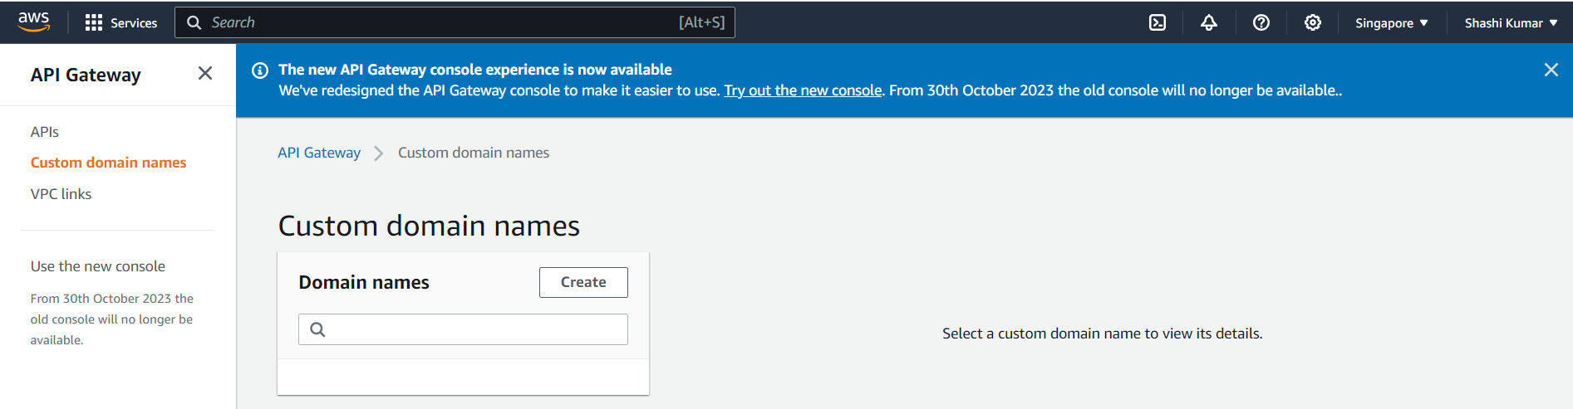

* Configuring the custom domain in singapore region with the SSL certificate and regional endpoint

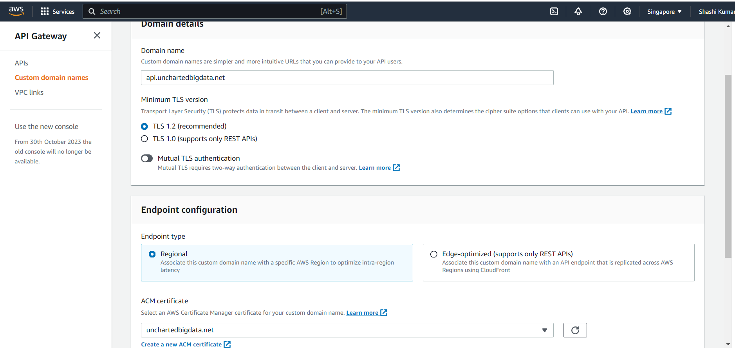

* Configuring the region specific custom domain in singapore region with the SSL certificate and regional endpoint

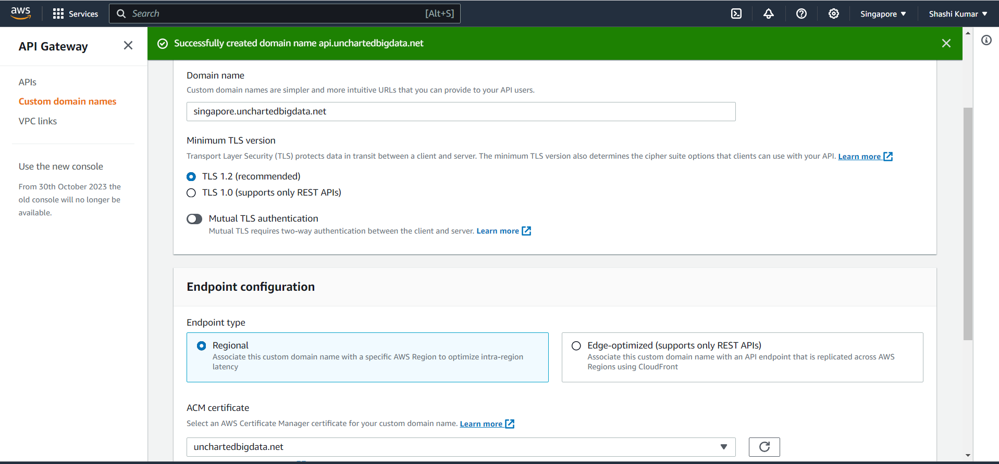

* Successfully created the custom domain names

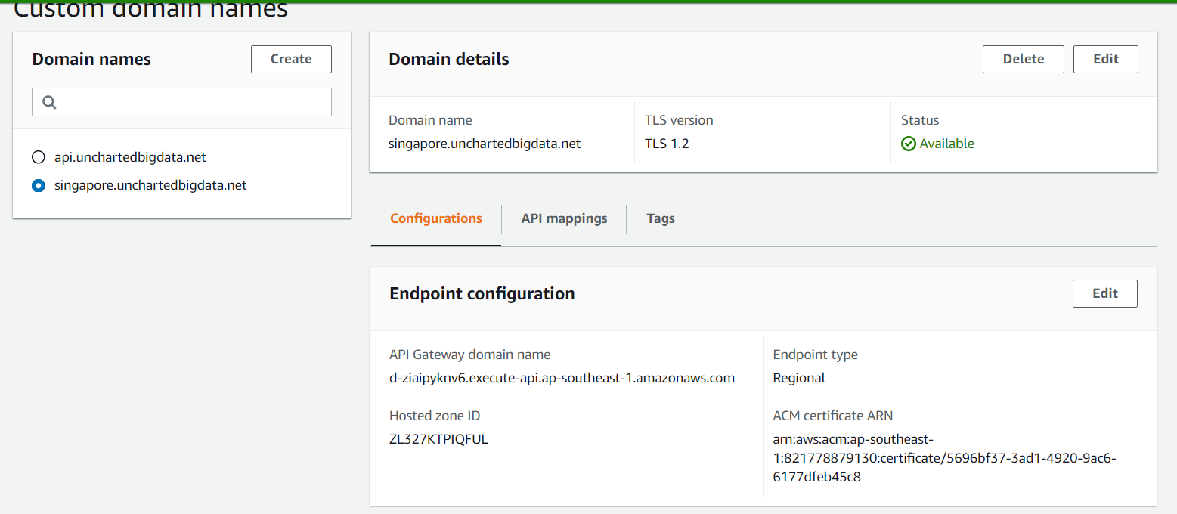

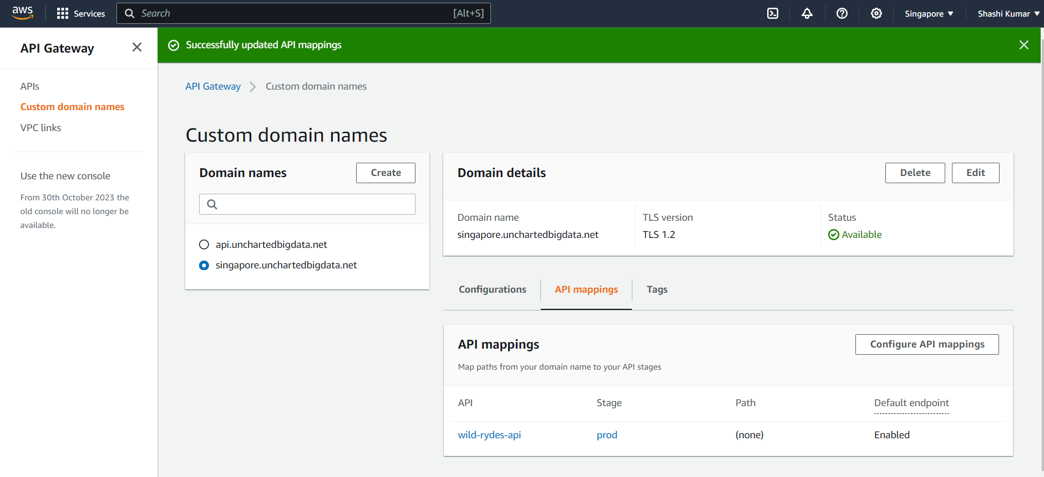

* Similarly created the 2 custom domain names in N. Virginia region

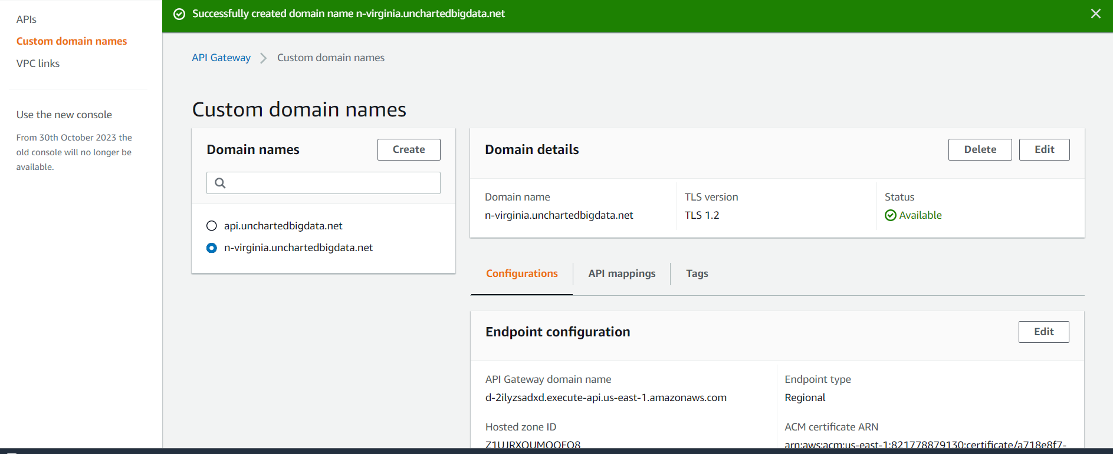

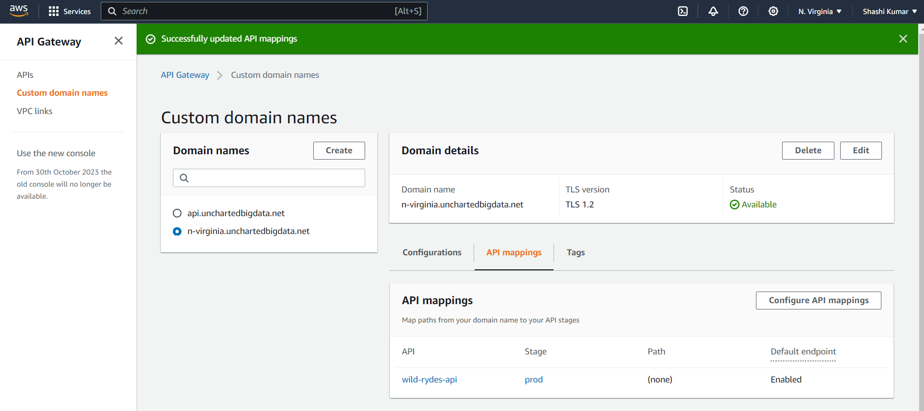

* In route 53, creating a new record under the hosted zones and our domain to link to the created custom domain in API gateway for n-virginia region

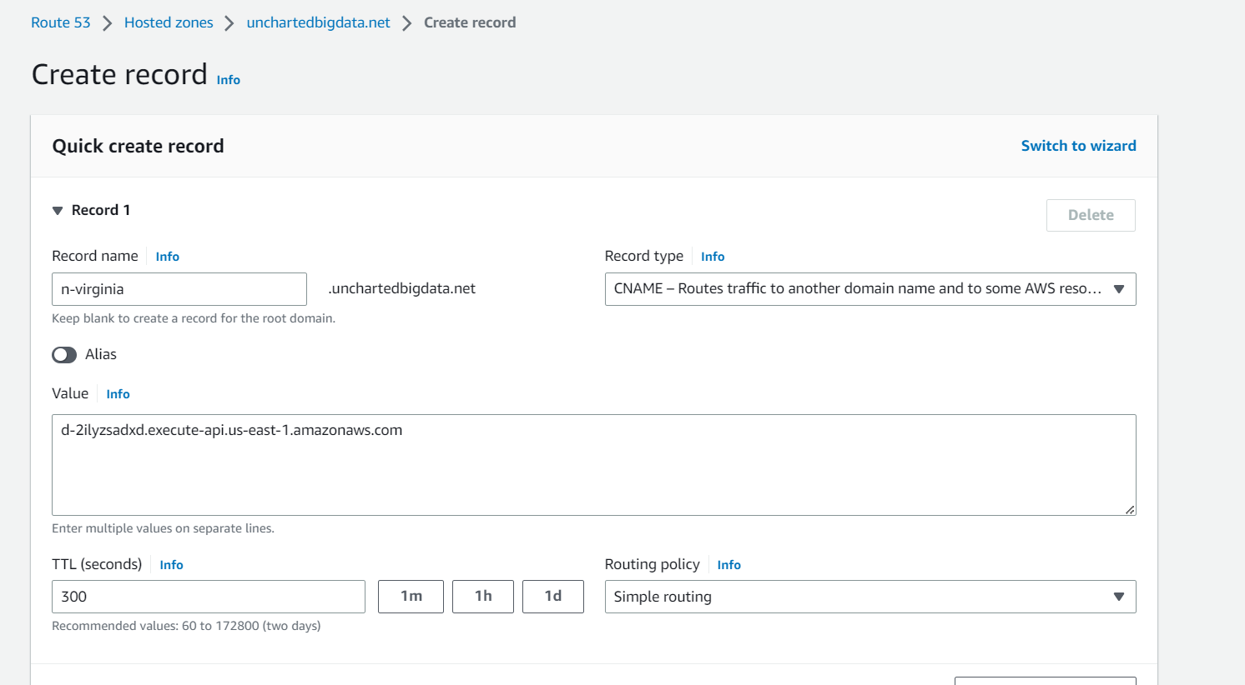

* In route 53, creating a new record under the hosted zones and our domain to link to the created custom domain in API gateway for singapore region

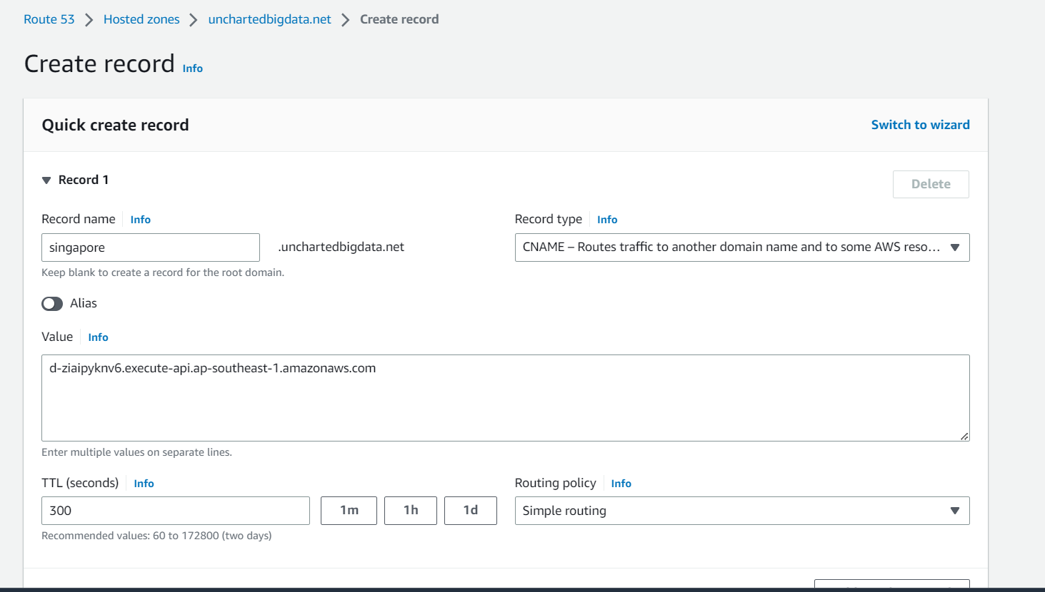

* Testing the url for singapore

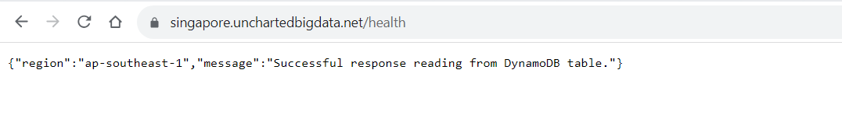

* Testing the url for n-virginia

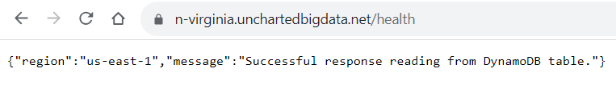

* Creating health check in route 53 to handle failovers

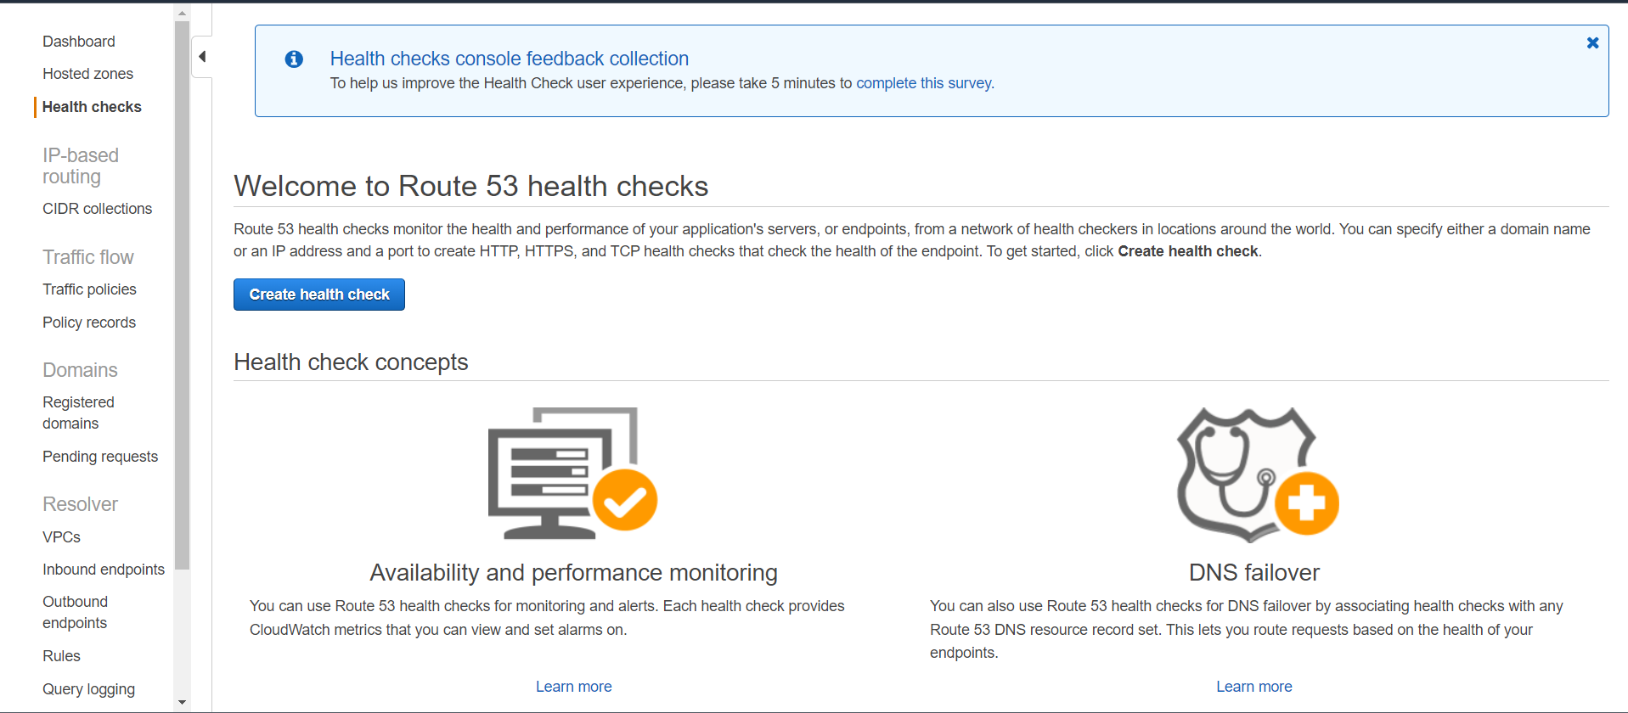

* Configuring the health check for n-virginia-api by providing the domain name with details and setting the request interval to fast and setting the failure threshold to 1

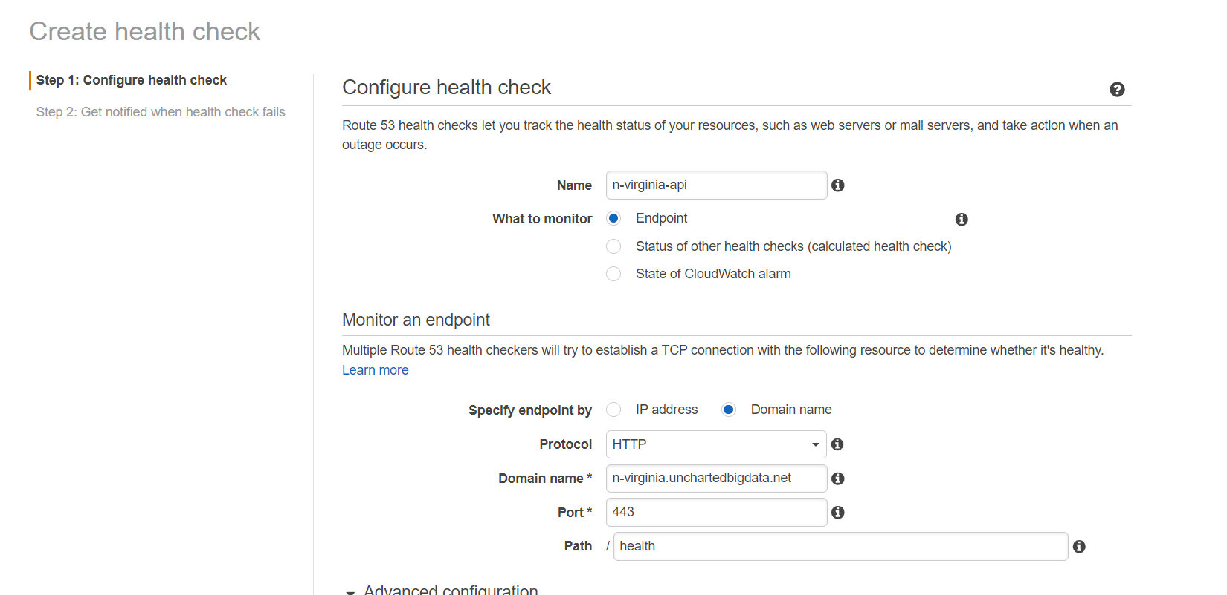

* Similarly, configuring the health check for singapore-api by providing the domain name with details and setting the request interval to fast and setting the failure threshold to 1

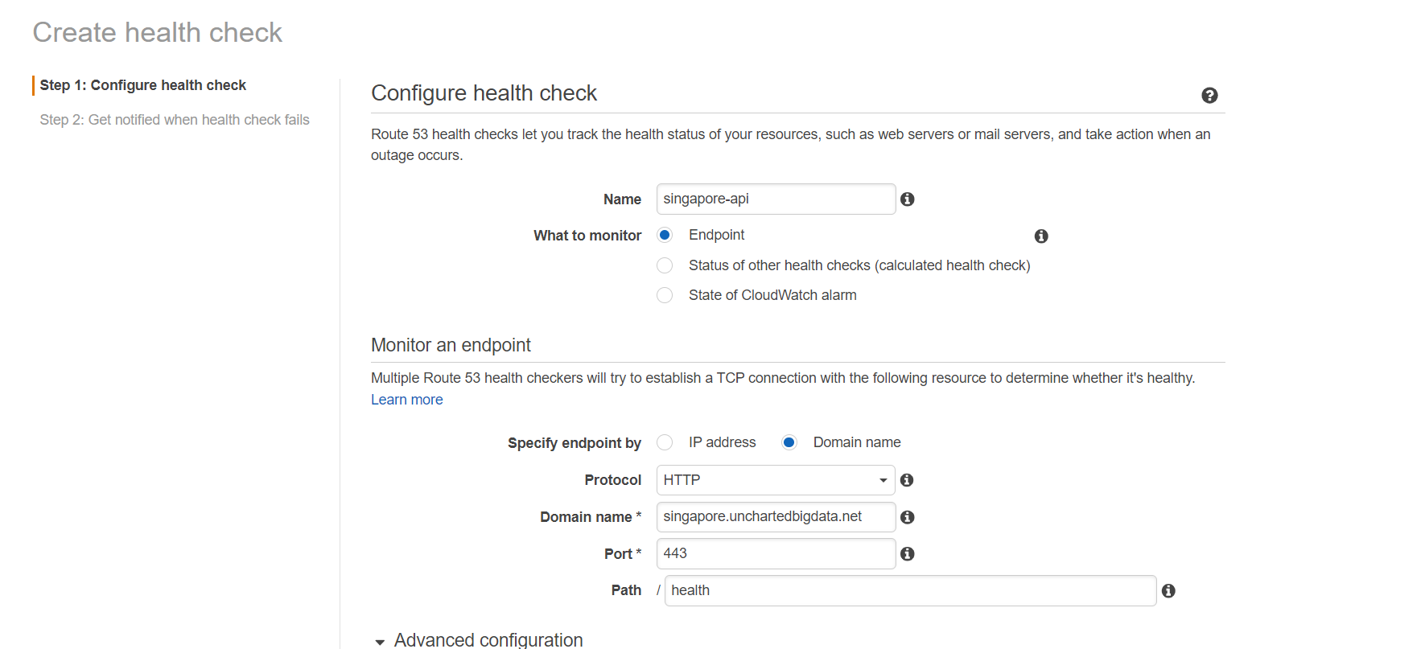

* N-virginia api is in a healthy state

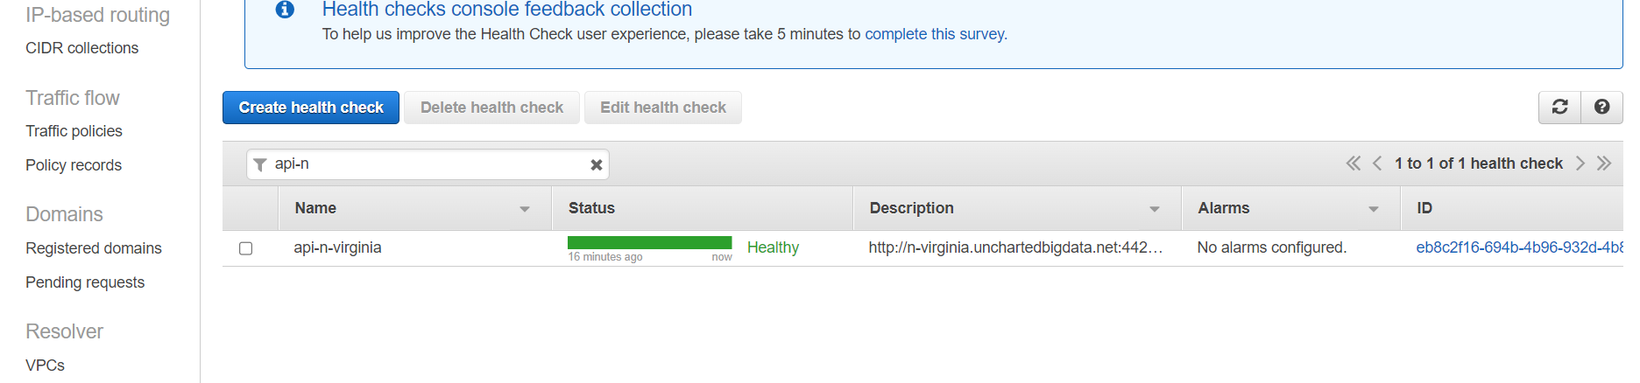

* Singapore api is in a healthy state

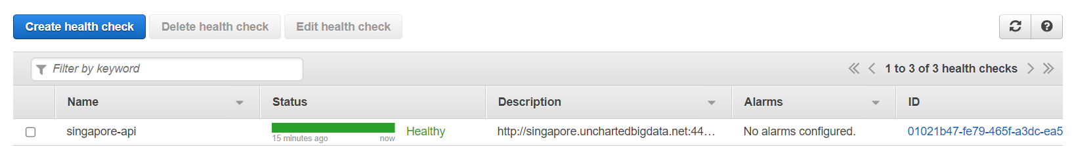

* Configuring a new weighted record in Route 53 for api.domain

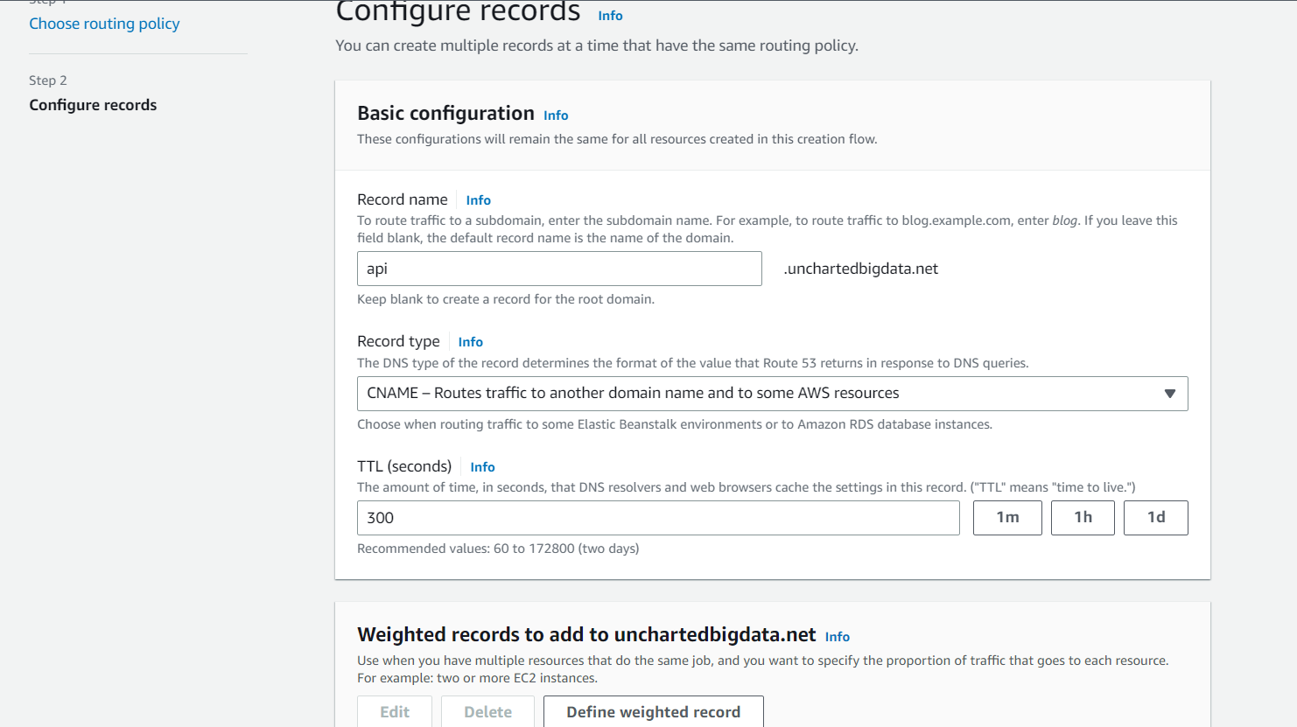

* Defining the weighted record in Route 53

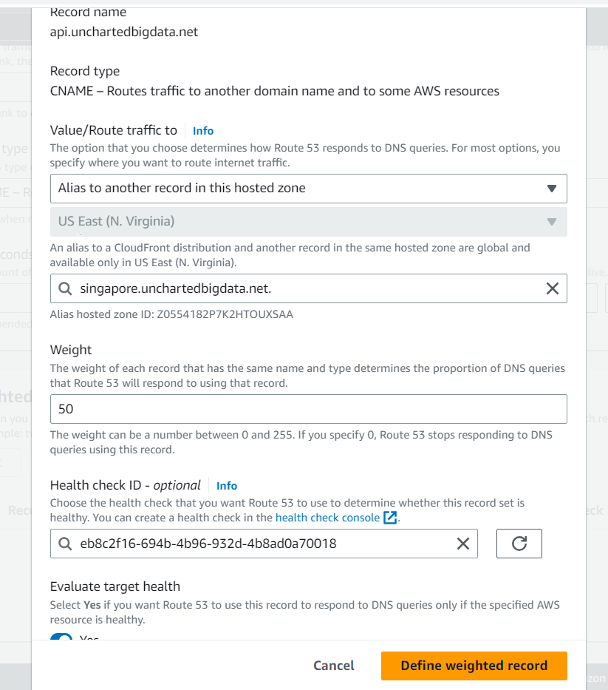

* Similarly creating the weighted record for singapore domain

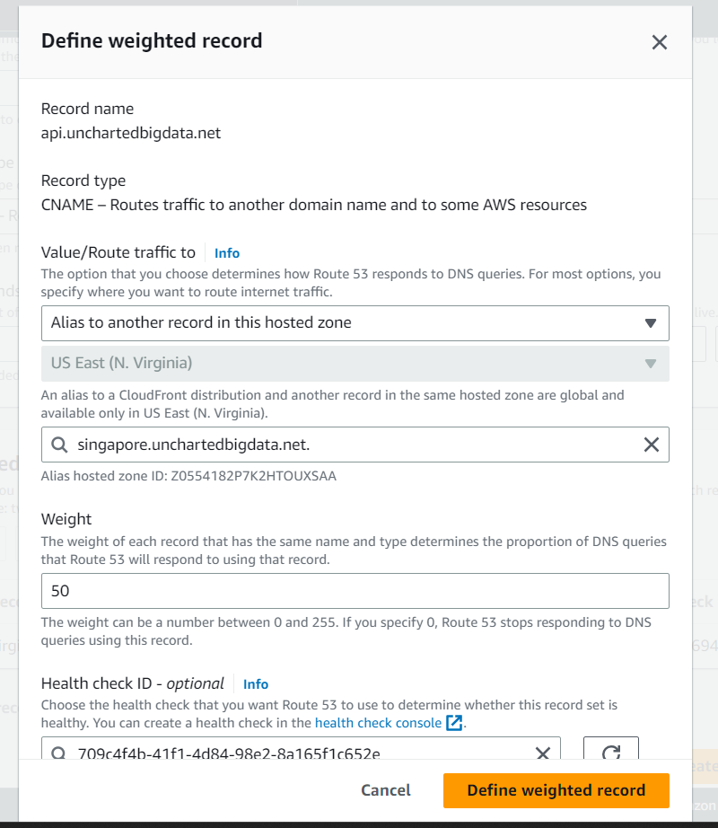

* The api successfully working

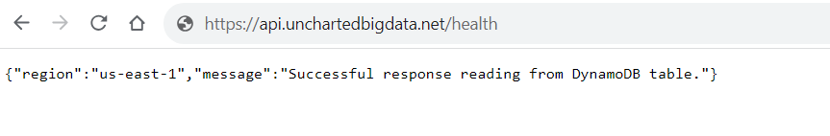

* Replacing the ticketAPI in the envoronments.ts file in 2_UI folder with the newly created domain

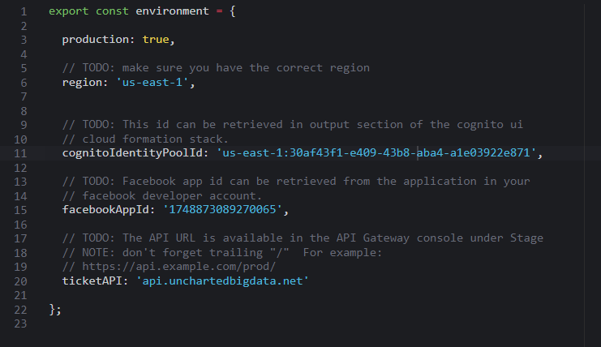

* Re-building the angular project on Cloud 9 since the above change was made

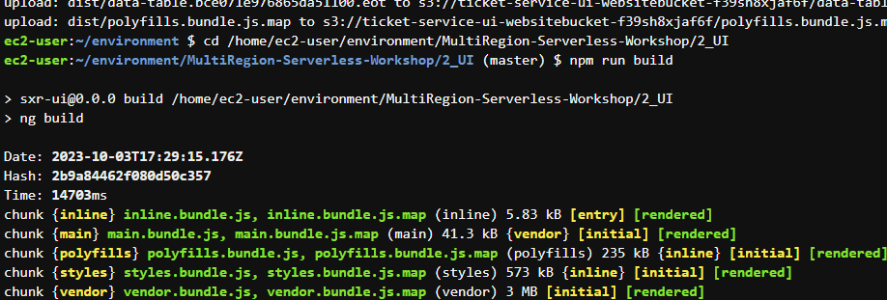

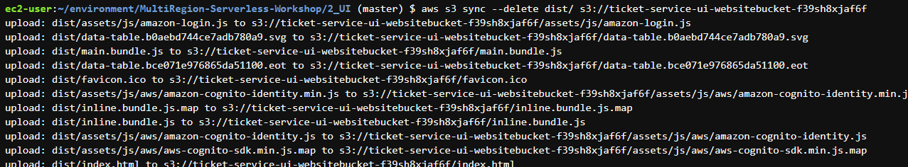

**Step 5**. Test failover

For Testing the failover, we need to purposefully break the primary region

* Replacing the health lambda function with the TicketPostFunction to break the flow

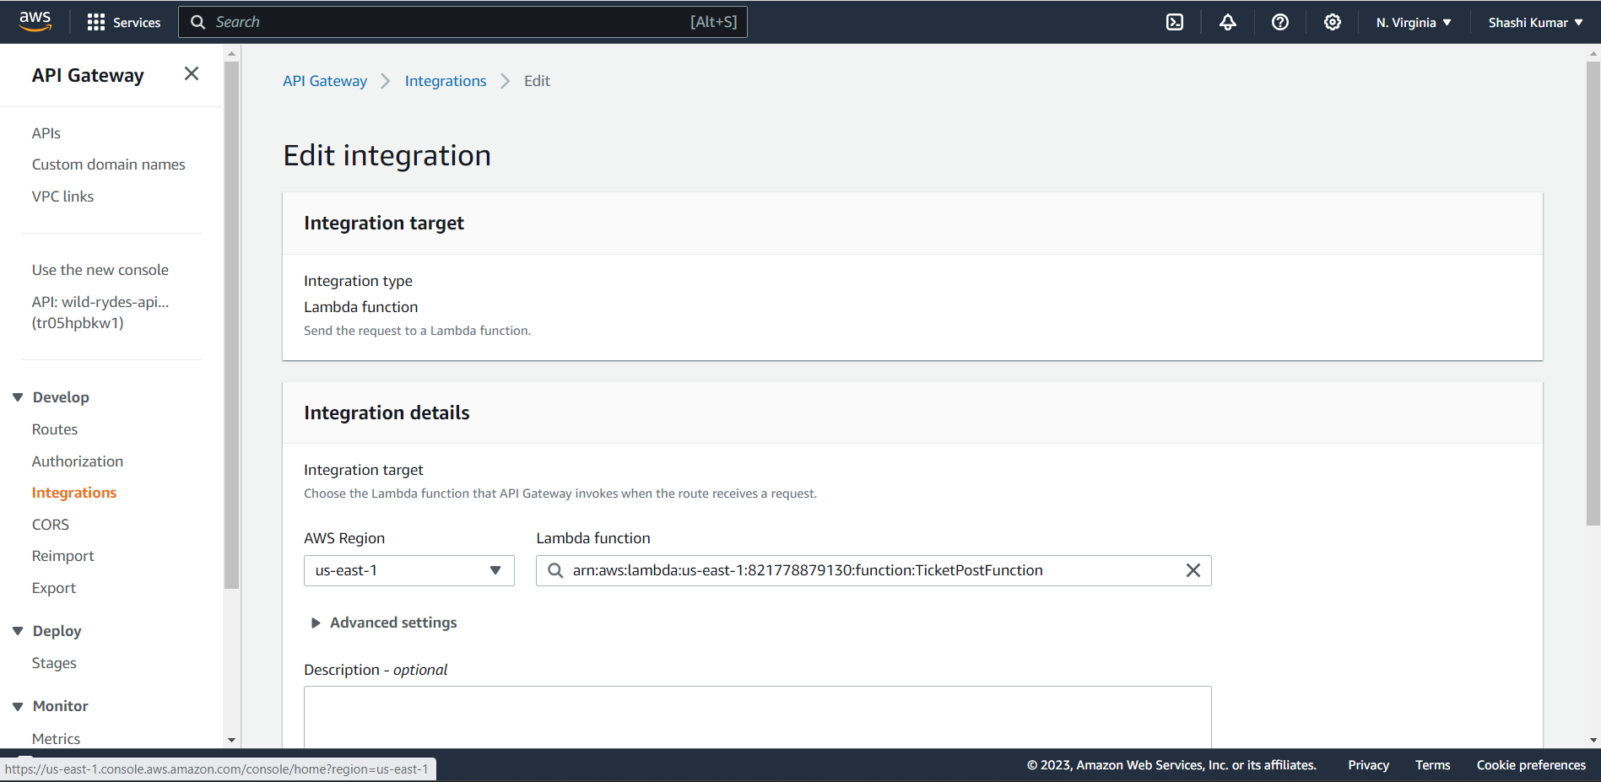

* The api at n-virginia region is no longer healthy



* When testing the api prefix of our domain, singapore region is used

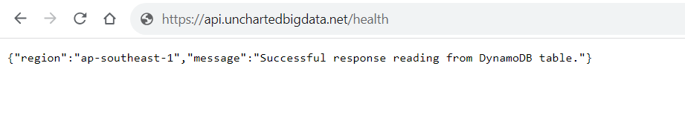

* After adding the records using the website, the data is populated in the SXRTickets table in DynamoDB

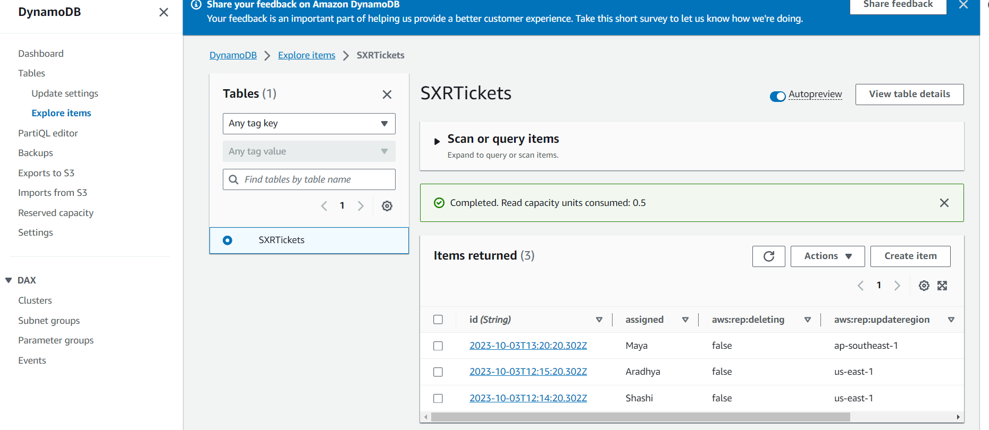

GitHub Link: https://github.com/shashikumar1998/BigdataMultiRegionApplication